# CHAPTER 1: INTRODUCTION

## 1.1 Introduction

The e-commerce platform for IT gadgets and electronics is designed to provide customers with a seamless and enjoyable shopping experience. Featuring a user-friendly interface, the website allows customers to effortlessly browse, select, and purchase a wide range of electronic items while efficiently managing their shopping carts by adding, editing, and removing products before checkout. To support smooth operations, the platform offers a comprehensive product selection and incorporates a two- level admin system: a normal admin with supplier-level access to monitor and manage their product sales, and a superuser with full control over suppliers, products, and overall platform management. Additionally, the statistical sales analysis tool provides valuable business insights, offering monthly revenue and sales data for each supplier in a clear bar graph format to visualize performance trends. With these robust features, the e-commerce website not only ensures a convenient shopping journey for customers but also empowers suppliers to track sales and optimize their offerings effectively.

## Problem Statement

Figure 1 Retail Sales Growth and Value (2018 – 2023)

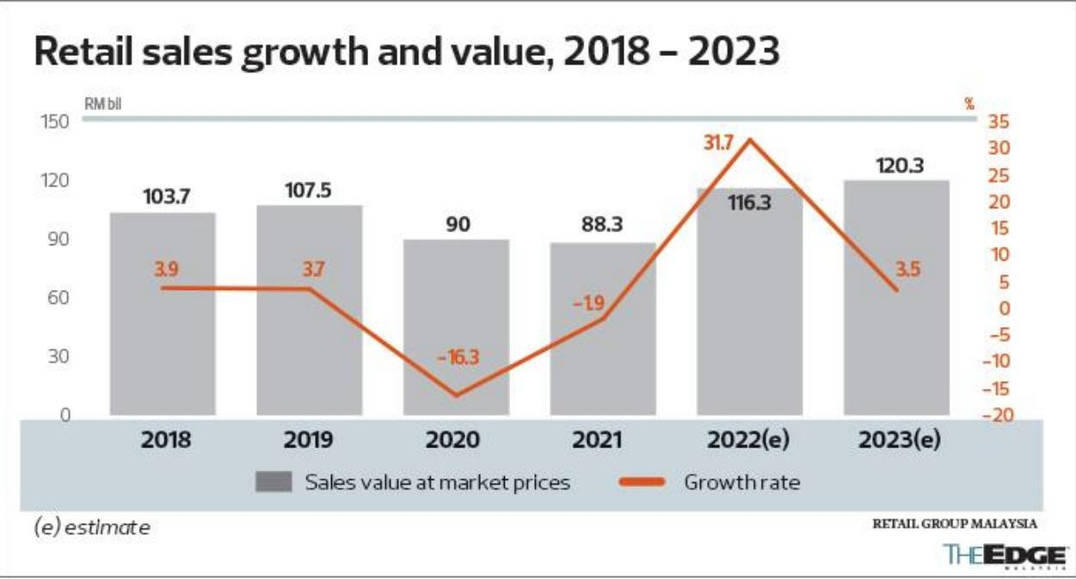Tech retail stores are facing increasing difficulties in maintaining profitability and adapting to a rapidly evolving retail environment. Physical retail sales, which were projected to generate $30 trillion in global revenue by 2025 (E-commerce Worldwide, 2024), have seen a significant decline. As shown in Figure 1 above, the sales drop sharply from 31.7% to 3.5%, striking a heavy blow to physical retail businesses. In Malaysia, the retail landscape from 2022 to 2025 reflects similar trends. Retail Group Malaysia (RGM) reported a 4.0% decline in retail sales during the second quarter of 2023, leading to a downward revision of the annual retail industry growth rate to 2.7% from the previously forecasted 4.8% (The Edge Malaysia, 2025). The decline highlights the challenges tech retail stores face in terms of expansion and growth, as shifting consumer preferences toward online shopping, rising operational costs, and intense market competition continue to pressure physical retail outlets. Addressing these issues requires innovative strategies to enhance customer experience, streamline operations, and leverage digital technologies to remain competitive.

Tech retail store is facing challenges related to expansion and growth.

Global e-commerce growth rate has been declining throughout the year due to ineffective stock management.

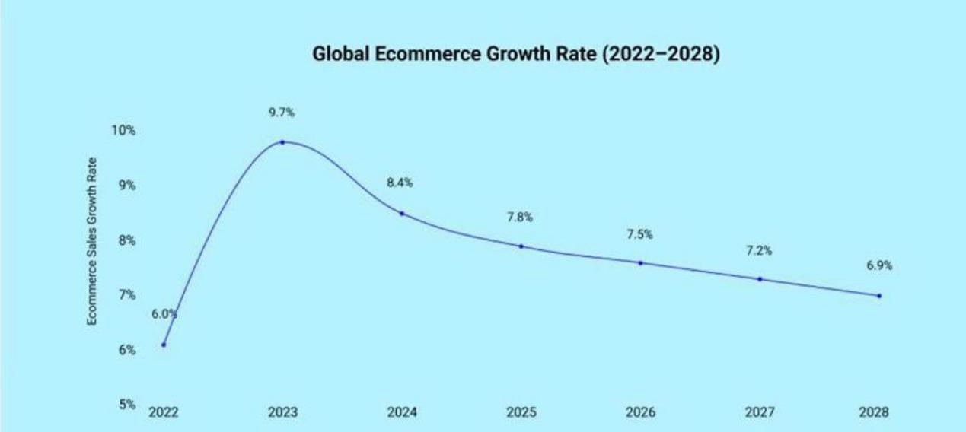

Figure 2 Global E-commerce Growth Rate (2022-2028)

As shown in Figure 2 above, physical retail sales were largely transformed into e-commerce by 2022. However, the growth rate began to decline toward 2028 from 9.7% to 6.9%. In Malaysia, stock management plays a critical role in ensuring operational efficiency and profitability across industries. As of July 2024, Malaysia’s wholesale and retail trade sales reached RM149 billion, reflecting a 6.7% year-on-year growth (Department of Statistics Malaysia, 2024). This growth is partly attributed to effective stock management practices. However, many businesses still face challenges in managing their inventory. Reports show that 58% of retail brands and direct- to-consumer manufacturers have an inventory accuracy rate below 80%, leading to issues such as overstocking or stock-outs, which can negatively impact profitability and customer satisfaction (Unleashed Software, 2024). Global e-commerce growth rate has been declining throughout the year due to ineffective stock management. Effective stock management remains a critical factor in the success of businesses in Malaysia, especially within the rapidly growing e-commerce sector. As market competition intensifies and operational costs rise, effective stock management will be key for businesses to maintain a competitive edge and drive long-term profitability.

## 1.3 Detail research question

1. What user-friendly and editable features can the application provide for the user a n super admin?
2. How can the application display monthly product sales to the admin?

## 1.4 Objective

The main objective of the proposed project is to develop an Web-based for e- commerce that allows users to purchase IT gadgets and electronic items. The app will include the following features:

1. To create a one stop e-commerce system to sell IT gadgets and electronics item and allow customer to add, edit and remove it from the shopping cart. It will include two levels of admin, normal admin which is the supplier of each product to monitor the sales accordingly and the superuser that has the full access.
2. To provide statistical analysis on how many revenue or sales generated by each supplier in monthly basis in a graph bar format.

## 1.5 Client Audience and Motivation

Client of the application:

* Users: Malaysians aged 18 and above (to comply with e-commerce regulations).
* Suppliers: List, manage, and monitor the sales performance of their IT gadgets and electronics on the platform.
* Admin: Responsible for managing and maintaining the application’s development, ensuring smooth technical operations.
* Super Admin: Oversees the entire platform, managing user roles, monitoring performance, and ensuring efficient operations.

The primary client audience for an e-commerce website focused on IT gadgets and electronics comprises general customers, suppliers, and super admins.   
 General customers are individuals aged 18 and above, seeking convenient access to a diverse range of electronics and tech products at competitive prices. Their motivation stems from the platform’s seamless shopping experience, featuring intuitive cart management that allows them to easily add, edit, or remove items, making their purchasing journey smooth and enjoyable.

Suppliers, functioning as normal admins, utilize the platform to list, manage, and track the sales performance of their products. They are driven by the ability to efficiently monitor inventory and sales data, ensuring smooth operations and fostering growth opportunities. Clear visibility into stock levels and sales trends empowers suppliers to make timely, informed decisions that optimize their business performance.

Super admins, on the other hand, have a broader oversight role, managing user roles and ensuring the platform's operational efficiency. They are motivated by access to comprehensive sales reports and statistical insights that enable informed decision-making. This elevated perspective helps them identify areas for platform improvements, support supplier success, and ultimately enhance both the user experience and the platform’s overall business growth.

## 1.6 Project Scope

The project scope focuses on developing a comprehensive e- commerce platform for IT gadgets and electronics, catering to both customers and administrative users. The system will provide core features such as product browsing, secure checkout, and cart management functions, allowing customers to add, edit, or remove items seamlessly.

The platform will include two levels of administrative access. Normal admins (suppliers) will be responsible for managing their product listings and monitoring sales performance. They will have access to sales data relevant to their products. Super admins will have full access to the entire system, including user management, product oversight, and reporting functions.

Additionally, the project will incorporate a statistical analysis module that visualizes sales and revenue data in bar graph format, providing monthly insights for both suppliers and the super admin. This feature will help track sales trends and enhance decision-making capabilities for all stakeholders. The system aims to deliver a user-friendly interface, secure transactions, and effective administrative control to support business growth and operational efficiency.

Summary of the Project Scope:

* + - Platform: The application is limited to web users only.
    - E-commerce Functionality: The app will focus solely on IT gadgets and electronics, excluding other product categories.
    - Admin Access: Admin functionalities are divided into two levels: Normal Admin (suppliers) and Super Admin (full access).
    - Sales Data Visualization: The statistical analysis feature will provide bar graphs displaying sales and revenue data; however, the accuracy of the data may depend on the input quality and user activity.
    - Internet Requirement: The app requires an active internet connection to browse products, complete transactions, and access statistical data.

## 1.7 Conclusion

The proposed web-based e-commerce platform for IT gadgets and electronics aims to provide a seamless shopping experience for customers, with features such as product browsing, secure checkout, and cart management. The system supports two levels of admin access, allowing suppliers to manage their product listings and track sales, while super admins have full control over the platform. The inclusion of a statistical analysis module helps both suppliers and admins track sales and revenue trends through visual data. With its user-friendly interface, secure transactions, and efficient administrative control, the platform is designed to support business growth and operational efficiency, providing a reliable solution for both customers and stakeholders in the IT gadget market.

# CHAPTER 2 : LITERATURE REVIEW

## 2.1 Literature Review

The literature review aims to compare e-commerce websites with top- rated platforms currently available on the market. By thoroughly examining these existing websites, a comprehensive understanding of their design principles, functionality, and overall user experience can be gained. The review will delve into various aspects of e-commerce platform design, such as navigation, accessibility, product display, and payment integration, to identify trends and best practices that contribute to the success of these platforms. Additionally, the analysis will explore the development tools and technologies commonly used to build these websites, providing insight into the tools that facilitate the creation of user-friendly and efficient e-commerce platforms. By comparing these top-rated platforms, valuable lessons can be learned on how to refine design approaches, improve performance, and enhance user interaction. This review not only aims to inform the development of a more effective e-commerce platform but also provides an opportunity to incorporate innovative features and functionalities that have proven successful in leading e-commerce solutions. Ultimately, this analysis will serve as a crucial resource for enhancing the design and operation of the e-commerce website, ensuring a more seamless and engaging experience for users.

## 2.2 Related review

A comparative review of Harvey Norman Malaysia, Best Buy, and the Odoo stock management system reveals the dynamic nature of modern e- commerce platforms and their administrative back-end capabilities.

Harvey Norman Malaysia's website caters to a local audience with a user-friendly interface and competitive pricing. The site focuses on providing a seamless shopping experience, featuring clear navigation, localized promotions, and easy access to customer service. Its digital presence reflects the brand's commitment to accommodating Malaysian consumers, offering a blend of online convenience and in-store reliability.

Best Buy's website, on the other hand, showcases a highly optimized digital retail experience with extensive product categories and seamless checkout options. The site is designed with efficiency in mind, incorporating advanced search filters, personalized recommendations, and a streamlined purchasing process that caters to both tech-savvy shoppers and casual buyers. This global retailer's online platform emphasizes innovation and customer satisfaction through technology-driven solutions.

However, these e-commerce websites are typically accessible only to the admin and super-user roles, meaning that managing the stock, orders, and customer information happens behind the scenes. This is where a system like Odoo becomes highly relevant, as it offers a powerful and customizable stock management solution designed for administrative use. Odoo enables businesses to efficiently track inventory, automate purchase orders, and integrate with multiple sales channels, bridging the gap between online storefronts and internal business operations. This seamless integration ensures real-time accuracy and enhances overall operational efficiency, making it a strong example of a stock management system that complements the e-commerce ecosystem.

In conclusion, while Harvey Norman Malaysia and Best Buy excel in providing front-end user experiences tailored to their respective markets, Odoo's robust back-end infrastructure highlights the importance of synchronizing digital retail platforms with comprehensive stock management tools. Together, these systems illustrate the evolving landscape of e-commerce, where front-end appeal and back-end functionality go hand in hand to drive business success.

## 2.3 Harvey Norman



Figure 3 Harvey Norman Malaysia

Harvey Norman Malaysia (Harvey Norman, 2025) is an established e- commerce platform that offers a wide range of products, including electronics, IT gadgets, home appliances, and furniture. As part of the global Harvey Norman brand, which has been a trusted name in retail for decades, the Malaysian online store provides customers with a convenient shopping experience. The website features detailed product listings, competitive pricing, and a secure payment system. With regular promotions and a user-friendly interface, Harvey Norman Malaysia aims to offer high-quality products and services to consumers seeking reliable electronics and home solutions.

### 2.3.1 Harvey Norman Main Page

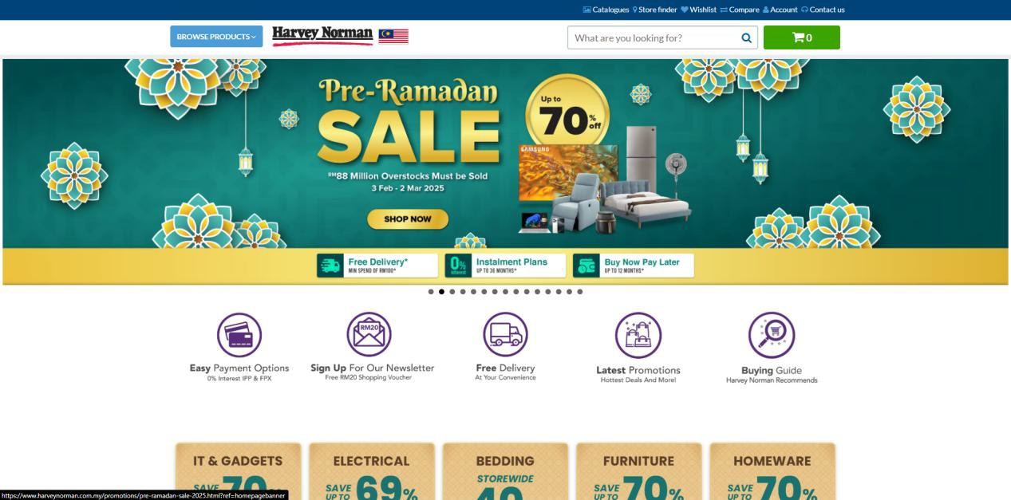The Harvey Norman Malaysia homepage is designed to provide a seamless and engaging shopping experience. At the top, a clean header features the Harvey Norman logo, a country selector, and a search bar for easy navigation, along with quick links to user accounts, shopping carts, and order tracking. The main visual highlight is a large rotating banner that showcases featured products and promotions, with clear call-to-action buttons encouraging visitors to shop immediately. Just below, a row of service icons emphasizes Harvey Norman’s convenient offerings, including easy payment options, newsletters, free delivery, installation services, and a “buy now, pay later” program, reassuring customers of a smooth and flexible shopping process.

Figure 4 Harvey Norman Malaysia Main Page

Further down, a colorful promotional grid highlights significant discounts across key product categories such as IT gadgets, electrical appliances etc. A prominent mid-page banner offers new users a 20% discount, adding an extra incentive for first-time shoppers.

Beyond the promotions, the site features thematic sales and curated gift guides, helping customers find the perfect products for festive seasons or home improvement projects. The homepage also showcases best-selling IT gadgets and home appliances in a clear, scroll-able carousel, complete with product images, pricing (including discounts), and “Add to Cart” buttons, encouraging quick purchases. Overall, the Harvey Norman Malaysia homepage is a thoughtfully designed space that balances promotional appeal with user-friendly navigation, creating a dynamic and enticing online retail experience.

### 2.3.2 Harvey Norman Malaysia Product Page

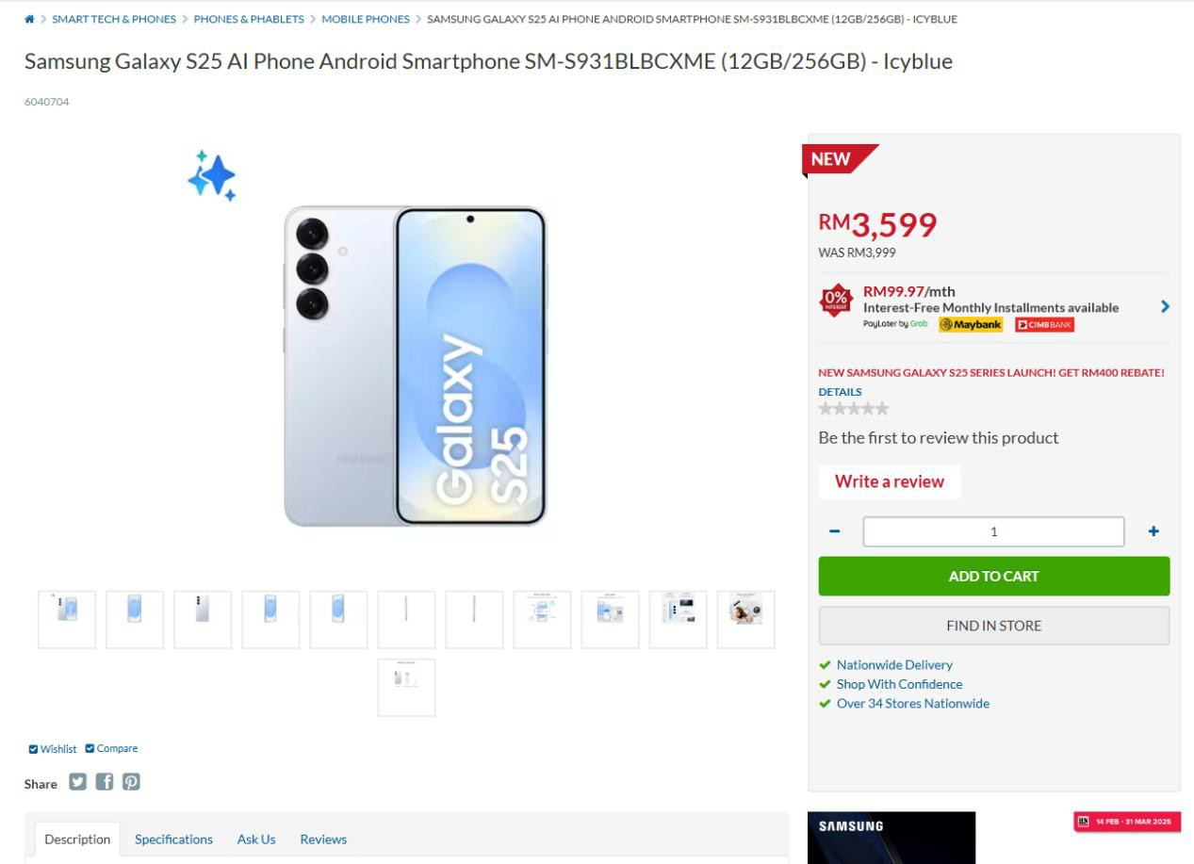 The website product page is designed to offer a smooth and informative shopping experience. At the top, a breadcrumb navigation trail helps users easily find their way back to broader categories, while a product image gallery provides multiple views of the product, allowing customers to inspect its design and details. The price section is prominently displayed, showing both the discounted and original price, with installment plan options and a clear promotion for a rebate. Shoppers can choose to add the item to their online cart or check its availability in physical stores, supported by trust signals like nationwide delivery, secure shopping, and over 34 store locations.

Figure 5 Harvey Norman Malaysia Main Page

Below, the information is organized into tabs for Description, Specifications, Q&A, and Reviews, keeping the page clean and easy to navigate. Social sharing buttons for Facebook, Twitter, and Pinterest encourage engagement, while a promo period banner ensures customers are aware of the time-limited offer. Overall, the layout balances visual appeal with practical functionality, guiding users smoothly from product discovery to purchase.

### 2.3.3 Harvey Norman Malaysia Catalogues and Promotions Page

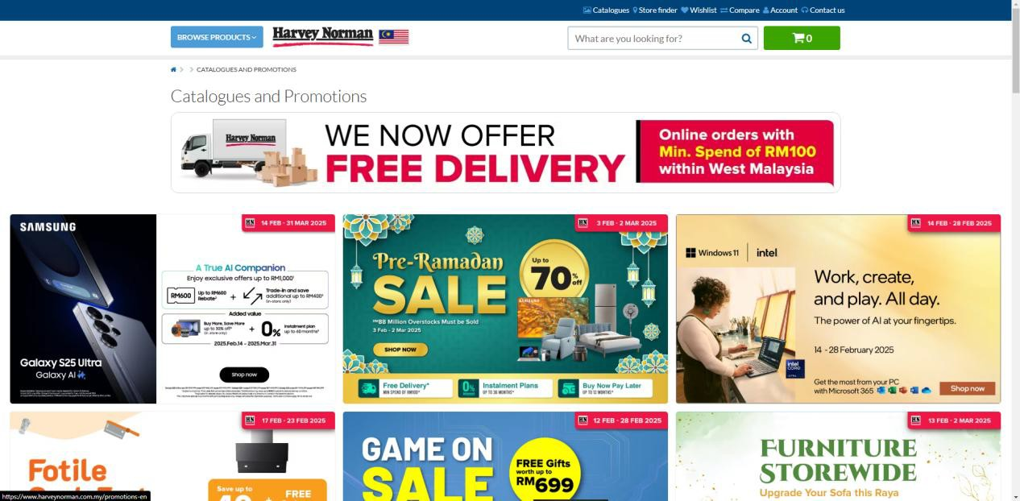

Figure 6 Harvey Norman Malaysia Catalogues and Promotions Page

This page from Harvey Norman Malaysia focuses on catalogues and promotions, designed to attract shoppers with special offers and discounts. At the top, there’s a large “Free Delivery” banner, announcing that online orders within West Malaysia qualify for free shipping with a minimum spend of RM100 — a clear incentive to encourage purchases.

Below, the page features a grid of promotional sections, each highlighting different sales events. There are banners promoting significant discounts on a variety of products, including electronics and home essentials, with free delivery and flexible payment options. Further down, there are additional promotions offering special incentives with purchases, highlighting accessories, home appliances, and furniture, all designed to help customers upgrade their homes with attractive deals.

Overall, the page is visually engaging, with colorful graphics, clear discount percentages, and prominent “Shop Now” buttons, designed to drive conversions and boost seasonal sales.

### 2.3.4 Harvey Norman Malaysia Store Finder Page

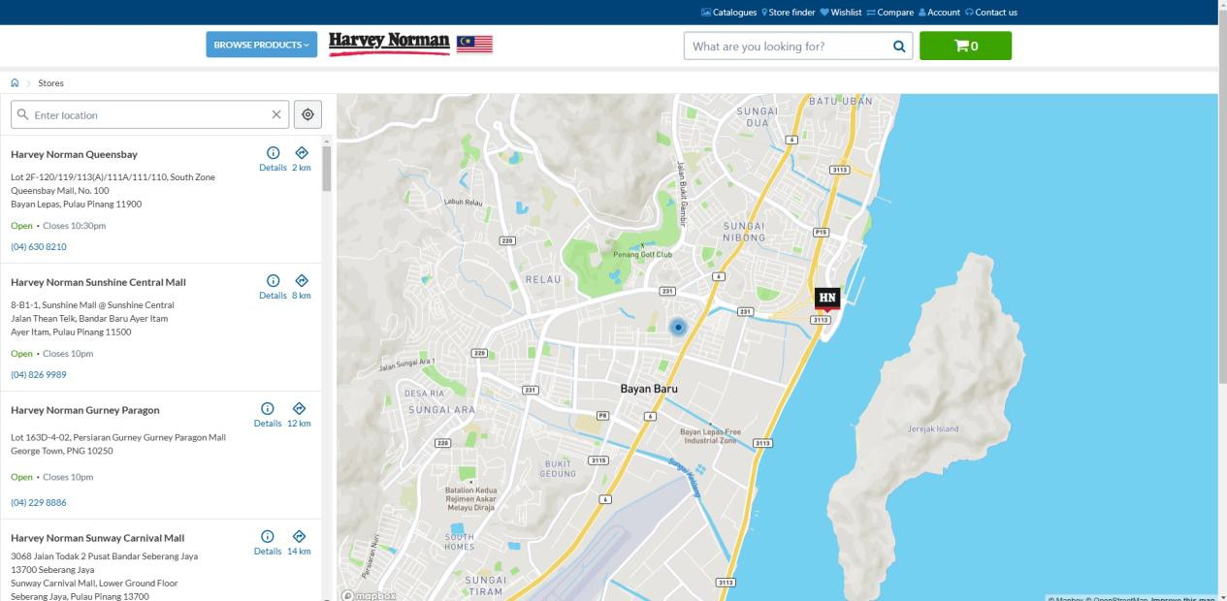

Figure 7 Harvey Norman Malaysia Store Finder Page

This is a store finder page for Harvey Norman Malaysia, designed to help users locate nearby outlets. On the left side, there’s a list of store locations, each with an address, contact number, and operating hours. The stores are displayed in order of proximity, with the nearest location shown first.

On the right side, there’s an interactive map that visually marks the store locations. A distinctive HN icon pinpoints each outlet, allowing users to easily see where the stores are relative to their current location. The map can be zoomed in and out for convenience, helping users get a better sense of directions and surroundings.

Overall, the store finder combines a clean layout with practical navigation tools, making it simple to plan a visit to the nearest store.

### 2.3.5 Harvey Norman Malaysia Wishlist

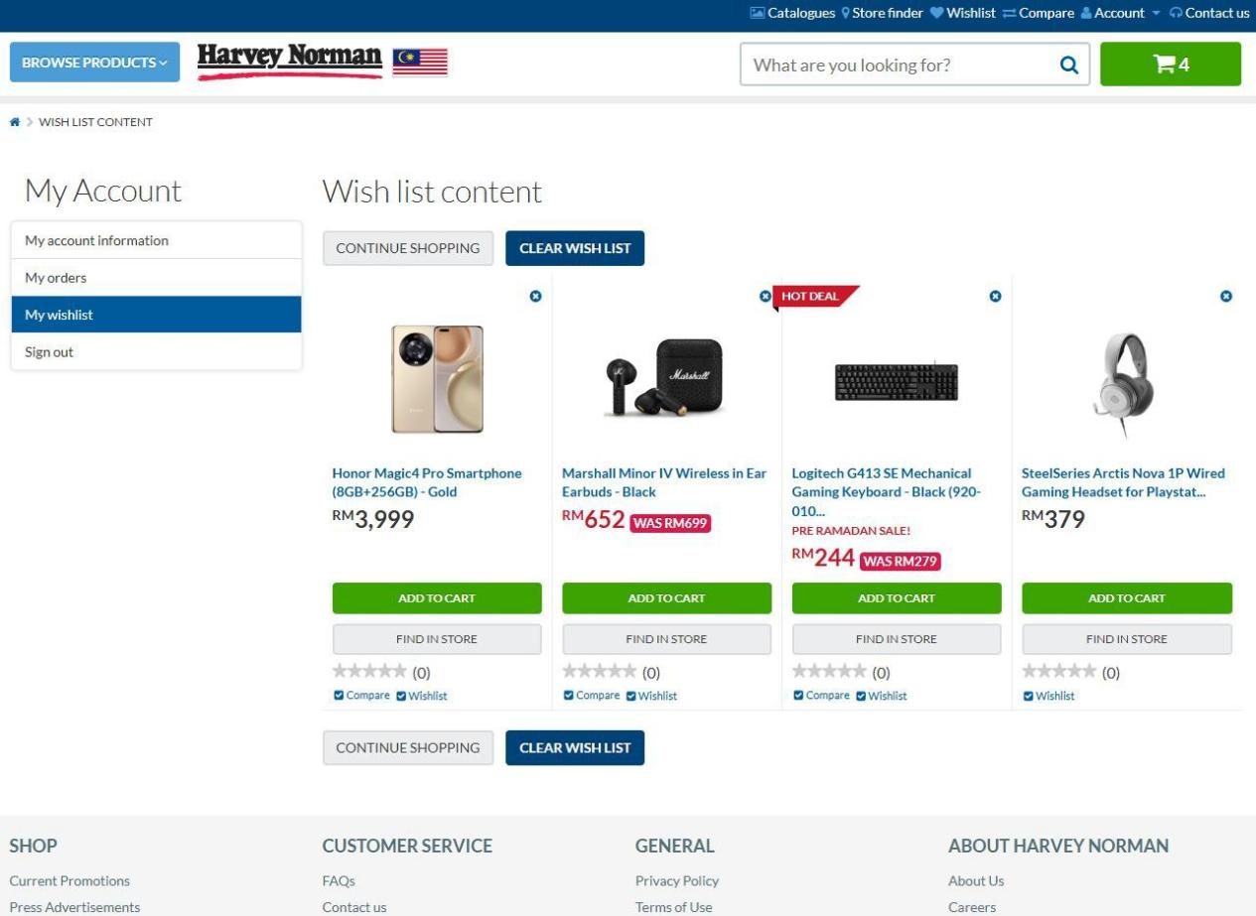

Figure 8 Harvey Norman Malaysia Wishlist Page

This is a wish list feature from page for Harvey Norman Malaysia, designed to save products of interest for future purchases. On the left side, the My Account section manages account information, order history, wish list access, and sign-out options. The My Wish list tab is active, displaying a collection of saved items.

The wish list content showcases products with clear visuals, names, prices, and available discounts. Notable labels are highlight for special offers, making it easy to spot bargains. Each item includes two main actions: an Add to Cart button for immediate purchase and a Find in Store option to check availability at physical locations. Additional features allow comparison of items, checking product ratings, and removing individual items if no longer needed.

To streamline shopping, the page offers two key management buttons: Clear Wishlist, which removes all saved products in one click, and Continue Shopping, which redirects to browse for more items.

At the bottom of the page, a comprehensive footer provides links to customer service resources, such as FAQs, contact information, and terms of use, alongside company details like careers and current promotions. This thoughtful setup organizes shopping interests, facilitates product revisits, and supports purchasing decisions efficiently.

### 2.3.6 Harvey Norman Malaysia Product Comparison

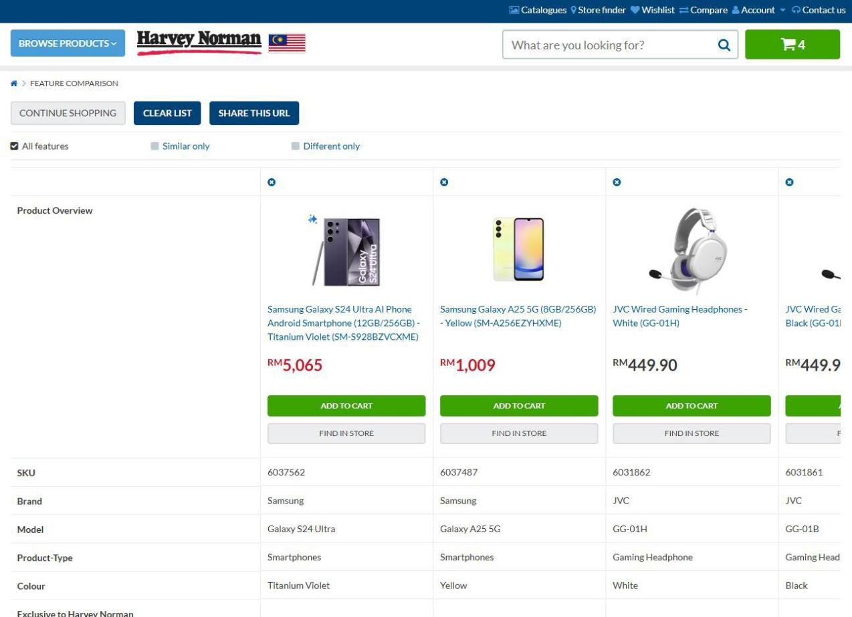

Figure 9 Harvey Norman Malaysia Product Comparison Page

Figure 9 Harvey Norman Malaysia Product Comparison Page

This is a product comparison page from Harvey Norman Malaysia’s online store, designed to help shoppers evaluate multiple products side-by- side. The interface showcases a selection of items, each with clear images, names, and prices, along with options to Add to Cart or Find in Store.

The comparison tool allows filtering by All features, Similar only, or Different only, making it easy to spot key differences or shared attributes. Below the product images, a Product Overview section presents essential details such as SKU, brand, model, product type, color, and whether the item is exclusive to Harvey Norman Malaysia.

Convenient action buttons, including Clear List to remove all items and Share This URL to send the comparison to others, enhance the user experience. This layout helps customers make informed buying decisions by offering a clear and organized view of product specifications and value.

### 2.3.7 Harvey Norman Malaysia Shopping Cart

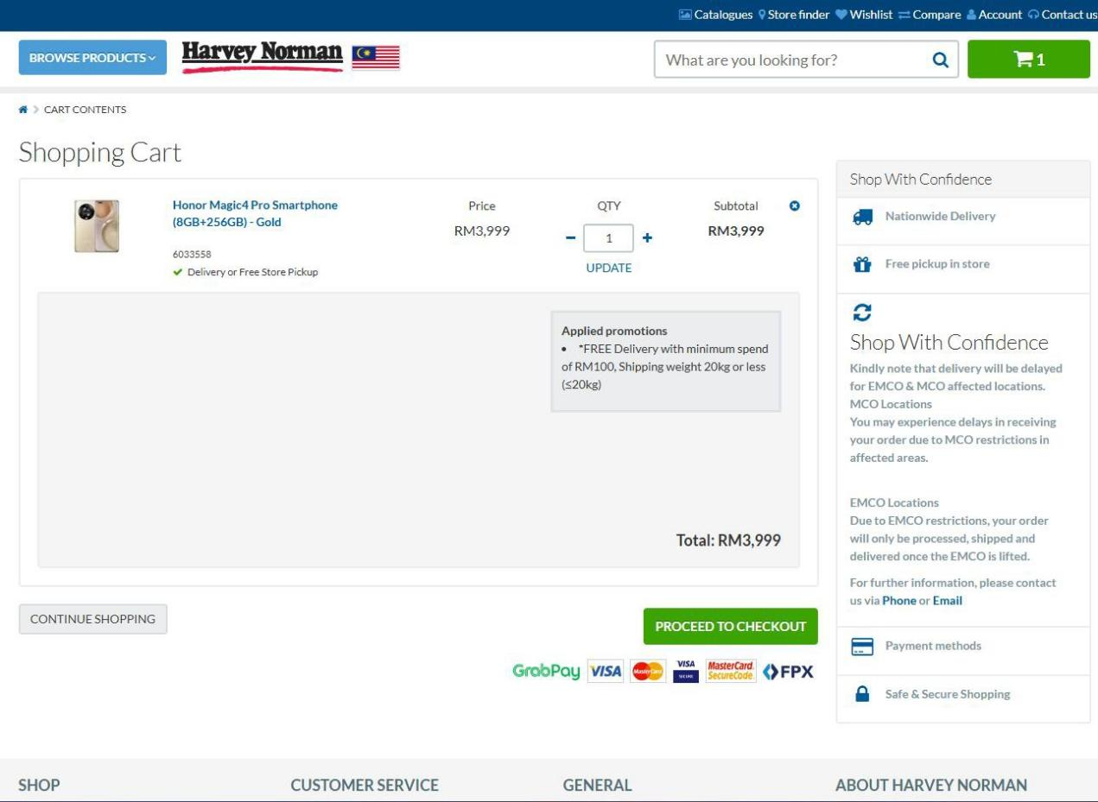

Figure 10 Harvey Norman Malaysia Product Comparison Page

The shopping cart feature on the Harvey Norman Malaysia website offers a clean and straightforward experience. It prominently displays the total amount, with options to adjust the quantity of items or update the cart. A promotion section highlights available deals, such as free delivery for orders over RM100, with clear terms. On the right-hand side, the “Shop With Confidence” section reassures customers with information about nationwide delivery, free in-store pickup, and notes on potential delays due to EMCO & MCO restrictions. The bottom of the page shows supported payment methods, including GrabPay, Visa, MasterCard, SecureCode, and FPX, ensuring flexibility and security. The checkout button stands out in green, guiding users smoothly toward completing their purchase.

### 2.3.8 Harvey Norman Malaysia Profile Details Page

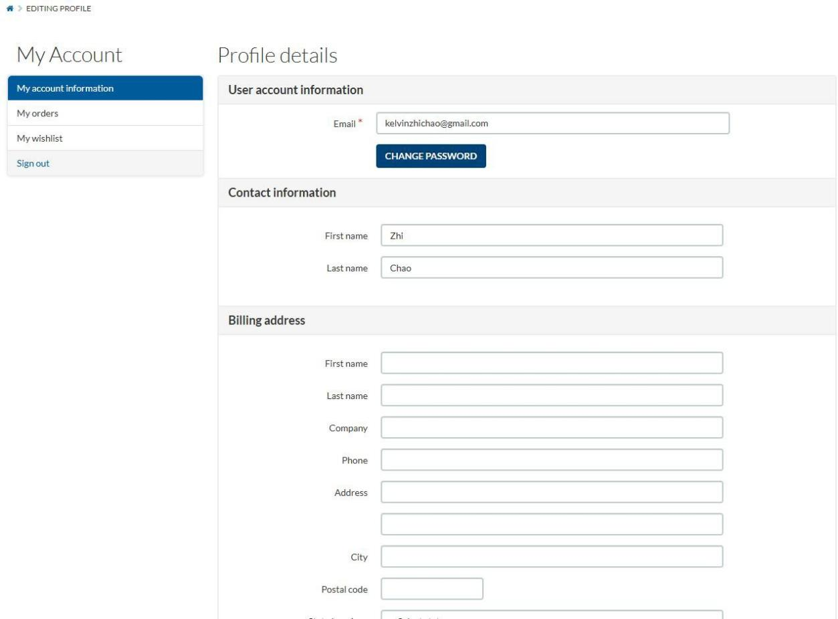

Figure 11 Harvey Norman Malaysia Profile Details Page

This is the My Account page, allowing users to manage personal information. The interface consists of sections for User Account Information, Contact Information, and Billing Address.

The User Account Information section displays the registered email address with an option to change the password. The Contact Information section includes fields for the first and last name. The Billing Address section provides fields for essential details such as name, company, phone number, address, city, postal code, and state.

On the left panel, navigation options include My Account Information, My Orders, My Wishlist, and Sign Out, ensuring easy access to account settings and purchase history. The clean layout ensures smooth editing and updating of personal details.

### 2.3.9 Harvey Norman Malaysia Sign In Page

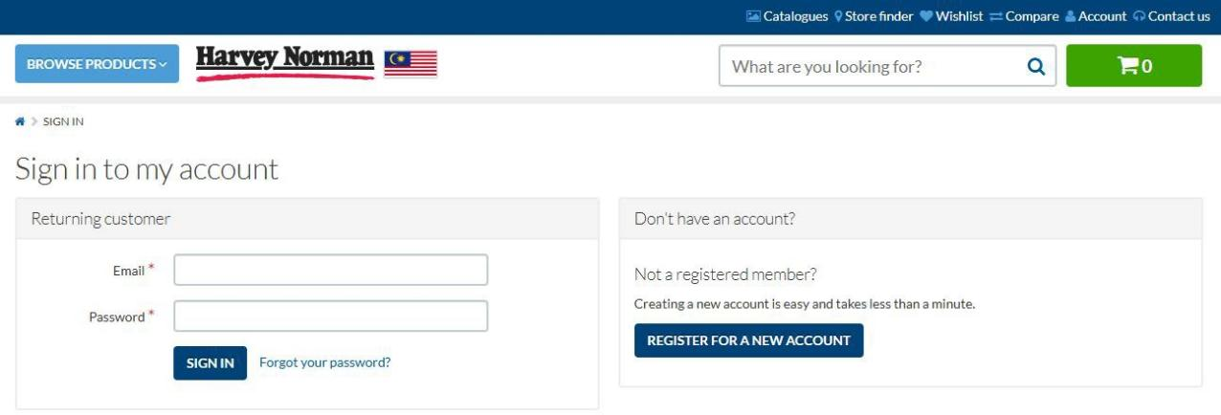

Figure 12 Harvey Norman Malaysia Sign In Page

The Sign in to *my account* page from Harvey Norman Malaysia provides a seamless experience for both returning and new customers. On the left side, returning customers can enter their email and password to sign in, with an option to recover their password if forgotten. On the right side, new customers are encouraged to create an account, with a clear call-to-action button that emphasizes how quick and easy the registration process is.

### 2.3.10 Harvey Norman Malaysia Register Page

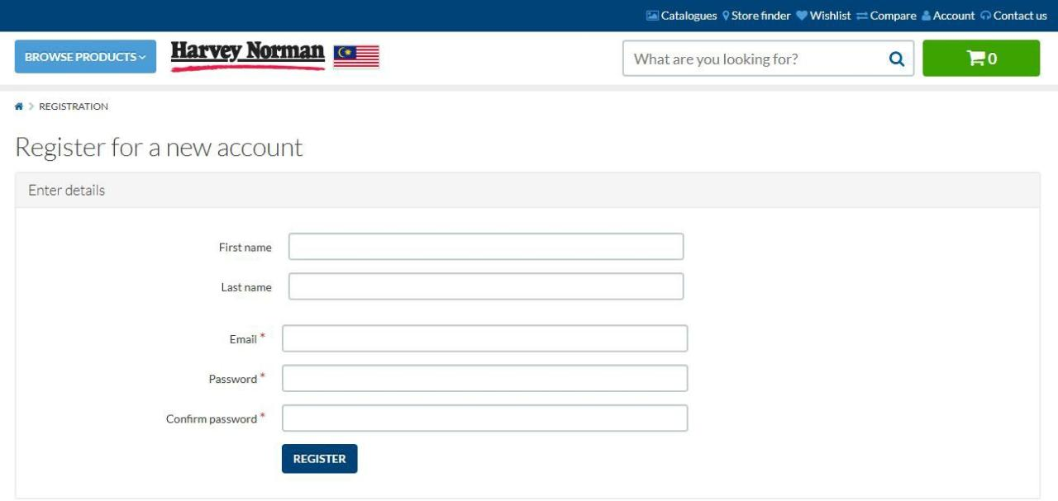

Figure 13 Harvey Norman Malaysia Register Page

The Register for a *new account* page on Harvey Norman Malaysia offers a straightforward and user-friendly form for creating an account. Users are prompted to enter their first name, last name, email address, and create a password, which they must confirm. Required fields are clearly marked with an asterisk (*), ensuring users provide the necessary information. A REGISTER button at the bottom completes the process, making it quick and easy for new customers to join.

## 2.4 Best Buy



Figure 14 Best Buy

*(https://[www.bestbuy.com/)](http://www.bestbuy.com/))*

Best Buy (Best Buy, 2025) is one of the largest and most recognized consumer electronics retailers in the United States. Founded in 1966 as Sound of Music, the company rebranded to Best Buy Co., Inc. in 1983 and has since grown into a global leader in selling technology products, services, and solutions. The company offers a wide range of products, including computers, smartphones, home appliances, gaming consoles, smart home devices, and IT accessories. With over 1,000 physical stores across the U.S., Canada, and Mexico, along with a strong online platform, Best Buy caters to both in-person and digital shoppers. A key differentiator is its Geek Squad services, which provide installation, repairs, and technical support, fostering customer trust and encouraging repeat business ( Wells. T, 2024). Best Buy’s focus on delivering personalized experiences, such as knowledgeable staff, curbside pickup, and easy returns, sets it apart from many online-only competitors.

The company has also expanded its e-commerce capabilities with fast shipping, same-day pickup, and a third-party marketplace for sellers, creating opportunities for businesses to reach a vast customer base. Studying Best

Buy’s combination of trusted service, omnichannel retailing, and tech-focused offerings could offer valuable insights for building an e-commerce platform for IT gadgets and electronics.

### 2.4.1 Best Buy Main Page

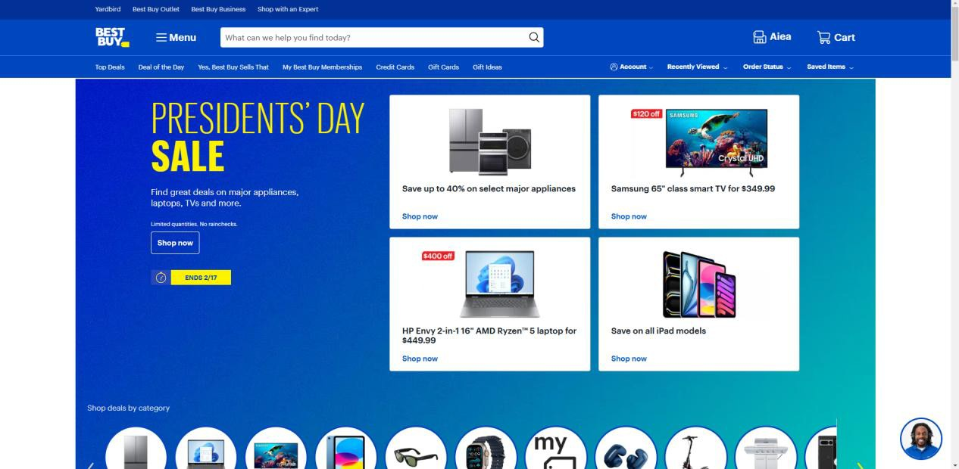

Figure 15 Best Buy Main Page

The Best Buy homepage features a clean, blue-themed design focused on promotions and product deals. At the top, a navigation bar includes the Best Buy logo, search bar, account options, and shopping categories like Top Deals, Memberships, and Gift Cards. A large promotional banner highlights the Presidents' Day Sale, offering major discounts on appliances, laptops, and TVs. Below, featured deals showcase discounted Samsung TVs, HP laptops, and iPads. A category-based shopping section uses circular icons for quick access to product types like smartphones, wearables, and home gadgets. A customer support icon at the bottom ensures easy assistance. The layout is visually engaging, making it simple for users to browse and shop efficiently.

### **2.4.**2 Best Buy Top Deals

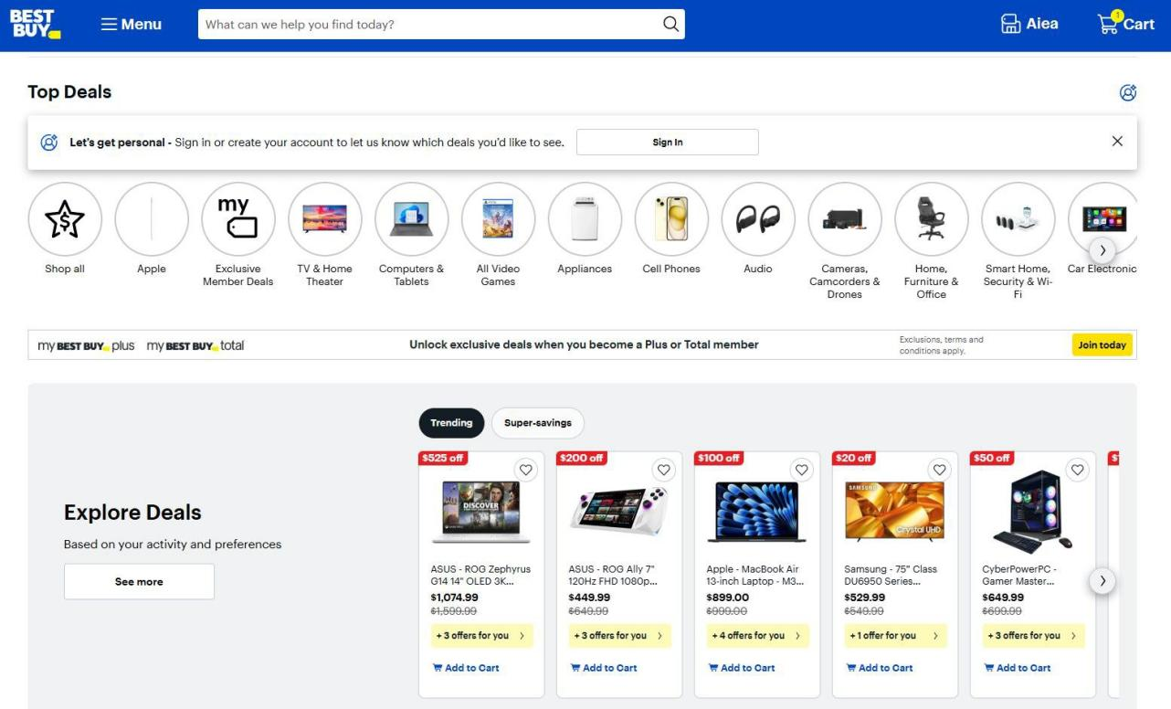

Figure 16 Best Buy Top Deals Page

This page presents a clean and organized layout designed to highlight top deals and enhance the shopping experience. At the top, a navigation bar provides quick access to search functionality, account management, and the shopping cart. Below, a series of circular icons offers easy navigation through popular product categories, including electronics, appliances, audio, and smart home devices. A personalized recommendation section encourages users to sign in for customized deals, while a membership offer banner promotes exclusive savings for premium members. The main content focuses on trending and super-savings deals, showcasing products with clear price reductions, original prices, and multiple purchasing offers. Each product listing features a prominent “Add to Cart” button, making the buying process seamless. Additionally, the "Explore Deals" section tailors suggestions based on user activity and preferences, with a convenient “See more” button to encourage further browsing. Overall, the page emphasizes convenience, personalization, and promotional visibility to create a smooth and engaging shopping journey.

### 2.4.3 Best Buy Product Page

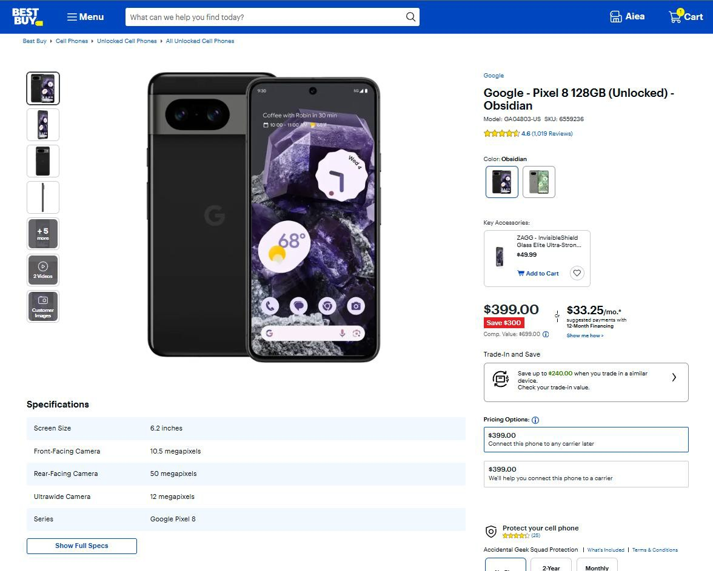

Figure 17 Best Buy Product Page

The Best Buy website product page offers a clean and informative shopping experience, designed to guide users smoothly from browsing to purchase. At the top, breadcrumb navigation helps shoppers keep track of their location within the site, making it easy to explore related categories. A prominent product image gallery on the left allows for detailed visual inspection, with multiple angles, videos, and customer-uploaded images. On the right, the product name, model information, and customer ratings are displayed, followed by clear color options and key accessories, which can be added to the cart with a single click. The price section highlights savings with a bold red discount tag, alongside flexible payment plans and trade-in savings, creating a sense of value and affordability. Below, specifications such as screen size, camera megapixels, and series details are neatly organized, with a "Show Full Specs" button for more technical information. The page also

encourages users to protect their purchase with warranty options and displays clear monthly pricing breakdowns. Overall, the layout prioritizes user engagement, transparency, and convenience, enhancing the online shopping journey.

### 2.4.4 Best Buy Cart Page

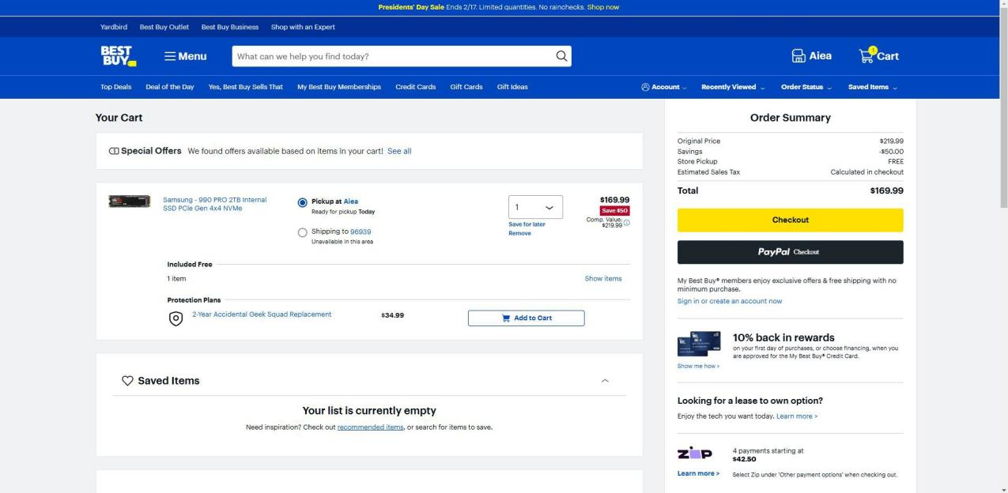

Figure 18 Best Buy Cart

The image shows the cart page of Best Buy's website. At the top, the navigation bar remains consistent, displaying the Best Buy logo, search bar, account options, and cart icon with an item count. The user can choose between store pickup (available today) or shipping (unavailable for the selected area).

On the right side, the Order Summary displays the original price, discount, and total amount due, with checkout options via Best Buy or PayPal. Below, promotional banners highlight benefits like "10% back in rewards" for credit card users and lease-to-own payment plans. The page also includes a Saved Items section, which is currently empty, encouraging users to explore recommended products. The layout is user-friendly, ensuring a seamless checkout experience.

### 2.4.5 Best Buy Memberships Page

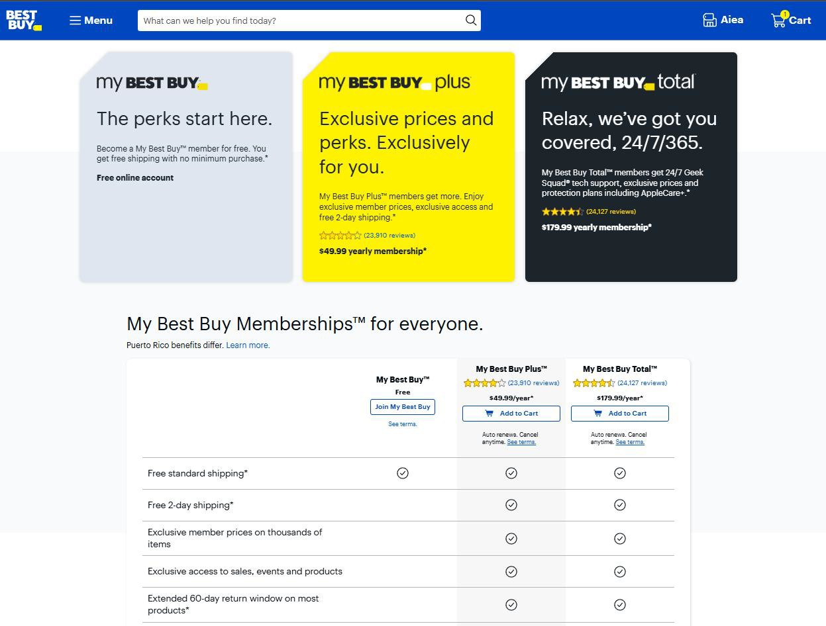

Figure 19 Best Buy Memberships Page

This is the page for the My Best Buy Membership program, and it’s one of the features that can really enhance the shopping experience for Best Buy customers. By offering different tiers of benefits — from free standard shipping to exclusive discounts and 24/7 tech support — this program creates value for shoppers at every level. Whether someone’s a casual buyer looking for convenience or a tech enthusiast who wants premium protection and fast service, the membership options cater to a range of needs. Plus, the clear breakdown of perks helps customers easily decide which membership fits their lifestyle.

### 2.4.6 Best Buy Credit Cards Feature Page

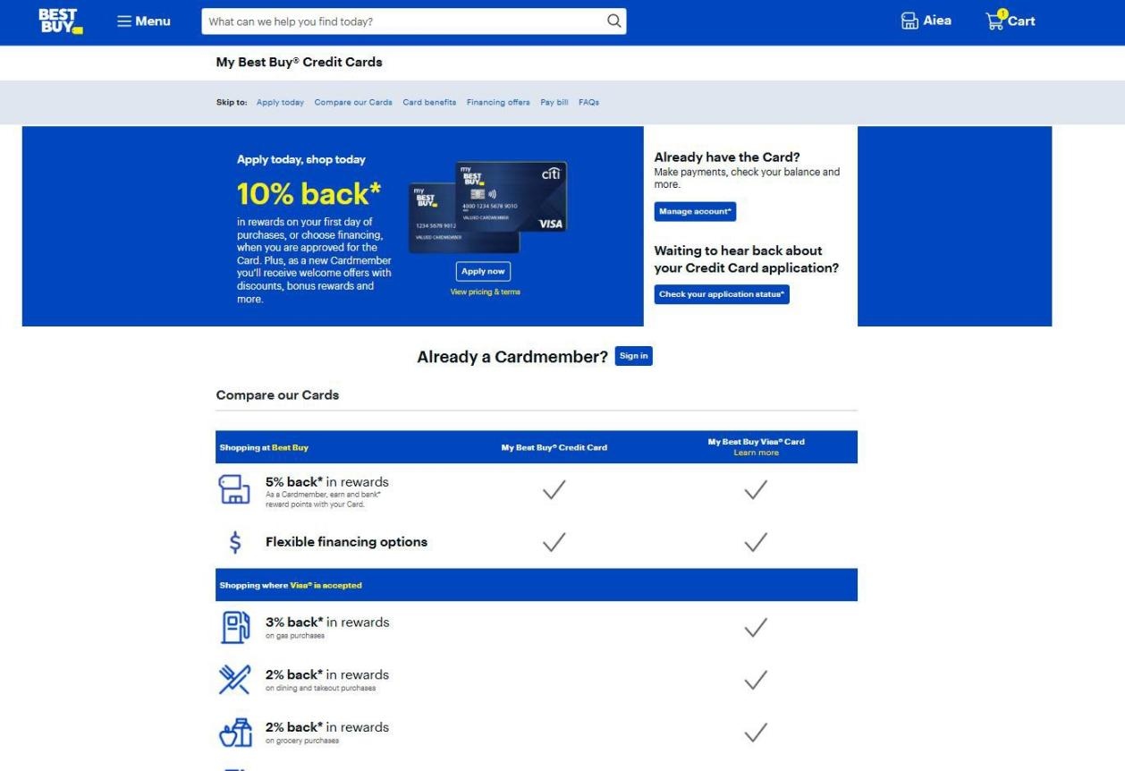

Figure 20 Best Buy Memberships Page

The Best Buy Credit Card feature adds even more value for shoppers. With this card, customers can enjoy rewards on purchases, including cashback and special financing options. On the first day of purchases, there’s a bonus reward offer, which makes signing up even more enticing. Plus, cardholders can earn extra rewards not just at Best Buy but also on everyday expenses like gas, dining, and groceries, making it a practical choice beyond electronics shopping.

### 2.4.7 Best Buy Sign In Page

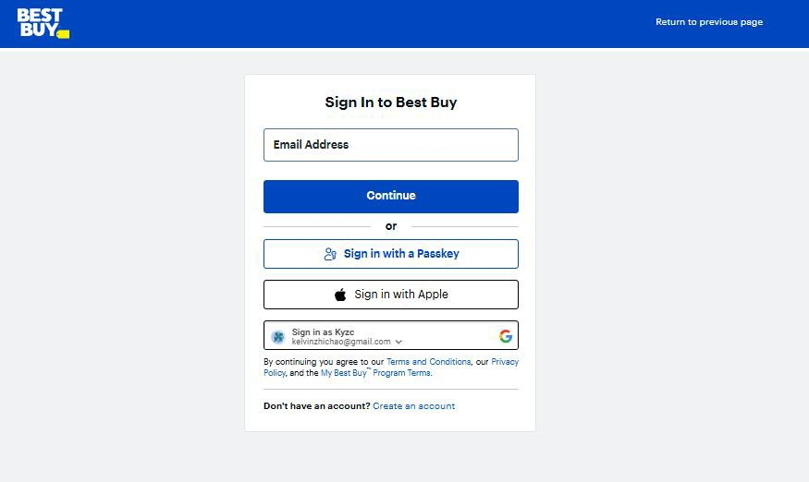

Figure 21 Best Buy Sign In Page

This is the Best Buy sign-in page, where users can access their accounts to manage purchases, rewards, and memberships. It offers multiple ways to sign in: by entering an email address, using a passkey for added security, signing in with Apple, or even with a Google account for convenience. If someone doesn’t have an account yet, there’s a quick option to create one right below.

### 2.4.8 Best Buy Sign In Page

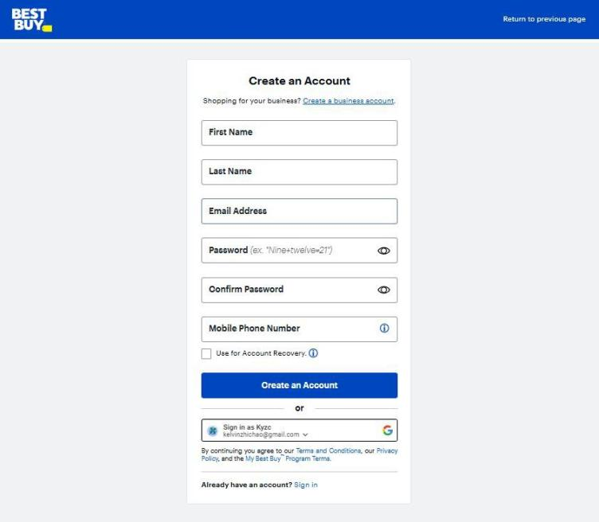

Figure 22 Best Buy Register Page

This is the Best Buy Create an Account page! It allows new users to sign up by providing their first and last name, email address, password, and mobile phone number. There’s also an option to use the account for rewards and receive updates. For added convenience, users can create an account by signing in with Google. At the bottom, there’s a link to sign in for those who already have an account.

## 2.5 Odoo

**

Figure 23 Odoo

*(https://[www.odoo.com/)](http://www.odoo.com/))*

Odoo (Odoo, 2025) is a powerful, open-source business management suite that provides a comprehensive range of applications for Customer Relationship Management (CRM), Enterprise Resource Planning (ERP), sales, inventory, accounting, HR, e-commerce, and project management. Its modular architecture allows businesses to start with essential apps and expand as needed, offering flexibility with both cloud and on-premise deployment. Featuring a user-friendly interface, strong customization options, and seamless integration with third-party tools, Odoo is designed for scalability, making it suitable for startups, *SMEs*, and large enterprises. Backed by a global open-source community, Odoo continuously evolves, enabling businesses to automate operations, improve efficiency, and drive digital transformation.

### **2.5.**1 Odoo Registration Page

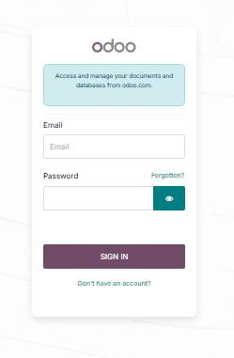

Figure 24 Odoo Registration Page

This is the login page for Odoo, a popular open-source business management software. The page allows users to access and manage their documents and databases from odoo.com. It includes fields for entering an email address and password, with a "Forgotten?" link for password recovery. There’s also an eye icon to reveal or hide the password for convenience. Below the login fields, there's a prominent “Sign In” button, and for new users, a “Don’t have an account?” link to create one. The page design is clean and minimalism, focusing on secure and efficient user authentication.

### 2.5.2 Odoo Account Page

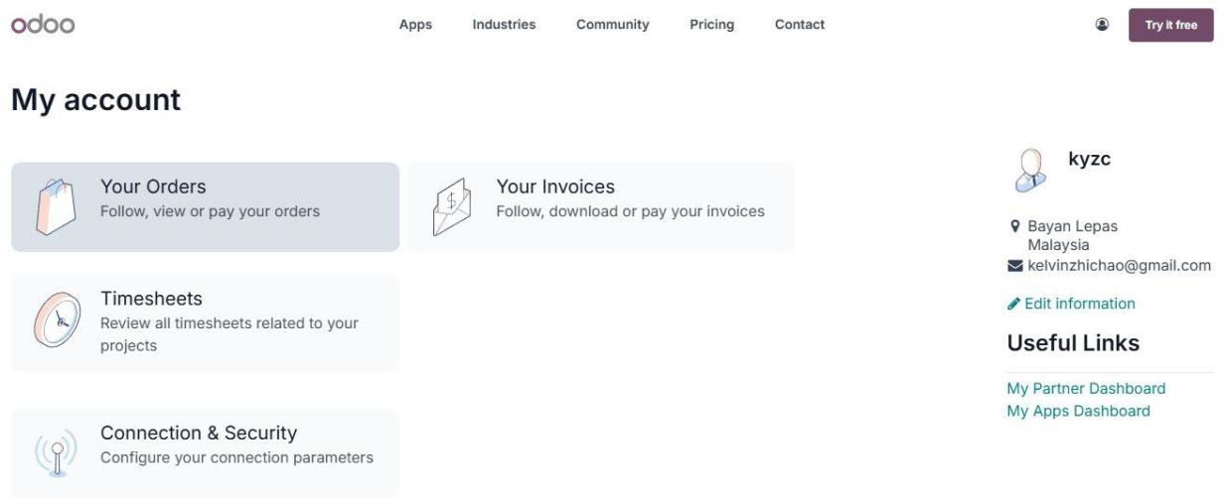

Figure 25 Odoo Account Page

The Odoo account dashboard provides a comprehensive and user- friendly interface for managing various business operations. The dashboard is divided into sections, allowing users to easily navigate between managing orders, tracking invoices, reviewing project-related timesheets, and configuring connection and security settings. On the right side, the user profile displays key information such as the user’s name, location, and email address, with quick options to edit personal details or access useful links like the Partner Dashboard and Apps Dashboard. This intuitive layout ensures that businesses can efficiently monitor their transactions and streamline their workflows, making Odoo a powerful tool for stock management and administrative tasks.

### 2.5.3 Odoo Connection and Security Page

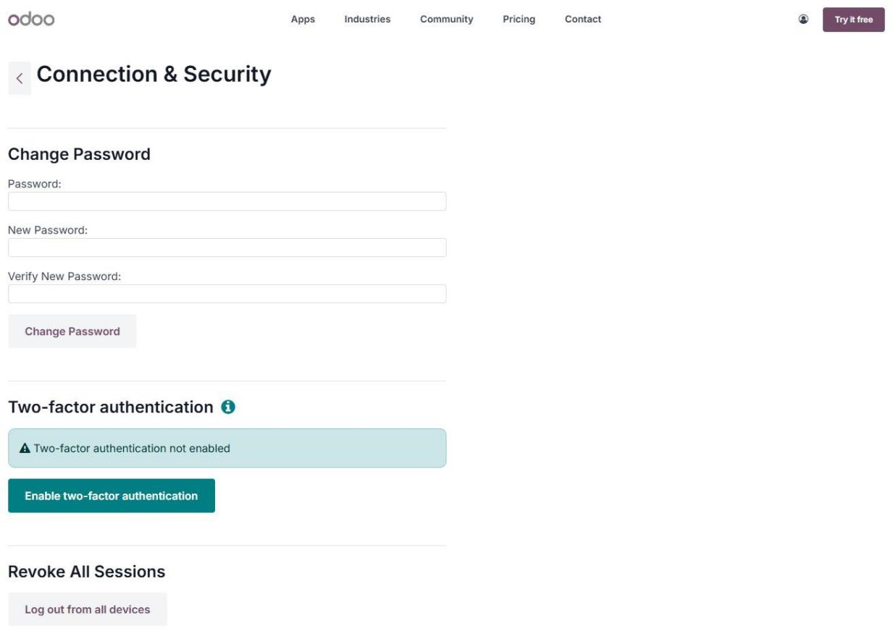

Figure 26 Odoo Connection and Security Page

This Odoo "Connection & Security" page offers users a centralized interface to manage account safety. It allows for password changes by entering the current password and setting a new one, ensuring secure access. Additionally, the page highlights the importance of two-factor authentication (2FA), with a clear option to enable it, adding an extra layer of protection. For enhanced security, users can also revoke all active sessions by logging out from all devices with a single click. This design reflects Odoo’s commitment to safeguarding sensitive data, making it a reliable choice for managing business operations securely.

### 2.5.4 Odoo DashBoard

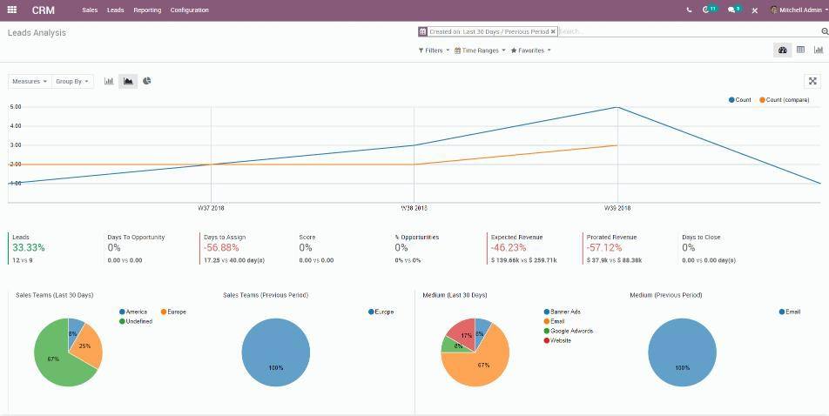

Figure 27 Odoo Dashboard

The website is a CRM (Customer Relationship Management) Leads Analysis dashboard. It provides key performance indicators (KPIs) and visual analytics related to lead generation and sales performance over different time periods.

At the top, there is a navigation bar with options like Sales, Leads, Reporting, and Configuration, allowing users to switch between different CRM functionalities. Below that, filters and time range options enable users to analyze data from specific periods.

The main section consists of a line chart comparing lead count trends over multiple weeks. The KPIs below the graph show percentage changes in key metrics such as the number of leads, days to opportunity, days to assign, expected revenue, prorated revenue, and days to close.

Further down, pie charts visualize the distribution of sales teams and marketing mediums. The sales team breakdown shows regions like America, Europe, and Undefined, while the marketing medium chart categorizes leads from email, banner ads, Google Ads, and websites.

Overall, this web-page serves as a data-driven lead analysis tool, helping CRM users track performance, identify trends, and optimize their sales and marketing strategies.

## 2.6 Comparison Table Between Existing Works

Table 1 Comparison Table Between Existing Works

|  |  |  |  |  |
| --- | --- | --- | --- | --- |
| **Feature** | **Harvey Norman**  **Malaysia** | **Best Buy** | **Odoo** | **ETech Hub** |
| **Type of Platform** | E-  commerce retail website | E-  commerce retail website | Business management ERP  (including e-  commerce) | E- commerce site retail website |
| **Main Function** | Sell home appliances, furniture, and  electronics | Sell electronics, appliances, and gadgets | Manage business operations (inventory,  sales, CRM) | Sell products online with basic admin management |
| **User Interface** | User- friendly, designed for general  consumers | Intuitive, optimized for tech and gadget  shoppers | Business- centric, designed for admin and  super users | An intuitive and user- friendly interface |
| **Stock Management** | Managed internally, invisible to  end-users | Managed internally, invisible to  end-users | Advanced inventory and stock tracking  tools | Basic stock management or manual  updates |
| **Customization** | Limited to front-end design and promotions | Limited to front-end promotions and deals | Highly customizable with apps and modules | Limited to front-end design and promotional  activities |
| **Security** | Standard e- commerce security  (SSL, | Strong security protocols for  online retail | Enterprise- grade security with  access | Depends on developer’s implementation |

|  |  |  |  |  |
| --- | --- | --- | --- | --- |
|  | payment  gateway) |  | control |  |
| **Admin Access** | Only internal staff can manage orders and  inventory | Only internal staff can manage orders and  inventory | Admin and super users manage all operations | Basic admin panel for product and order  management |
| **Integration** | Limited third-party integrations | API  integrations for logistics and  payments | Extensive integrations (accounting, marketing,  shipping) | Simple integrations with payment gateways and  shipping APIs |
| **Ease of Use** | Easy for customers; admin side not  accessible | Easy for customers; admin side not  accessible | More complex, designed for business  users | Easy to moderate, depending on developer  skills |
| **Scalability** | Suitable for large retail operations | Scales well for global e- commerce | Highly scalable for multi- company operations | Designed for seamless scalability to support growing business  needs |
| **Reason for Use** | Retail sales with a strong local presence | Retail sales with a focus on electronics and appliances | Complete business management, including e- commerce, stock, and  CRM | Cost-effective, flexible solution for small online businesses |

*Table 1 is* the comparison between Harvey Norman Malaysia, Best Buy, Odoo, and a e-commerce project - ETech Hub, its provides valuable insights that help shape the proposed work. By analyzing the strengths and limitations of each platform, we can identify critical features that contribute to an efficient and user-friendly e-commerce system. For instance, Harvey Norman Malaysia and Best Buy offer excellent front-end experiences with intuitive navigation and comprehensive product categories, which highlights the importance of a well-structured User Interface (UI) design for the proposed work.

Meanwhile, Odoo's robust back-end capabilities, including stock management, order tracking, and user authentication, demonstrate the necessity of integrating a reliable administrative system. This insight suggests that incorporating a similar administrative panel in the proposed system would improve inventory control and operational efficiency.

Additionally, the simplicity of a custom e-commerce project emphasizes the flexibility and adaptability required to cater to specific business needs, encouraging the inclusion of customizable modules and scalable features. Combining these observations, the proposed work aims to deliver a comprehensive, secure, and adaptable e-commerce platform that enhances both the customer journey and administrative management.

## 2.7 Summary of Related Existing System

The existing e-commerce systems analyzed, Harvey Norman Malaysia, Best Buy and Odoo each offer distinct functionalities catering to different aspects of online shopping and business management. Harvey Norman Malaysia and Best Buy are robust retail platforms designed for consumers, providing seamless browsing, purchasing, and delivery services. These websites focus heavily on user experience, offering intuitive interfaces and secure checkout processes to encourage online sales.

In contrast, Odoo serves as a comprehensive business management tool, offering integrated solutions for stock management, sales tracking, and administrative tasks. Unlike the consumer-facing platforms, Odoo is tailored for internal use by admins and super users, ensuring streamlined operations within an organization. Meanwhile, Ecom represents a simpler, customizable e-commerce project, typically built to meet the specific needs of a business or developer. Though it may lack the advanced automation and integrations of Odoo, it offers flexibility and control over the online shopping experience.

Overall, the combination of these systems reflects the diversity within e-commerce solutions, where some platforms prioritize customer engagement and sales, while others, like Odoo, emphasize operational efficiency behind the scenes. This variety allows businesses to choose tools that best suit their specific requirements, whether for managing stock, enhancing the shopping journey, or supporting administrative processes.

## 2.8 Comparision of Project Development Tools

### 2.8.1 HyperText Markup Language (HTML)



Figure 28 HTML

HTML (HyperText Markup Language) is the core foundation of any web page, providing the essential structure and content that allows browsers to render and display information correctly. As the backbone of web development, HTML defines a wide range of elements, including headings, paragraphs, images, links, tables, and forms. These elements work together to create a coherent and organized layout, ensuring a smooth and engaging user experience.

At its core, HTML uses a system of tags and attributes to structure content. Tags are the building blocks, enclosing pieces of content to indicate their purpose — for example, a heading, a paragraph of text, or an image. Attributes, on the other hand, provide additional information about elements, such as specifying a link destination, setting image dimensions, or assigning unique identifiers for styling and scripting.

Moreover, HTML is designed to work seamlessly with CSS (Cascading Style Sheets) for visual presentation and JavaScript for interactivity, forming the classic triad of front-end web development. By understanding HTML’s role in this ecosystem, developers can create modern, responsive, and user- friendly websites.

In conclusion, HTML is much more than just a markup language — it’s the essential building block of the web. Its straightforward syntax and powerful capabilities make it accessible to beginners while offering the depth needed for professional web development. Mastering HTML opens the door to creating engaging digital experiences, making it an invaluable skill for anyone interested in building for the web.

### 2.8.2 Cascading Style Sheets (CSS)



Figure 29 Cascading Style Sheets (CSS)

CSS (Cascading Style Sheets) is the core foundation of web design, providing the essential visual presentation and layout that allows browsers to display information attractively and consistently. As a fundamental part of web development, CSS defines a wide range of styling properties, including colors, fonts, spacing, positioning, and animations. These properties work together to create a cohesive and engaging user experience.

At its core, CSS uses a system of selectors and declarations to apply styles to HTML elements. Selectors target specific elements on a web page, while declarations define the appearance, such as text color, background, margins, and padding. By separating content from design, CSS makes it easier to maintain and update the look and feel of a website.

One of the strengths of CSS is its flexibility and responsiveness. Whether designing a simple static page or crafting a dynamic web application, developers use CSS to ensure a consistent and adaptive layout across different devices and screen sizes. The introduction of CSS3 brought even more powerful features, including media queries, flexbox, grid layout, and animations, which enhance both the aesthetics of web pages and their usability for diverse audiences.

Moreover, CSS is designed to work seamlessly with HTML for structure and JavaScript for interactivity, forming the classic triad of front-end web development. By mastering CSS, developers can transform plain HTML into visually stunning, responsive, and user-friendly websites.

In conclusion, CSS is much more than just a styling language — it’s an essential tool for creating beautiful, accessible, and modern web experiences. Its straightforward syntax and powerful capabilities make it accessible to beginners while offering the depth needed for professional web development. Understanding and mastering CSS opens the door to designing compelling digital interfaces, making it an invaluable skill for anyone interested in building for the web.

### 2.8.3 JavaScript (JS)



Figure 30 JavaScript (JS)

JavaScript (JS) is a powerful and versatile programming language that brings web pages to life by enabling interactivity, dynamic content, and seamless user experiences. Unlike HTML and CSS, which focus on structure and design, JavaScript allows developers to create engaging functionalities, such as interactive forms, image sliders, and real-time updates without reloading the page.

At its core, JavaScript operates within the browser, manipulating the Document Object Model (DOM) to respond to user actions. Through event listeners, developers can create a wide range of interactive behaviors, from simple button clicks to complex animations and API-driven content loading. This ability to create dynamic, event-driven experiences has made JavaScript an essential part of front-end development.

Beyond the basics, JavaScript has grown into a full-stack language with the rise of technologies like Node.js, which allows developers to build server-side applications using the same language as the front-end. This unification simplifies development workflows, enabling seamless communication between client and server.

Modern JavaScript also benefits from a rich ecosystem of libraries and frameworks, such as React, Angular, and Vue.js, which streamline development and enhance performance. With these tools, developers can build complex, scalable, and maintainable web applications with ease.

In conclusion, JavaScript is more than just a web scripting language — it’s a critical component of modern web development that empowers developers to create dynamic, responsive, and engaging digital experiences. Whether you’re building a simple interactive webpage or a full-fledged web application, mastering JavaScript opens the door to endless possibilities.

### 2.8.4 Node.JS VS Python



Figure 31 Node.JS VS Python

Table 2 Node,js vs Phython

|  |  |  |
| --- | --- | --- |
| Feature | Node.js | Python |
| Core Strength | Non-blocking, event- driven architecture for  high performance | Simplicity, readability, and rapid development |
| Ideal applications | Real-time apps (chat, gaming, streaming) | Data processing, AI, machine learning,  scientific computing |
| Development workflow | Unified language (JavaScript) for front-  end & back-end | Clean syntax with less code and fewer bugs |
| Performance | Handles multiple concurrent connections  efficiently | Slower for asynchronous tasks, but  asyncio helps |
| Scalability | Asynchronous nature supports thousands of  connections | Can support high traffic with architectural  optimizations |
| Ecosystem &  packages | Rich npm ecosystem  with extensive modules | Vast PyPI ecosystem  with powerful libraries |
| Community support | Large, active community with continuous contributions | Strong, dedicated community with  abundant resources |
| Learning curve | Easier for JavaScript developers (full-stack) | Easier for beginners due to readability and  simplicity |
| Long-term viability | Growing adoption for  web apps and microservices | Established, reliable,  and widely used across industries |
| Recommended for | Real-time interactivity and speed | Ease of development,  data analysis, and maintainability |

When comparing Node.js and Python for back-end development, both offer unique strengths, and choosing between them often depends on the specific requirements of the project. Node.js, built on Chrome’s V8 JavaScript engine, is known for its non-blocking, event-driven architecture, making it an excellent choice for building scalable and high-performance applications. It shines in real-time applications such as chat platforms, gaming servers, and streaming services, where handling multiple concurrent connections is crucial. Since Node.js uses JavaScript on both the front-end and back-end, it creates a seamless development workflow, allowing teams to build full-stack applications with a unified language. This consistency reduces context switching and often speeds up development cycles.

On the other hand, Python is widely recognized for its simplicity and readability (Python, 2025) , making it ideal for rapid development and prototyping. Its clean syntax and vast ecosystem of libraries, particularly with frameworks like Django (Django, 2025) and Flask (Flask, 2025) , enable developers to build robust and secure back-end systems with less code and fewer bugs. Python excels in data processing, machine learning, and scientific computing, which makes it the preferred choice for AI-driven web applications or projects requiring complex algorithms. However, Python may lag behind Node.js when it comes to raw performance and handling large volumes of asynchronous tasks, as it is inherently synchronous and may require additional tools like asyncio to achieve similar results.

That said, both languages are highly scalable; Node.js leverages its asynchronous nature to handle thousands of simultaneous connections efficiently, while Python, with the right architectural optimizations, can also support high-traffic applications. Additionally, both ecosystems are rich in resources—Node.js with npm (npm, 2025) and Python with PyPI—offering a wealth of modules and packages that streamline development. This extensive support system allows developers to quickly find solutions, integrate third- party services, and extend the functionality of their applications with minimal effort.

Another key consideration when choosing between Node.js and Python is community support and long-term viability. Node.js has a large, active community that continuously contributes to its growth, ensuring up-to-date libraries and solutions for common development challenges. Python, being older and more established, also boasts a strong and dedicated community, with an abundance of documentation, tutorials, and open-source projects that make learning and troubleshooting more accessible. This strong backing makes both languages reliable choices for production environments.

In conclusion, Node.js and Python are powerful back-end technologies, each with distinct advantages. Node.js is often the better choice for applications that demand speed and real-time interactivity, whereas Python stands out for projects focused on ease of development, data analysis, and maintainability. The right choice ultimately depends on the nature of the application, the team's expertise, and long-term development goals. By understanding the strengths of both languages, developers can make informed decisions that lead to more efficient, scalable, and successful web applications.

### 2.8.5 Firebase vs Mongo DB

Table 3 MongoDB vs Firebase

Figure 32 Node.JS VS Python

|  |  |  |
| --- | --- | --- |
| **Feature** | **MongoDB** | **Firebase** |
| **Type** | NoSQL database using JSON-like BSON  documents | Backend-as-a-Service (BaaS) |
| **Primary Strength** | Complex, evolving data structures; advanced  queries | Real-time data synchronization; rapid  development |
| **Ideal applications** | E-commerce platforms,  content management systems | Chat apps, social  media, collaborative tools |
| **Data structure** | Flexible and dynamic | Denormalized, may lead  to data duplication |
| **Performance & scalability** | Horizontal scaling via  sharding for large datasets | Scalable with Google  Cloud, optimized for real-time |
| **Development speed** | More setup, but greater | Faster development with |

|  |  |  |
| --- | --- | --- |
|  | control and flexibility | built-in tools |
| **Deployment & management** | MongoDB Atlas for  cloud-managed convenience | Minimal backend  management, built-in hosting |
| **Strengths** | Complex queries, large-  scale analytics | Real-time interactions,  quick prototyping |

MongoDB and Firebase are two popular database solutions, each with unique strengths tailored to different types of projects. MongoDB, a NoSQL database using JSON-like BSON documents, offers flexibility for complex, evolving data structures and powerful querying capabilities. Ideal for applications that require advanced data manipulation, such as e-commerce platforms and content management systems.

Firebase, developed by Google, is a Backend-as-a-Service (BaaS) known for its real-time data synchronization, making it perfect for chat apps, social media, and collaborative tools. With built-in services like authentication, hosting, and analytics, Firebase enables rapid development with minimal backend management, especially for mobile and web applications.

In terms of performance and scalability, MongoDB uses horizontal scaling through sharding to handle large datasets and complex queries efficiently. Firebase, though scalable with Google Cloud, focuses on real-time responsiveness and simplicity, but its denormalized data structure may lead to duplication and maintenance challenges for large applications.

Firebase often provides faster development for small to medium-sized projects, thanks to its ready-to-use tools, while MongoDB requires more setup but offers greater control and flexibility. MongoDB Atlas helps ease deployment and scaling, closing the gap for teams that want cloud-managed convenience.  
 The best choice depends on the project’s needs: MongoDB excels with complex queries and large-scale analytics, while Firebase shines in real-time interactions and quick prototyping. Some teams even use both to leverage their strengths for a balanced and scalable application.

### 2.8.6 GitHub



Figure 33 GitHub

GitHub is an essential tool for managing projects, ensuring every code change is tracked and nothing gets lost or overwritten. At the heart of GitHub is Git, a version control system that records modifications and allows rolling back to previous versions if needed. This functionality is valuable in large projects with multiple contributors. GitHub stores code and provides a clear history of changes, offering transparency and accountability throughout the development process.

A typical project begins with creating a repository, acting as a central hub for code, documentation, and resources. Developers clone the repository, make changes, and push updates back. To avoid conflicts, branches allow work on new features or fixes without disrupting the main codebase. Once a feature is complete, a pull request signals readiness for review and integration.

Collaboration thrives through pull requests, enabling code review, comments, and suggestions. This process catches bugs, improves code quality, and ensures team understanding. GitHub issues track bugs, request features, and organize tasks, seamlessly linking code changes to project management.

Automation adds significant value through GitHub Actions, setting up workflows to automatically test, build, and deploy applications on code pushes. Continuous integration and deployment (CI/CD) helps catch errors early and keeps the latest version production-ready. Automated pipelines allow teams to move faster and with more confidence.

Beyond code storage, GitHub fosters community and serves as a developer portfolio. Open-source projects thrive with global collaboration, while active profiles showcase coding skills and commitment to learning. For professional development, personal projects, or team collaborations, GitHub supports the entire software development lifecycle and enhances teamwork and technical expertise.

## 2.9 Conclusion

In conclusion, the literature review of e-commerce websites for Harvey Norman, Best Buy, Odoo, and the e-commerce project highlights the significance of leveraging advanced technologies to streamline business operations. The reviewed platforms demonstrate the importance of key features such as inventory tracking, real-time stock updates, automated restocking alerts, order processing, and sales analytics. These functionalities enable businesses to optimize inventory management, prevent stock shortages, and enhance customer satisfaction. Integration with multiple sales channels and synchronized data across platforms further improves operational efficiency and accessibility. Comprehensive reporting tools provide valuable insights into sales trends, stock levels, and financial performance, supporting informed decision-making and strategic planning. The review emphasizes the role of cloud-based platforms and ERP solutions in creating scalable and efficient e-commerce systems. Overall, adopting modern development tools and essential features helps businesses achieve better inventory control, enhance sales operations, and drive greater profitability.

# CHAPTER 3 : RESEARCH METHODOLOGY

## 3.1 Project Methodology Introduction

In this chapter, the research methodology outlines the systematic approach used to plan, develop, and evaluate the IT Gadget E-Commerce Website. It defines the methods for data collection, analysis, and system development, ensuring accuracy and reliability. The Waterfall Model is selected as the development methodology, providing a structured framework from requirement analysis to maintenance. This chapter also includes research techniques such as user feedback, case studies, and system testing to enhance functionality and user experience.

## 3.2 System Development Methodology

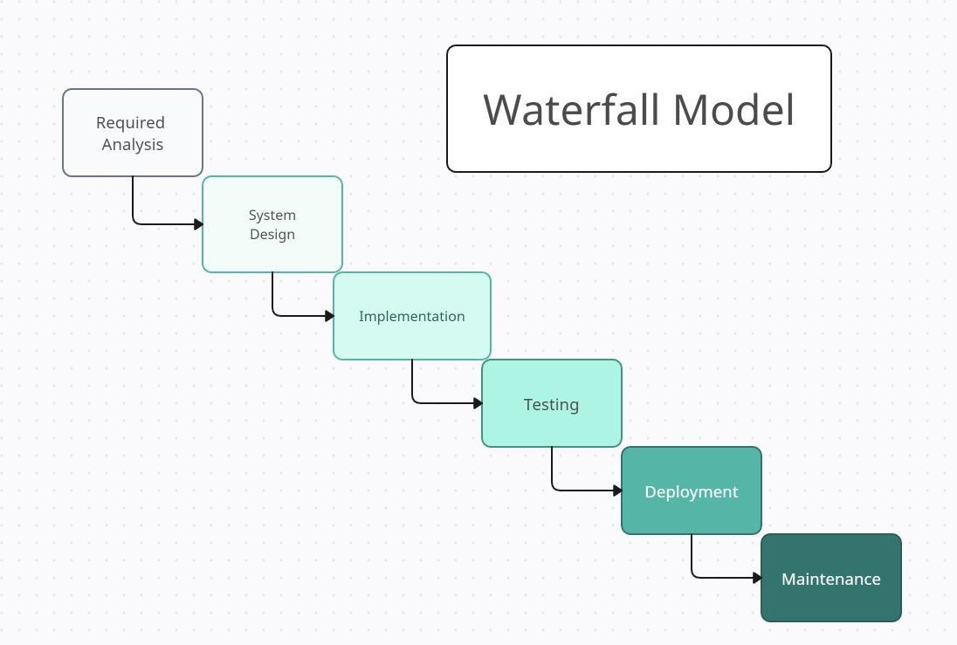

Figure 34 Waterfall Model

The Waterfall Model is a linear and sequential software development methodology where each phase is completed before moving to the next. It consists of Requirement Analysis, System Design, Implementation, Testing, Deployment, and Maintenance. This structured approach ensures clear documentation, controlled progress, and minimized errors, making it suitable for projects with well-defined requirements, such as an IT Gadget E- Commerce Website.

Figure 34 above shows the Waterfall Model, which follows a sequential development process for the IT Gadget E-Commerce Website. Each phase—Requirement Analysis, System Design, Implementation, Testing, Deployment, and Maintenance—is completed in order before moving to the next. This structured approach ensures clear documentation, minimizes errors, and allows for systematic project management.

### 3.2.1 Requirement Analysis

The first phase in the Waterfall Model is Requirement Analysis, where the needs and expectations of the e-commerce platform are gathered and documented. This includes identifying key functionalities such as user registration, product browsing, shopping cart, order processing, and payment gateway integration. Security aspects like SSL encryption, authentication mechanisms, and compliance with e-commerce regulations (such as GDPR) are also determined. Additionally, stakeholders define the target audience, set project goals, and establish business rules, ensuring a clear vision before proceeding to the next phase.

### 3.2.2 System Design

In the System Design phase, the technical structure and architecture of the e-commerce platform are planned. This involves selecting the technology stack, such as React.js or Vue.js for the frontend, Node.js or PHP for the backend, and MySQL or MongoDB for the database. The system's overall workflow, including how users interact with the website and how data flows between different components, is designed. UI/UX wireframes are created for a user-friendly shopping experience, while the admin dashboard layout is structured for easy product and order management. Additionally, the database schema is designed to efficiently store product details, user accounts, and order histories.

### 3.2.3 Implementation (Development)

During the Implementation Phase, the actual coding and development of the IT Gadget E-Commerce Website take place. Developers begin by setting up the backend, building API endpoints, and integrating the database. The frontend is then developed to allow users to browse products, search items, add products to their cart, and complete purchases. Essential e- commerce functionalities such as user authentication, order processing, and payment gateway integration (e.g., PayPal, Stripe, or local banking systems) are implemented. The admin panel is also developed to allow product management, order tracking, and customer support handling. This phase converts design blueprints into a functional website.

### 3.2.4 System Testing

After development, the website undergoes System Testing to ensure it functions correctly and meets performance, security, and usability standards. Unit testing is performed on individual features, while integration testing verifies that different system components work together seamlessly. Security testing is crucial to identify vulnerabilities such as SQL injection, cross-site scripting (XSS), and unauthorized access. Performance testing ensures the website can handle a high number of concurrent users and transactions without slowdowns. If any bugs or errors are found, developers work on fixing them before proceeding to deployment.

### 3.2.5 Deployment

Once the website passes testing, it moves to the Deployment Phase, where it is launched and made accessible to users. The e-commerce platform is hosted on Vercel (Vercel, 2025), a cloud platform optimized for front-end frameworks and static site deployment. A domain name is assigned, and secure SSL certificates are configured to encrypt transactions, ensuring customer data is protected. Final quality assurance checks are performed to confirm the website runs smoothly. After going live, real-time monitoring tools are set up to track user activity, transaction processing, and system performance.

### 3.2.6 Maintenance

The Maintenance Phase ensures that the e-commerce website remains functional and up to date. Regular updates are rolled out to improve features, fix security vulnerabilities, and optimize performance. New products, promotions, and discount codes are added based on customer demands. Bug fixes and improvements are made based on user feedback to enhance the shopping experience. As traffic grows, server scalability is implemented to accommodate higher volumes of users and transactions. Ongoing security patches and data backups are crucial to safeguard customer information and ensure business continuity.

## 3.3 Use Case Diagram

Figure 35 shows the Use Case Diagram for the IT Gadget E- Commerce Website, illustrating the interactions between different user roles— Customer, Admin/Staff, Super Admin, and Supplier—and the system functionalities. Each role has specific actions assigned, ensuring a structured and well-defined workflow. This diagram helps visualize how users interact with the platform, streamlining e-commerce operations efficiently.

Figure 35 Use Case Diagram

Customers interact with the IT Gadget E-Commerce Website primarily to explore and purchase products. They can browse through different product categories, add items to their shopping cart, proceed with checkout and payment, and track their order status. These actions ensure a seamless shopping experience, allowing customers to manage their purchases efficiently.

The Admin/Staff are responsible for handling operational tasks within the e-commerce platform. Their key functions include managing user accounts, updating and maintaining product listings, and processing customer orders. They ensure that the platform runs smoothly by overseeing inventory levels and addressing customer inquiries when needed.

The Super Admin has higher control over the e-commerce system compared to regular Admins. They are responsible for managing all user accounts, including Admins, and generating reports for business analysis. These reports provide insights into sales trends, customer behavior, and inventory performance, helping in strategic decision-making and overall business growth.

Suppliers play a crucial role in maintaining the product inventory. They are responsible for managing stock levels, restocking products when needed, and ensuring that the latest gadgets are available on the platform. By efficiently handling inventory, they help prevent stock shortages and keep the business running smoothly.

This structured role distribution ensures that the IT Gadget E-Commerce Website operates efficiently, providing a seamless experience for customers while maintaining proper business management.

## 3.4 Requirement Breakdown Structure

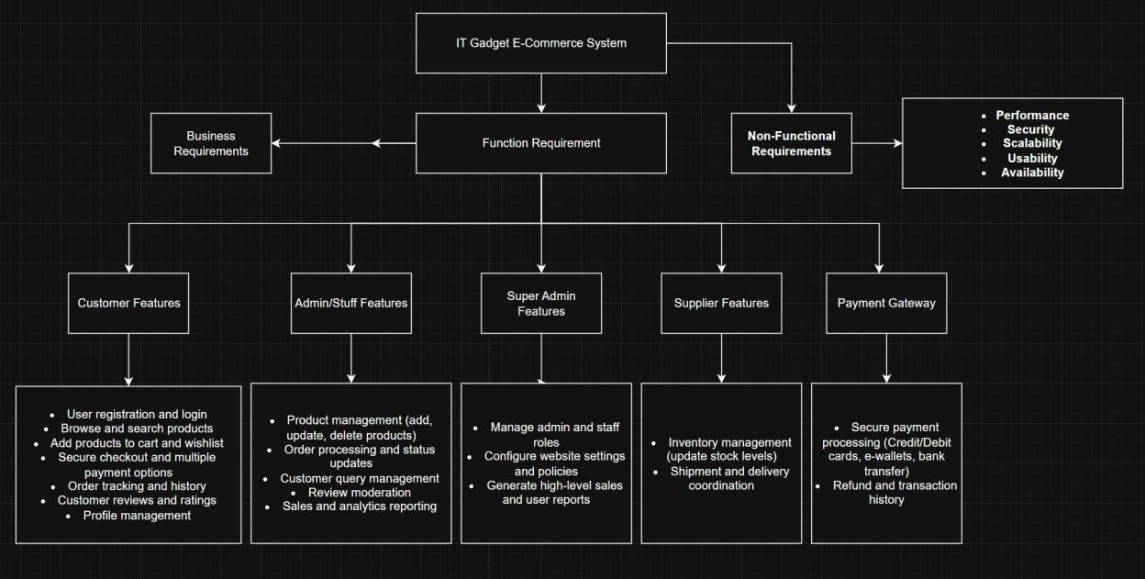

Figure 36 Requirement Breakdown Structure

The Requirement Breakdown Structure (RBS) for the IT Gadget E- Commerce Website categorizes the project requirements into three main levels: Business Requirements, Functional Requirements, and Non- Functional Requirements. This structured approach ensures clarity in project planning and development.

### 3.4.1 Business Requirements

Business requirements define the overall goals and objectives of the e- commerce website. The system should provide a user-friendly platform for customers to purchase gadgets efficiently, ensure secure transactions, and offer seamless order management. It should also allow administrators to manage products, orders, and users effectively.

### 3.4.2 Functional Requirements

Functional requirements describe the specific features and functionalities the system must include. These involve user authentication (secure login and registration), product management (adding, updating, and deleting products), shopping cart functionality, checkout and payment processing, order tracking, and an admin panel for managing users and sales data. These core functionalities ensure smooth operations for both customers and administrators.

### 3.4.3 Non-Functional Requirements

Non-functional requirements focus on system quality and performance aspects. The website must ensure security by encrypting user data and providing safe payment methods. It should have high performance, ensuring fast loading times and the ability to handle multiple users simultaneously. Usability is essential, ensuring a user-friendly interface that enhances customer experience. Lastly, availability guarantees system reliability with minimal downtime, ensuring continuous access to users.

3.5 Gantt Chart

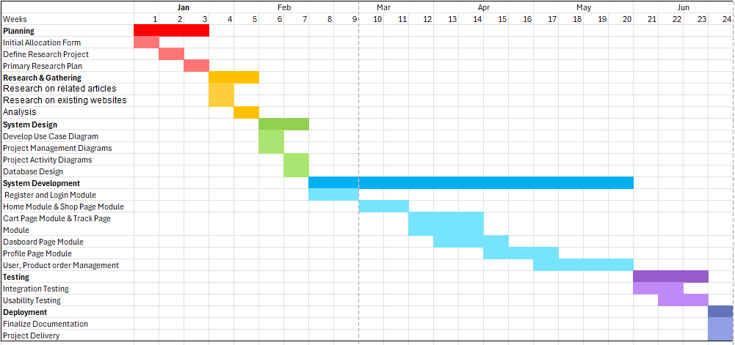

Figure 37 Gantt Chart

This Gantt chart provides a structured visual timeline of a project scheduled from January to June, with weekly intervals marking the progression of tasks. The chart is divided into distinct phases—Planning, Research & Gathering, System Design, System Development, Testing, and Deployment—each represented by different colored bars to enhance readability and indicate phase boundaries. The Planning phase, marked in red, kicks off in early January and includes foundational tasks such as completing the initial allocation form, defining the research project, and preparing the primary research plan. This is followed by the Research & Gathering phase (orange/yellow), which runs from late January to late February and focuses on reviewing related articles, studying existing websites, and conducting analysis.

The System Design phase, shown in green, spans late February through March and involves the creation of various diagrams and database structures. It transitions into the System Development phase (light blue), the most extensive part of the project, lasting from early March to late June. This phase covers multiple technical modules including user registration, page development, and management systems. In mid-June, the project enters the Testing phase (purple), where integration and usability are evaluated. Finally, the Deployment phase (dark purple/light brown) begins in late June, wrapping up with the finalization of documentation and the delivery of the completed project. The clear layout of tasks, durations, and dependencies makes this Gantt chart an effective tool for managing and monitoring project progress.

## 3.6 Entity Relationship Diagram (ERD)

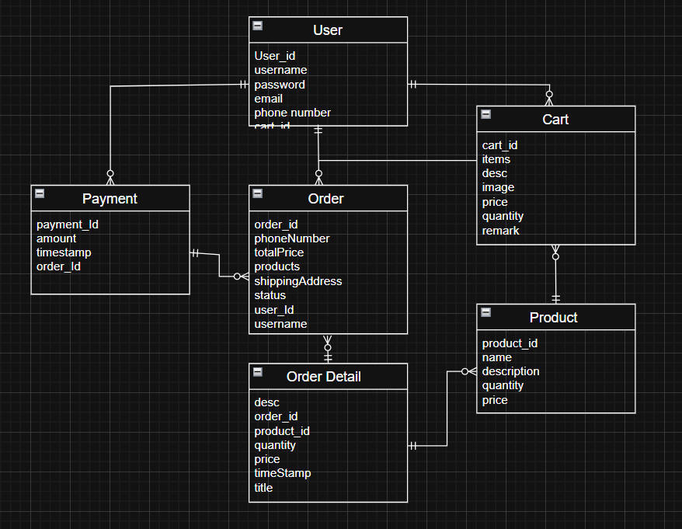

Figure 38 Entity Relationship Diagram (ERD)

Figure 38 showcases an Entity-Relationship (ER) diagram that models the database structure of an electronic gadget e-commerce platform. Using crow’s foot notation, the diagram effectively displays the entities, attributes, and relationships involved in managing users, products, shopping carts, orders, and payments. The visual organization helps clarify how data is stored, linked, and retrieved within the system.

The User entity contains essential user information such as user ID, username, password, email, and phone number. Each user can be associated with one or more Carts and can place multiple Orders. The Cart entity includes fields such as cart ID, item descriptions, images, prices, quantities, and remarks. Although a user typically maintains only one active cart, the diagram supports a one-to-many relationship, potentially for tracking historical cart data.

The Product entity holds details of the items sold on the platform, including product ID, name, description, quantity, and price. Products are linked to both the Cart and the Order Detail entities, representing the products a user adds to their cart and those purchased in an order, respectively.

Each Order is placed by a user and includes attributes such as order ID, user ID, phone number, shipping address, total price, and status. Orders are further broken down into Order Details, which store specific information about each product in the order, such as the product ID, quantity, individual price, timestamp, and title or description. This allows for granular tracking of items purchased per order.

Lastly, the Payment entity captures transaction data including payment ID, amount, timestamp, and the order it is associated with. The one-to-one relationship between an order and its payment ensures that each order has a corresponding payment record. Overall, the ER diagram provides a well-structured and scalable design that reflects the operations and data flow of a functional e-commerce system.

## 3.7 Software Development Tools

Table 4 Software Development & Design Tools

|  |  |
| --- | --- |
| Software Tool | **Purpose / Usage** |
| Microsoft Visual Studio | Develop the web application using system software |
| Draw.io | Create UML diagrams such as use case, activity, and ERD |
| Microsoft Excel | Create and manage the project Gantt Chart timeline |
| Microsoft Word | Document the project report and write-up |
| Google Drive | Handle version control and backup for the project report |
| Google Forms | Create and distribute questionnaire evaluation forms |
| Github | Manage source code version control and team collaboration |

The table 4 above lists and explains the software tools used during the development of the e-commerce web application project. Each tool served a specific purpose at different stages of the development lifecycle, from planning and design to implementation, testing, documentation, and deployment.

Microsoft Visual Studio was used as the main development environment for building the web application. It provided an integrated platform for writing, debugging, and testing the source code efficiently. For system and database design, Draw.io was utilized to create various UML diagrams, such as use case diagrams, activity diagrams, and Entity Relationship Diagrams (ERD), which helped visualize the system's structure and workflows.

Microsoft Excel played a crucial role in project management, specifically for creating and managing the Gantt Chart, which outlined the project timeline, phases, and task progress. Microsoft Word was used to document the project report, including planning, system design, implementation details, and testing outcomes.

To ensure safe and collaborative access to documentation, Google Drive was employed for version control and backups of the project report, allowing team members to access and update the files remotely. Google Forms was used to create and distribute questionnaire-based evaluation forms for gathering user feedback and conducting usability assessments.

Lastly, GitHub served as the version control system for managing source code, enabling the development team to track changes, collaborate in real-time, and maintain an organized codebase throughout the project. This set of tools collectively supported a structured and efficient workflow during the entire project development lifecycle.

# CHAPTER 4: PROJECT IMPLEMENTATION

## 4.1 Introduction

This chapter presents a comprehensive review of the project implementation phase of the Electronic E-commerce Website. Specifically, it outlines the development of key components such as the user interface, back-end functionality, and the flow of screens and modules throughout the system. Important features—including user registration, product browsing, cart management, order processing, and the admin dashboard—will be discussed in detail. Each feature will be supported with relevant code snippets, user interface screenshots, and technical explanations to demonstrate how the system meets the project’s objectives.

A significant component of the platform is the dashboard, which provides administrators with a centralized control panel to manage products, view user activity, track orders, and analyze sales data. This feature enhances the overall efficiency and oversight of the e-commerce operations.

The purpose of this chapter is to demonstrate how the web-based system was designed and implemented to streamline the online shopping experience for customers while providing robust administrative tools for back-end users. The implementation highlights include a responsive design, secure authentication, real-time database connectivity, and a clean, intuitive user interface—ensuring a seamless and effective digital commerce solution for the electronics and IT gadgets industry.

## 4.2 Firebase Firestore Design

### 4.2.1 Users Collection

Table 5 Users Collection with Datatypes

|  |  |
| --- | --- |
| Field name | Datatype |
| id | String |
| address | String |
| email | String |
| password | String |
| phoneNumber | String |
| role | String |
| timeStamp | timestamp |
| username | String |

The table 5 above shows the *Users collection* with the field names and data types. It is created when a user signs up for the first time. Below are the fields' descriptions:

* **id**: The unique identifier for the user (often a UUID or Firebase Auth UID).
* **address**: The physical address provided by the user.
* **email**: The email address used for login/authentication; it should be unique.
* **password**: The user's password, stored in a hashed format (use *bcrypt* or Firebase Auth).
* **phoneNumber**: The contact number associated with the user’s account.
* **role**: The user’s role in the system, such as admin, super-admin, user, etc.
* **timeStamp**: The time the user was created or registered in the system.
* **username**: The display name of the user, useful when email is not shown.

### 4.2.2 Products Collection

Table 6 Products Collection with Datatypes

|  |  |
| --- | --- |
| Field name | Datatype |
| id | String |
| desc | String |
| img | String |
| price | number |
| status | String |
| timeStamp | timestamp |
| title | String |
| wh1qty | number |

The table 6 above shows the *Products* collection’s field names and data types. It is created when an admin or seller adds a new product to the system. Below are the field’s descriptions:

* **id**: The unique identifier of the product.
* **desc**: The detailed description of the product.
* **img**: The URL or path to the product image.
* **price**: The price of the product.
* **status**: The availability status of the product (e.g. active, out of stock).
* **timeStamp**: The time the product record was created or last updated.
* **title**: The title of the product.
* **wh1qty**: The quantity of the product available.

### 4.2.3 Orders Collection

Table 7 Orders Collection with Datatypes

|  |  |
| --- | --- |
| Field name | Datatype |
| id | String |
| products | array |
| qty | number |
| shippingAddress | String |
| status | String |
| timeStamp | timestamp |
| totalPrice | number |
| userId | String |
| username | String |

**The table 7 above shows the O*rders* collection’s field names and data types. It is created when a user places a new order in the system. Below are the field’s descriptions:**

* **id**: The unique identifier of the order.
* **products**: The array containing all the products included in the order.
* **qty**: The number of products added in cart.
* **shippingAddress**: The delivery address where the order should be sent.
* **status**: The current status of the order (e.g. pending, shipped, delivered, cancelled).
* **timeStamp**: The time the order was placed or last updated.
* **totalPrice**: The total amount to be paid for the order.
* **userId**: The unique identifier of the user who placed the order.
* **username**: The display name of the user who placed the order.

### 4.2.4 Carts Collection

Table 8 Collection with Datatypes

|  |  |
| --- | --- |
| Field name | Datatype |
| id | String |
| items | array |
| remark | String |
| userId | String |

The table 8 above shows the *Carts* collection with the field names and data types. It is created when a user adds products to their shopping cart. Below are the field’s descriptions:

* **id**: The array containing unique identifiers related to the feedback or reported items (e.g. product IDs, order IDs, etc.).
* **items**: The array containing all the products added to the cart, typically including product ID, quantity, and other item details.
* **remark**: The written comment or note provided by the user.
* **userId**: The unique identifier of the user who submitted the remark.

## 4.3 Implementation of Client Application

The frontend implementation for the EtechHub Electronic Gadget E-commerce Website includes the following pages (also known as views or components):

* **Sign Up Page and Login Page**. This page allows users to register a new account or log in to access the website’s features, such as shopping, order tracking, and profile management.
* **Home Page**. The Home Page displays featured products, promotional banners, and category highlights. It serves as the main landing page for users to explore available gadgets and offers.
* **Product Listing Page**. This page shows a list of products filtered by category, brand, or search keywords. Users can view product thumbnails, brief descriptions, prices, and add items to the cart.
* **Product Detail Page**. The Product Detail Page provides detailed information about a selected gadget, including images, specifications, reviews, pricing, and availability. Users can add the product to their cart from this page.
* **Cart Page**. This page displays all the items that the user has added to their shopping cart. Users can adjust quantities, remove items, view total price, and proceed to checkout.
* **Order Page**. The Order Page allows users to enter shipping information, select payment methods, and place orders. After ordering, users can track the status of their purchases.
* **Profile Page**. The Profile Page allows users to view and edit their personal information, manage saved addresses, view order history, log out, or deactivate their account.

### 4.3.1 Sign Up page

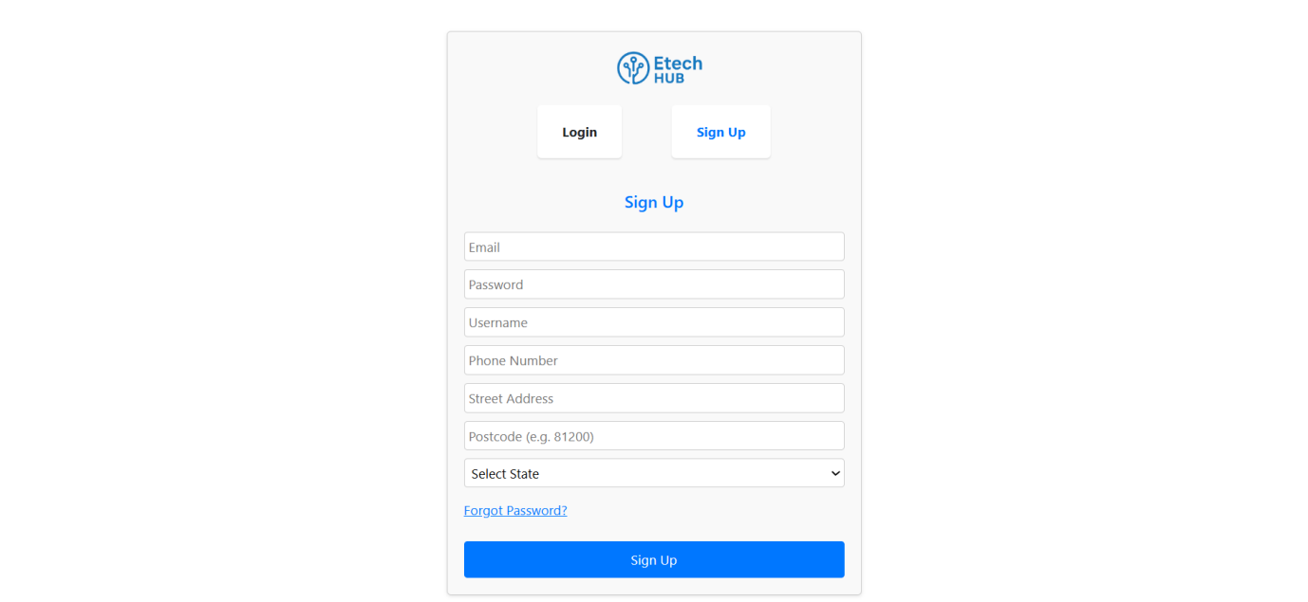

Figure 39 Sign Up

The Sign-Up interface of the E-tech Hub e-commerce platform was designed with user experience and clarity in mind. As shown in Figure 4.1, the screen presents a clean and centered registration form that allows new users to create an account by entering essential details such as email, password, username, phone number, street address, postcode, and state selection via a drop-down menu. The interface also includes navigation tabs that enable seamless switching between the login and sign-up views. A “Forgot Password?” link is provided for account recovery, enhancing usability and user support. The form submission is handled with validation and real-time feedback to ensure data accuracy and security. This screen plays a critical role in on-boarding new users into the platform, enabling access to personalized shopping, order tracking, and cart management features. The implementation was done using React.js for the front-end and is integrated with Firebase Authentication for secure and scalable user management.

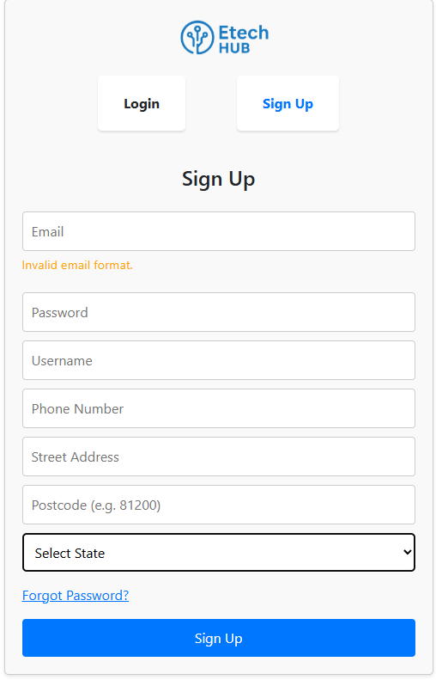

Figure 40 Sign Up page showing Invalid email format

An “Invalid email format” message appears below the email field, indicating that the email input does not meet the required format (e.g., missing @ or domain name). This demonstrates the real-time validation feature implemented on the sign-up form to enhance user experience and ensure proper data entry.

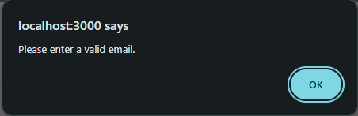

Figure 41 Please enter a valid email

The figure 41 shows a browser alert message from *localhost:3000* with the text 'Please enter a valid email.' This message appears when a user tries to submit the *signup* form without providing a properly formatted email address.

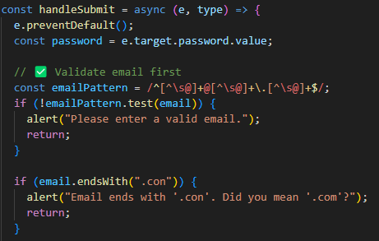

Figure 42 Code Sniped of handlesubmit of email

The code snippet shown in the figure 42 is part of the *handleSubmit* function in the *RegisterAndLogin* component. It demonstrates how email validation is performed before processing the registration or login request. When the form is submitted, the function first prevents the default form behavior using *e.preventDefault()*. It then extracts the password value and performs email validation using a regular expression *(emailPattern)*. This regex ensures the input matches a standard email format with valid characters, an '@' symbol, and a domain. If the entered email does not match the expected pattern, an alert is triggered with the message "Please enter a valid email.", and the function stops further execution using return. In addition, the code handles a common user typo where the email ends in ".con" instead of ".com". If this mistake is detected using *email.endsWith(".con")*, another alert is displayed: "Email ends with '.con'. Did you mean '.com'?", and form processing is again halted. This early validation step ensures that only properly formatted email addresses are accepted, helping prevent registration errors and improving data accuracy in the system.

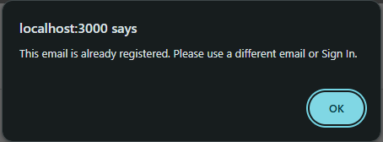

Figure 43 This email is already registered

The figure 43 shows a browser alert box from *localhost:3000* with the message: "This email is already registered. Please use a different email or Sign In." This alert appears when a user attempts to sign up with an email address that is already associated with an existing account. This directly corresponds to the else if *(error.code === "auth/email-already-in-use") { alert("This email is already registered. Please use a different email or Sign In."); }* block within the *handleSubmit* function in the provided *RegisterAndLogin.js* code, which handles Firebase authentication errors.  
  
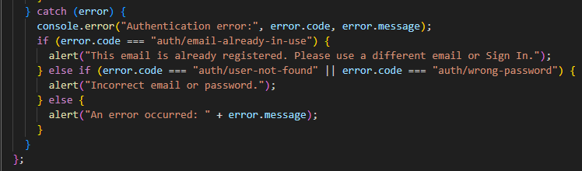

Figure 44 Code sniped Authentication error

On the other hand, the figure 44 above illustrates a catch block designed to handle any errors that occur during the authentication process, whether during user sign-up or login. When an error is encountered, the block first logs the error code and message to the browser console to aid debugging. It then evaluates the specific error code to provide meaningful feedback to the user. If the error code is "*auth/email-already-in-use*", this indicates that the email address entered is already associated with an existing account, and the user is prompted to either use a different email or sign in instead. If the error is "*auth/user-not-found*" or "*auth/wrong-password*", it suggests that the login credentials provided are incorrect, prompting an alert to inform the user. For any other unexpected issues, a general alert is shown that includes the error message returned by Firebase, ensuring users are made aware of the problem even if it falls outside common authentication errors.

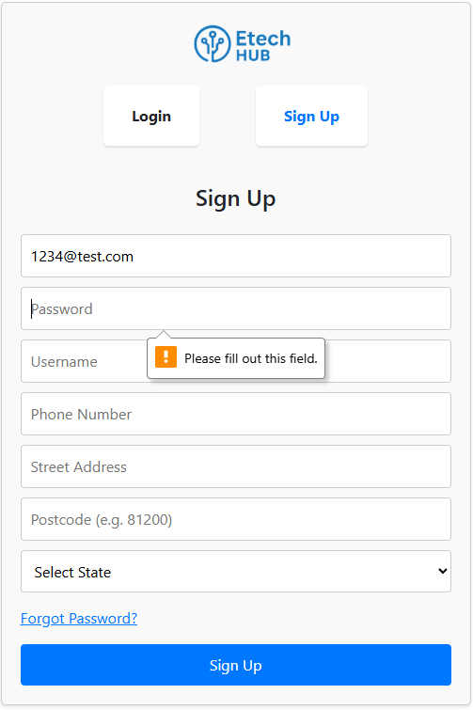

Figure 45 Sign Up page showing Please fill out this field

Figure 45 shows the Sign-Up Page Interface of the EtechHub Electronic Gadget E-commerce Website, demonstrating the browser’s built-in form validation. In this instance, the user has entered an email address (1234@test.com) but attempted to submit the form without filling in the Password field. As a result, a validation alert appears stating "Please fill out this field." This indicates that the password field is required and must be completed before the form can be submitted. Such real-time validation enhances the user experience by preventing incomplete form submissions and ensuring that all necessary information is provided.

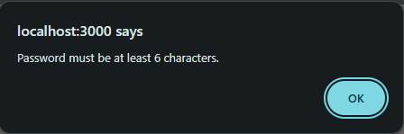

Figure 46 Password must be at least 6 characters

"The image displays a browser alert from *localhost:3000* stating 'Password must be at least 6 characters.' This message appears when a user attempts to sign up with a password that doesn't meet the minimum length requirement."

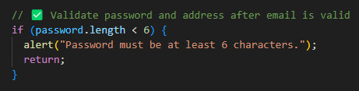

Figure 47 Code snippet password length

The code snippet checks whether the password entered by the user is at least 6 characters long. If the password is shorter than 6 characters, it triggers a browser alert with the message 'Password must be at least 6 characters.' and stops further execution by using return. This validation is performed after confirming that the email is valid, as noted in the comment.

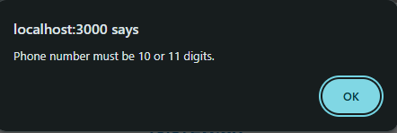

Figure 48 Phone number must be 10 or 11 digits

The figure 48 displays a browser alert from *localhost:3000* stating "Phone number must be 10 or 11 digits." This message appears when a user attempts to input a phone number that doesn't meet the specified length requirement.

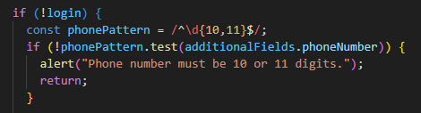

Figure 49 Code snippet phonePattern

The code snippet is responsible for validating phone number input. It's enclosed within an if (!login) block, indicating that this validation specifically applies when a user is not in a login context, such as during account registration or when updating profile information. The core of the validation lies in a regular expression, ^\d{10,11}$, which is defined as *phonePattern*. This pattern strictly checks that the input string starts (^) and ends ($) with only digits (\d), and that there are either 10 or 11 of them ({10,11}). If the *additionalFields.phoneNumber* value does not conform to this pattern, an alert box is triggered, displaying the message "Phone number must be 10 or 11 digits.", and the function execution is halted with a return statement. This ensures that the user is immediately notified of the incorrect phone number format and further processing is prevented until a valid input is provided.

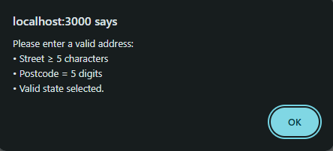

Figure 50 Please enter a valid address

The figure 50 shows a browser alert originating from *localhost:3000*, titled *"localhost:3000* says." The alert informs the user about the requirements for entering a valid address, specifying three distinct conditions: the "Street" field must contain at least 5 characters, the "Postcode" must be exactly 5 digits, and a "Valid state" must be selected. An "OK" button is provided for the user to dismiss this informative message.

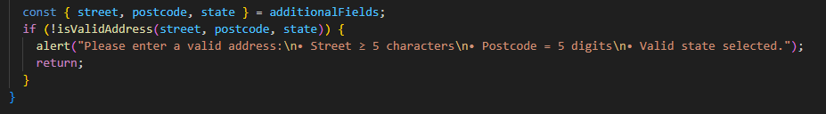

Figure 51 Code snippet additionalFields

This JavaScript code snippet handles the validation of address information provided by a user. It begins by destructing an *additionalFields* object to extract the street, postcode, and state values. These extracted values are then passed to an *isValidAddress* function. If this function returns false, indicating that the address is not valid, an alert box is triggered. This alert clearly informs the user with the message: "Please enter a valid address:\n• Street ≥ 5 characters\n• Postcode = 5 digits\n• Valid state selected." The newline characters (\n) and bullet points (•) ensure the validation rules are presented in a readable format within the alert. Following the display of the alert, a return statement immediately halts the execution of the current code block, preventing any invalid address data from being processed further.

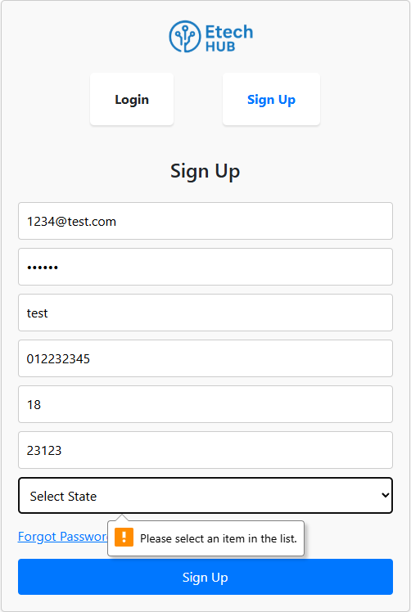

Figure 52 Sign Up Please select an item in the list

The figure 52 highlights a common form validation scenario focused on the "Select State" dropdown menu. The menu itself is labeled "Select State," prompting the user to make a choice. Critically, an orange exclamation mark icon is displayed next to it, accompanied by a tooltip that reads: "Please select an item in the list." This visual cue and message collectively indicate that the "State" field is a mandatory selection, and the user has not yet chosen a valid option from the dropdown list.

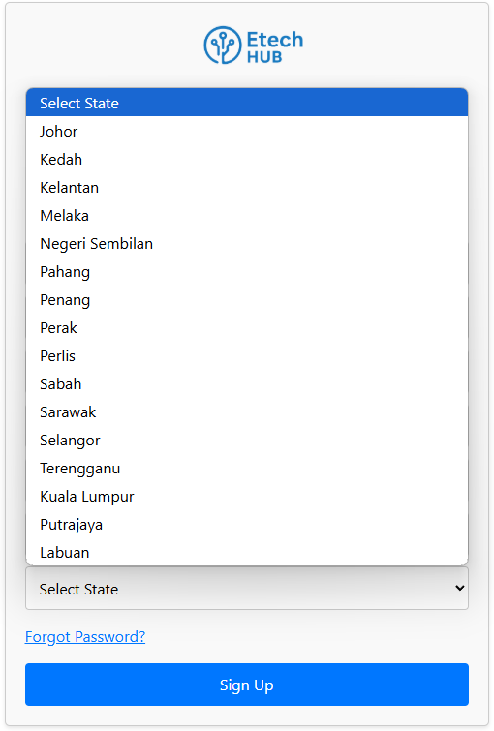

Figure 53 Sign Up Select State

The Figure 53 shows the "Etech HUB" sign-up form with the "Select State" dropdown expanded, displaying a list of Malaysian states and federal territories: Johor, Kedah, Kelantan, Melaka, Negeri Sembilan, Pahang, Penang, Perak, Perlis, Sabah, Sarawak, Selangor, Terengganu, Kuala Lumpur, Putrajaya, and Labuan. This visual directly correlates to the <select> element in the provided JavaScript code, specifically the <option> elements generated by mapping through the *validStates* array within the JSX.  
  
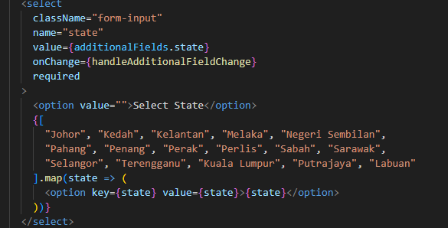

Figure 54 Sniped code Select State

The sniped code above displays a React JSX code snippet for a <*select*> dropdown element. This element is designed to allow a user to choose a "state." It includes a default "Select State" option with an empty value and then dynamically generates a list of Malaysian states and federal territories (Johor, Kedah, Kelantan, etc.) as individual <*option*> elements using a *.map()* function. The required attribute on the <*select*> tag ensures that the user must make a valid selection.  
  
  
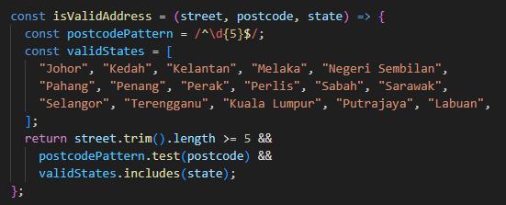

Figure 55 Sniped code isValidAddress

This JavaScript function, *isValidAddress*, is designed to validate the completeness and correct formatting of street, postcode, and state inputs for an address. It first establishes a *postcodePattern* using a regular expression, ^\d{5}$, ensuring that any entered postcode must consist of exactly five digits. Concurrently, it maintains a *validStates* array, which acts as a comprehensive whitelist of all legitimate Malaysian states and federal territories. The function then returns a boolean value, true only if all three validation checks pass: the street field, after trimming any *whitespace*, must be at least 5 characters long; the postcode must strictly adhere to the five-digit numerical pattern; and the state provided must be present within the predefined list of *validStates*. This collective validation ensures that an address is considered valid only when it satisfies all specified criteria.

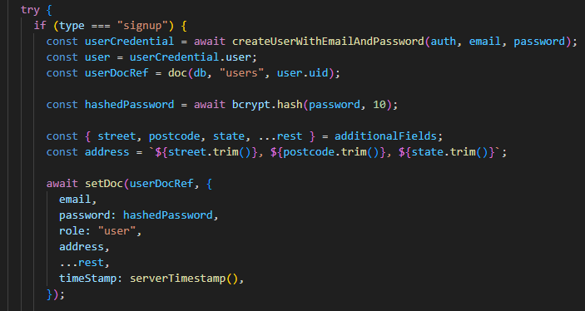

Figure 56 Sniped Code Signup

When a new user attempts to sign up, the code first checks whether the type is "*signup*". If true, it initiates the Firebase authentication process by calling *createUserWithEmailAndPassword*, passing in the provided email and password. Upon successful account creation, Firebase returns a *userCredential* object that includes the newly created user’s unique ID (UID). This UID is then used to create a reference to the user’s document in the Firestore database. Before saving the user’s data, the password is securely hashed using *bcrypt.hash* to ensure it is stored in an encrypted form rather than as plain text—enhancing security. The address input, composed of the street, postcode, and state fields, is combined into a single formatted string. Finally, the user’s information—including email, hashed password, user role ("user" by default), address, additional fields (like username and phone number), and a server-generated timestamp—is saved to *Firestore* using *setDoc*. This completes the registration process and securely stores the user’s data for future access and verification.

### **4**.3.2 Login page

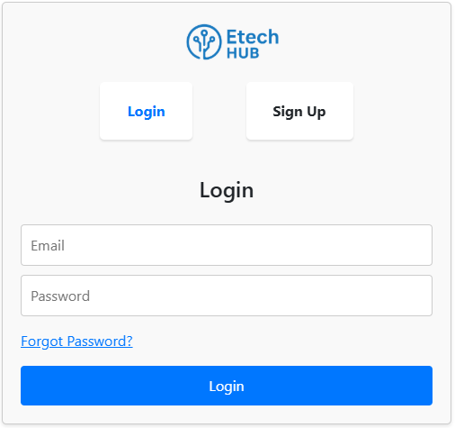

Figure 57 Login Page

The Login page presents a login interface for a platform named "Etech HUB," identifiable by its prominent logo at the top. The design features a clear navigation area with "Login" as the currently active tab and a "Sign Up" option for new users. The core of the page is dedicated to user authentication, providing two input fields for users to enter their "Email" and "Password." Additionally, a "Forgot Password?" link is available for account recovery, and a large, blue "Login" button serves as the primary action for users to proceed with logging into their accounts.

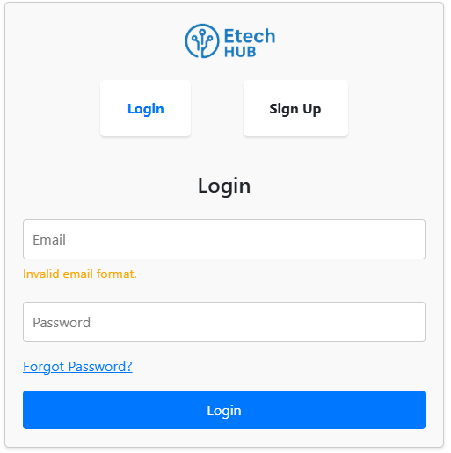

Figure 58 login page Invalid email format

If a user did not type any email into the "Email" field and then pressed the "Login" button, the webpage, as depicted in the image, would likely display an error message such as "Invalid email format." This message indicates that the system is performing client-side validation on the email input, ensuring that the field is not only populated but also contains a string that adheres to a typical email address structure (e.g., presence of "@" and a domain).

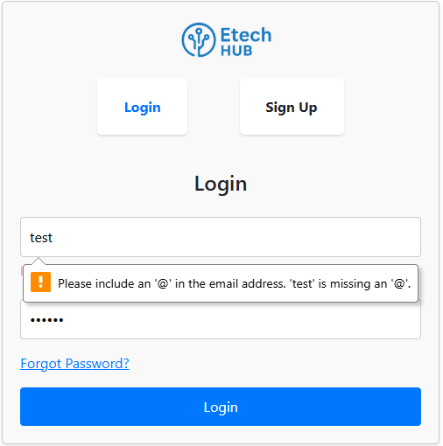

Figure 59 Please include an@ in the email address

The figure 59 displays the Etech HUB login page where a user has entered "test" into the email input field. This action has triggered an immediate client-side validation error, as indicated by the orange alert icon and the accompanying message: "Please include an '@' in the email address. 'test' is missing an '@'." This demonstrates the system's robust front-end validation, which aims to catch common input mistakes and ensure the provided email address conforms to a basic, valid format before attempting to process the login request. The password field is also shown with masked input, suggesting that some characters have been entered there, although this specific error pertains only to the email format.

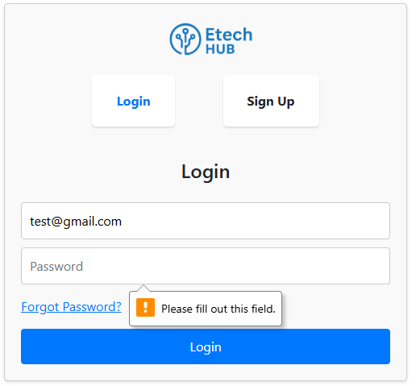

Figure 60 Please fill out this Field

The "Email" field has been populated with "*test@gmail.com*". However, the "Password" field is empty. When the user attempted to proceed (likely by clicking the "Login" button), the browser's built-in HTML5 form validation was triggered. An orange exclamation mark icon and a small pop-up bubble with the message "Please fill out this field." are displayed next to the empty "Password" input, indicating that this is a required field that must be filled before the form can be submitted.

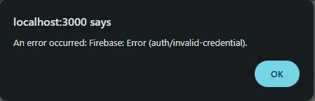

Figure 61 En error occurred: Firebase

The figure 61 displays a pop-up alert box from a web application. The title of the alert, "*localhost:3000* says", indicates that this message originates from a web application running on a local development server (port 3000). The main content of the alert is an error message: "An error occurred: Firebase: Error (auth/invalid-credential)." This specific message means that an attempt to authenticate (either log in or sign up) using Firebase failed because the credentials provided (likely the email and/or password) were not recognized as valid by the Firebase authentication service. Below the error message, there's a simple "OK" button to close the alert.  
”  
  
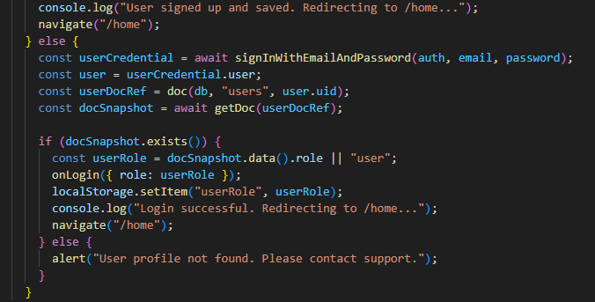

Figure 62 Code Snippet Login

This code snippet handles the login process for users of the Etech HUB platform. When a user submits the login form, Firebase's *signInWithEmailAndPassword* method is called using the email and password provided by the user. If the credentials are correct, Firebase returns a *userCredential* object containing the authenticated user's details. The code then uses the user's unique ID (UID) to locate their corresponding document in the Firestore database under the users collection. It attempts to retrieve this document using *getDoc*, which allows access to additional stored user information like their assigned role.

If the user’s document exists in the database, the role value is extracted—defaulting to "user" if no specific role is found—and passed to the *onLogin* callback function, which likely updates the application's user context or global state. The role is also stored in the browser's *localStorage* to maintain session data even after the page is refreshed. A message is then logged to the console confirming the successful login, and the user is redirected to the homepage (/home) using the navigate function from React Router.

However, if the *Firestore* document does not exist—meaning the user was authenticated but no associated profile was found—an alert is displayed informing the user that their profile is missing and they should contact support. This error handling ensures that only users with a properly stored and complete profile are allowed to proceed beyond the login screen, maintaining data integrity and a smooth user experience.  
  
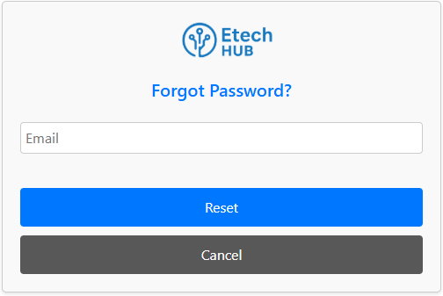

Figure 63 Forgot Password

The "Forgot Password?" page of the Etech HUB platform offers users a secure and convenient way to regain access to their accounts in the event they forget their login credentials. At the core of this feature is a functional email input field where users are prompted to enter the email address associated with their account. Upon submission, the system utilizes Firebase Authentication to initiate the password recovery process by sending an automated password reset email to the user. This email contains a secure link that allows the user to set a new password and restore access to their account. The feature is implemented to ensure account recovery is both user-friendly and secure, minimizing disruption while maintaining protection against unauthorized access. Additionally, users are given the flexibility to cancel the reset process and return to the login screen at any time.

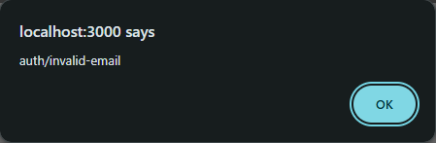

Figure 64 Auth/invalid-email

The message “*localhost:3000* says auth/invalid-email” appears when a user enters an improperly formatted or non-existent email address and attempts to reset their password. This error originates from Firebase Authentication, which validates the email input during the password reset process.

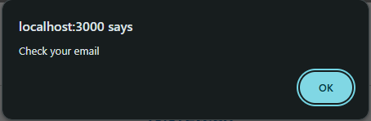

Figure 65 Check your email

The figure 65 displays a small pop-up alert box, typical of what a web browser might generate for JavaScript alert() calls. The title "*localhost:3000* says" indicates that the message is coming from a web application running on a local development server at port 3000. The message itself is simply "Check your email". This alert is a confirmation to the user that an email, likely a password reset email or a confirmation email, has been sent to their registered email address. This appears after a successful backend process (like a Firebase password reset request) has been initiated.

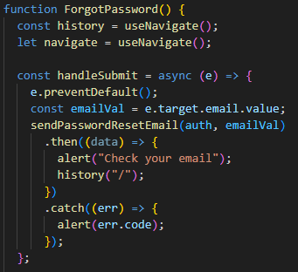

Figure 66 Code Snippet Forget Password

This code snippet implements the *ForgotPassword* function, which manages the password reset functionality in a React application using Firebase Authentication. It utilizes the *sendPasswordResetEmail* method from Firebase to send a reset link to the user’s provided email address. The *useNavigate* hook from *react-router-dom* is employed to redirect users upon a successful operation.

When the user submits the form, the *handleSubmit* function is invoked. This function first prevents the default form submission behavior using *e.preventDefault()*. It then retrieves the email input value via e.target.email.value and passes it to *sendPasswordResetEmail*. If the operation is successful, the user is notified through a browser alert stating "Check your email", and they are redirected to the homepage ("/"). In the case of an error—such as an invalid or unregistered email address—the error is caught, and an alert displays the relevant error code (e.g., "auth/invalid-email" or "auth/user-not-found"), providing clear feedback to the user.  
  
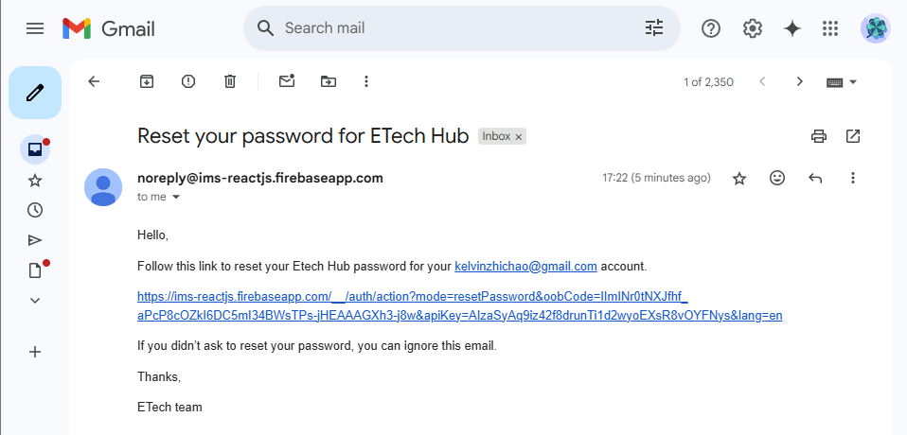

Figure 67 Reset password Gmail

The figure 67 shows a screenshot of a Gmail inbox featuring an opened email titled "Reset your password for ETech Hub", sent from noreply@ims-reactjs.firebaseapp.com. The email content informs the user that a password reset request was made for the account associated with kelvinzhichao@gmail.com. It provides a clearly visible blue hyperlink directing the user to a Firebase-hosted URL (ims-reactjs.firebaseapp.com) containing parameters such as *mode=resetPassword* and a secure *oobCode*, verifying it as a legitimate Firebase password reset link. Additionally, the message includes a standard disclaimer stating, “If you didn’t ask to reset your password, you can ignore this email.” This email confirms the proper operation of the password recovery process through Firebase, ensuring users can securely reset their credentials when necessary.

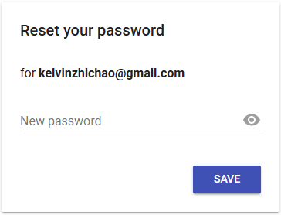

Figure 68 Reset your password

The figure 68 shows a "Reset your password" screen for the email address. There is a field labeled "New password" where you can enter your desired new password. To the right of this field, there's an eye icon, which typically allows you to toggle the visibility of the entered password. At the bottom right of the screen, there's a "SAVE" button, which you would click after entering your new password to confirm the change.

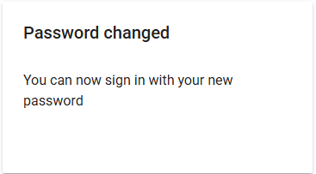

Figure 69 Password changed

The figure 69 displays a confirmation message indicating that a password has been successfully changed. This massage typically appears after a user has successfully completed a password reset or change process.

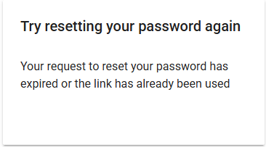

Figure 70 Try resetting your password again

The figure 70 shows an error message related to a password reset attempt. This means that the user tried to use a password reset link that is no longer valid, either because too much time has passed since it was generated, or because it was already clicked and used once before. The user will need to initiate the password reset process again to get a new, valid link.

### 4.3.3 Home page

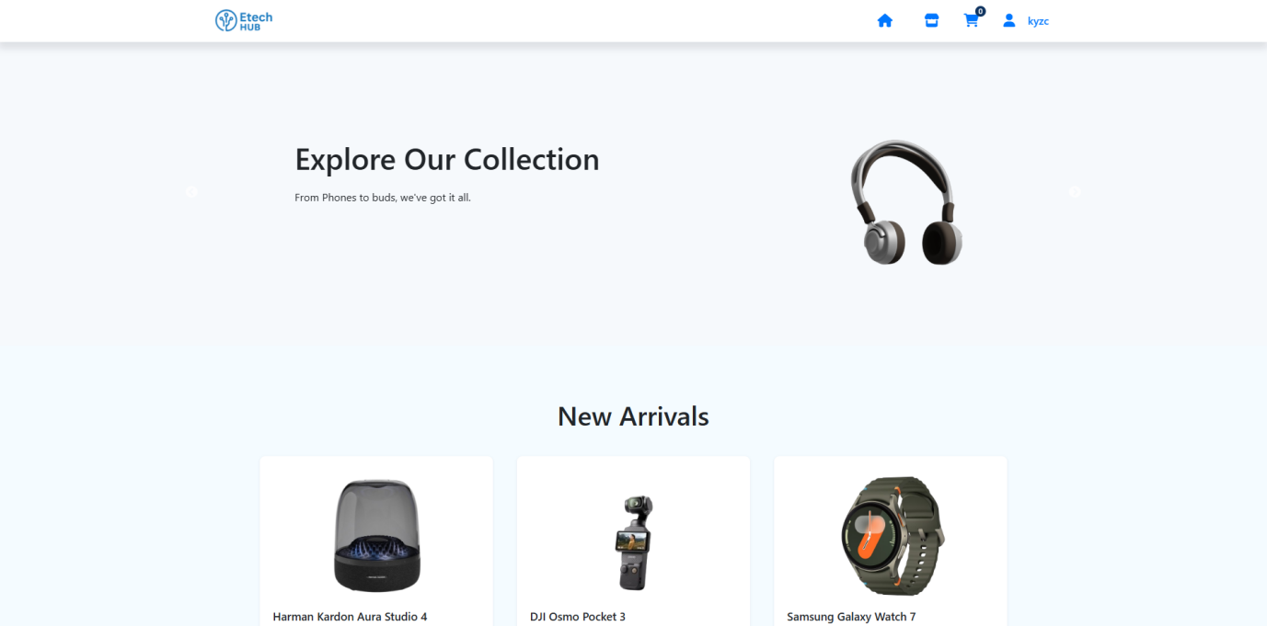

Figure 71 Home page

The Home Page of Etech HUB functions as the central hub of the platform, welcoming users immediately after they log in or register. The interface is designed to be visually engaging, intuitive, and personalized, catering to both casual shoppers and administrative users depending on their roles.

At the very top of the page, a fixed navigation bar features essential elements such as the Etech HUB logo, a home icon, a shopping cart icon (which shows as empty by default), and a user profile icon that includes the logged-in user’s name—for example, "kyzc". These icons provide quick access to the most frequently used sections, including product browsing, user profile management, and cart overview.

The main section of the page is dominated by a visually striking hero banner. This area greets users with a warm welcome message like “Discover a wide range of products” and often includes a high-quality promotional image—for instance, a Harman Kardon Aura Studio speaker. This banner area is designed to rotate automatically every few seconds, thanks to a sliding card component that cycles through featured products or promotional content. This dynamic visual experience draws attention to key items or deals and creates a modern shopping atmosphere.

Immediately beneath the hero section lies a "New Arrivals" segment, which introduces the latest additions to the store. This area typically showcases three recently added electronic gadgets, complete with thumbnail images, product names, and possibly pricing or quick action buttons like "View Details" or "Add to Cart". These items are laid out in a clean and responsive grid format to ensure accessibility across devices.

Depending on the user’s role:

* Regular users are shown a streamlined shopping interface focused on product discovery, with personalized recommendations and promotional highlights.
* Admin users may instead see shortcuts to administrative tools such as inventory management, order tracking, and user oversight panels, allowing for efficient backend control of the e-commerce system.

Overall, the Home Page of Etech HUB offers an engaging, user-focused starting point that blends visual appeal with seamless navigation. It serves not only as the platform’s welcome screen but also as a key access point for exploring products, managing accounts, or overseeing business operations.

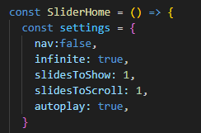

Figure 72 Slider Home

The settings object in the *SliderHome* component controls how the homepage slider works. It allows the slides to loop endlessly (infinite: true) and shows one slide at a time *(slidesToShow: 1)*. It also scrolls one slide at a time *(slidesToScroll: 1)* and automatically changes slides without user action *(autoplay: true*). The *nav:* false part is meant to hide navigation arrows, but the correct name might depend on the slider library being used. Overall, this setup creates a simple, auto-playing slider that cycles through content smoothly.

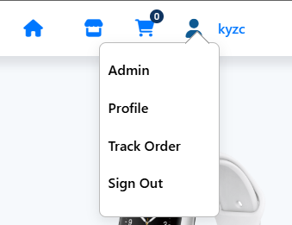

Figure 73 Dorp down menu

The figure 73 shows a dropdown menu that appears when a user clicks on the user icon or their username in the navigation bar of an E-commerce website. The dropdown menu contains the following options:

* Admin: This suggests that the logged-in user ("kyzc") has administrative privileges on the website, allowing them access to backend management features.
* Profile: This option would likely lead to a page where the user can view and edit their personal information, shipping addresses, etc.
* Track Order: This allows the user to check the status of their past or current orders.
* Sign Out: This option logs the user out of their account.

The presence of the "Admin" option is noteworthy, indicating that the user is not just a regular customer but also has a higher level of access to the E-Tech Hub Online Store system.

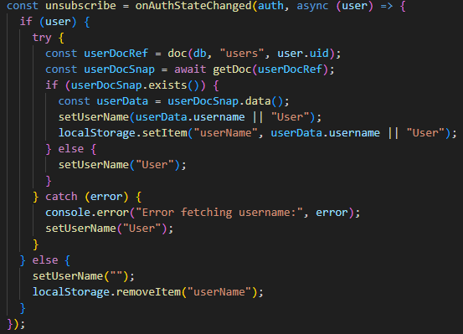

Figure 74 Code snipped that gets the username from Firebase

This section of the code uses Firebase's *onAuthStateChanged* method to monitor whether a user is currently logged in or has logged out. When a user is authenticated (logged in), it attempts to retrieve that user’s document from the Firestore database using the user's unique ID (user.uid). It does this by creating a document reference with doc(db, "users", user.uid) and then fetching the document snapshot with *getDoc(userDocRef)*.

If the document exists (meaning user data was successfully found), it extracts the username from the document using *userDocSnap.data()*, updates the *userName* state using *setUserName*, and also stores the username in the browser’s *localStorage* for persistence across sessions. If no document is found, it sets a default username of "User".

In case of any errors while fetching the document—such as network issues or permission errors—the code catches the exception, logs it to the console, and still defaults the displayed name to "User". If no user is logged in (i.e., the user object is null), it clears the *userName* state and removes the stored name from *localStorage*. This approach ensures the navigation bar always reflects the correct user's login state and name.

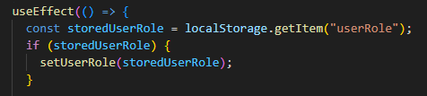

Figure 75 StoredUserRole

When the component first loads, this *useEffect* checks if a *userRole* value has been saved in the browser's *localStorage*. If such a value exists (for example, "admin" or "user"), it updates the component's *userRole* state by calling *setUserRole(storedUserRole)*. This allows the UI to immediately reflect the correct user permissions or interface (such as showing admin links), even before any real-time authentication checks occur. This behavior is useful for persisting user session data across page reloads without having to wait for Firebase to respond.

### 4.3.4 Products Listing Page

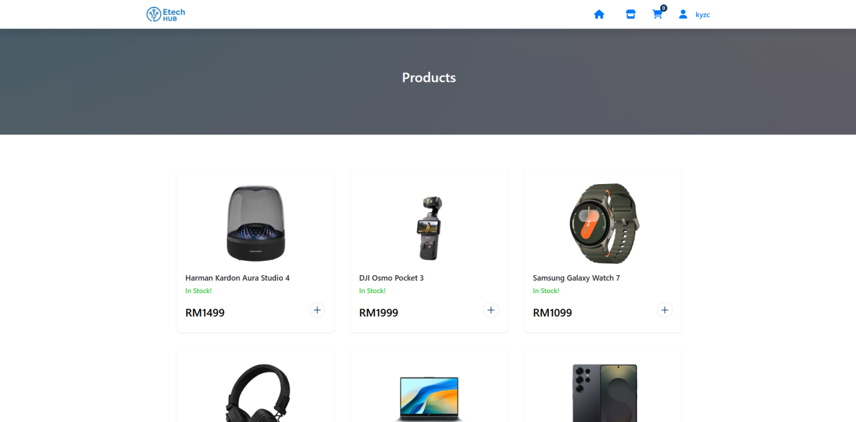

Figure 76 Products Listing Page

The Shop page of the E-Tech Hub online store offers a structured and visually clean layout for browsing available electronics. It retains a consistent header design that includes the E-Tech Hub logo and key navigation icons—such as links to the homepage, shopping cart, and the user profile, indicating the currently logged-in user. At the top of the page, a bold dark grey banner clearly labels the section as “Products,” helping users instantly recognize the purpose of the page.

Below the banner, the main content area is dedicated to displaying a grid of products in a neat, scrollable format. The layout emphasizes clarity and usability, allowing users to quickly scan through multiple items at once. Visual consistency across product tiles ensures a pleasant shopping experience, and the interface suggests support for interactive features like adding items to the cart. The bottom of the visible screen hints that more products are available, encouraging users to explore further by scrolling.

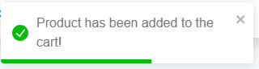

Figure 77 Product has been added to the cart!

Figure 77 above displays a toast message to notify the user that the product was successfully added to the cart. This provides both functionality and a positive user experience through real-time feedback.

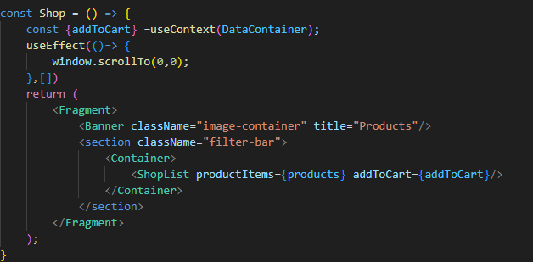

Figure 78 Code snipped addToCart

When the Shop component loads, it immediately scrolls the browser window to the top of the page using *window.scrollTo(0,0)*, ensuring a consistent user experience each time the page is accessed. The main structure of the component is wrapped inside a React Fragment, meaning it won’t render any extra HTML element in the DOM.

At the top of the page, a Banner component is displayed with the title "Products," likely serving as a header or visual introduction to the page. Below the banner, there's a section element with the class name "filter-bar" which holds the main product listing.

Inside this section, the ShopList component is rendered and receives two props: *productItems*, which represents the array of available products, and *addToCart*, a function that enables users to add items to their shopping cart. The layout is wrapped in a Container to keep the content properly aligned and styled.

This component is simple, clean, and responsible only for displaying the shop interface and passing product and cart functionality to child components.

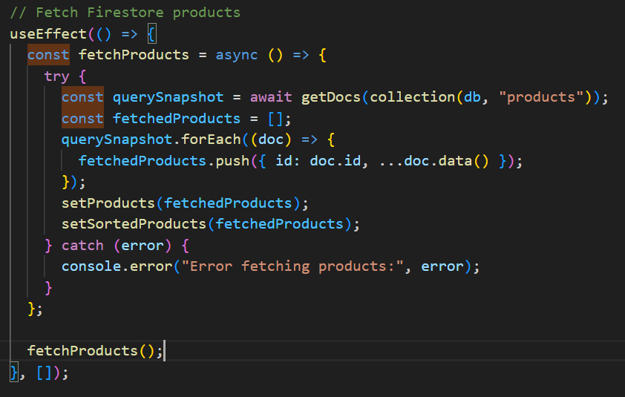

Figure 79 Code Snipped fetchProducts

This *useEffect* hook is used to fetch product data from a Firebase Firestore collection named "products" when the React component is first rendered (on mount). Inside the effect, an asynchronous function *fetchProducts* is defined and immediately invoked. It uses Firebase's *getDocs* method to retrieve all documents from the "products" collection. Each document is iterated using *forEach*, and its data is added to the *fetchedProducts* array along with the document ID. Once all products are fetched, the *setProducts* and *setSortedProducts* state setters are called to update the component's state with the retrieved product list. If any error occurs during this process (such as a network or permission issue), it is caught and logged to the console using console.error.

### 4.3.5 Products Detail Page

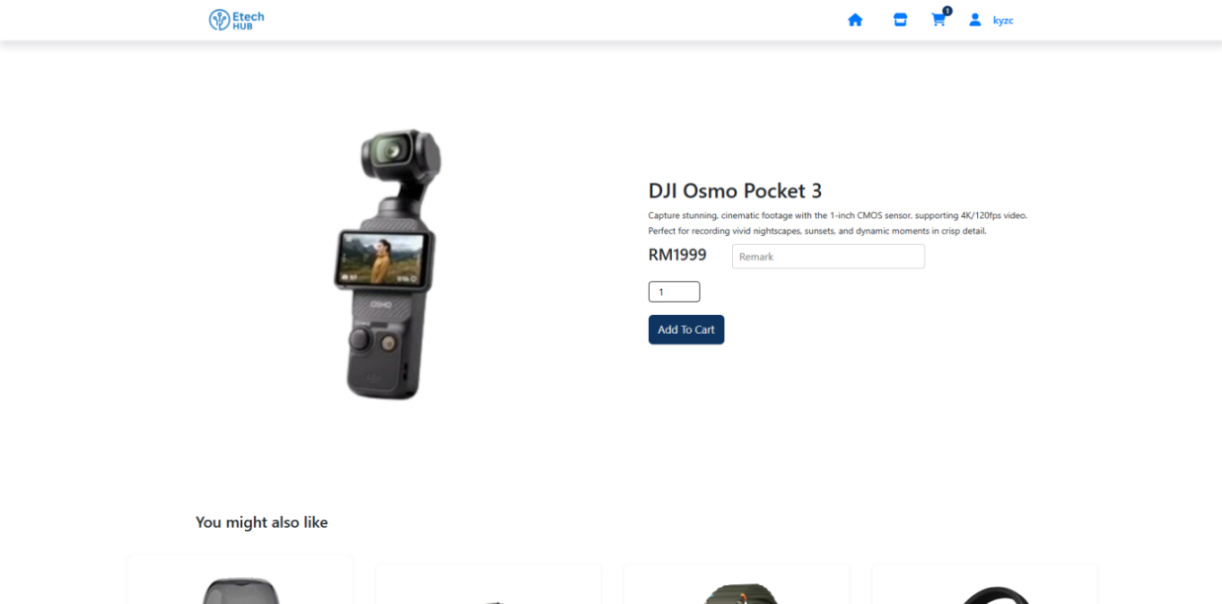

Figure 80 Product detail page

This figure 80 displays a product detail page from the "Etech Hub" online store. The page maintains the consistent header, featuring the "Etech Hub" logo on the left and navigation icons for home, shopping cart, and the logged-in user "kyzc" on the right. A prominent grey banner at the top of the content area presents the name of the item being viewed. Below this banner, the page is divided into two main sections.

On the left side, a large, clear image of the item is displayed, allowing the user to get a good visual representation of the product.

On the right side, the product's detailed information is presented. This includes a concise description highlighting its key features and capabilities, such as its image capture quality and video recording specifications. Below the description, the price of the item is clearly shown in Malaysian Ringgit (RM). There is also a text field labeled "Remark," likely for users to add specific notes about their purchase. Following this, a quantity input field is present, defaulting to "1," allowing users to specify how many units they wish to purchase. Finally, a prominent "Add To Cart" button is available for adding the item to the shopping cart. The overall design is clean and focuses on providing essential product information for the user to make a purchasing decision.  
  
 Below this main product display, there's a dedicated section titled "You might also like." This section is designed to suggest related or complementary items to the user, typically displaying images of other products that they might be interested in, thereby encouraging further Browse and potential additional purchases. While the suggested items themselves are not fully visible in this cropped view, their presence indicates a common e-commerce feature aimed at enhancing the shopping experience.

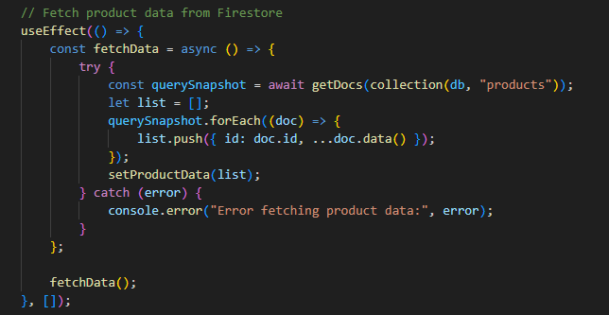

Figure 81 fetchData

This *useEffect* hook is designed to run once when the *ProductDetails* component mounts. Its primary function is to retrieve all product data stored in the Firestore database under the "products" collection. Inside the hook, an asynchronous function named *fetchData* is defined and immediately called. This function uses *getDocs* to query all documents in the products collection. For each document retrieved, it constructs a JavaScript object containing the document’s ID and data, and appends it to a local array called list. Once all documents are processed, the complete list of product data is stored in the *productData* state using *setProductData*. If any error occurs during this process, it is caught and logged to the console, ensuring the application doesn't crash unexpectedly. This setup ensures that the page always displays the most current product data from the Firestore database.

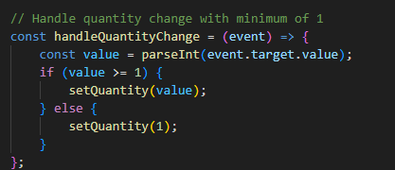

Figure 82 handleQuantityChange

The *handleQuantityChange* function is responsible for managing and validating the quantity input entered by the user when they are about to add a product to the cart. It ensures that the quantity is always a valid positive integer, with a minimum value of 1. When the user types a value into the quantity field, the function parses the input and checks whether it is greater than or equal to 1. If the input is valid, it updates the quantity state with the new value. However, if the user enters a number less than 1 or an invalid input, the function automatically resets the quantity to 1. This validation is crucial for maintaining data integrity in the shopping cart and avoiding unexpected behavior, such as attempting to add zero or negative quantities to an order.

### 4.3.6 Cart Page

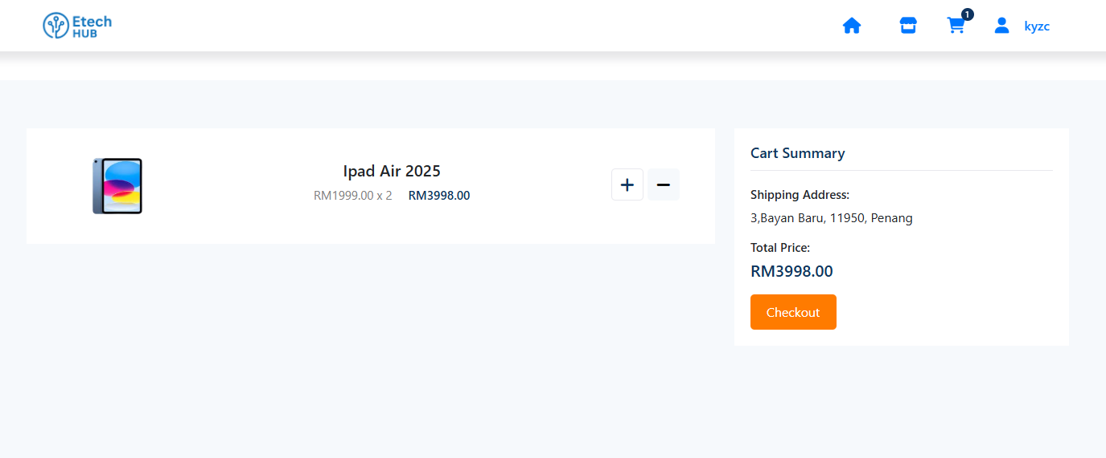

Figure 83 Cart Page

The figure 83 shows the shopping cart page of the "Etech Hub" online store, offering a clean and user-friendly layout. At the top, a familiar header includes the Etech Hub logo and key navigation icons for Home, Cart, and User Profile—indicating that the user is currently logged in. Notably, the shopping cart icon in the navigation bar dynamically updates its number to reflect the current quantity of items in the cart, providing real-time visual feedback as products are added or removed.

The main content area features a vertical list of items added to the cart, with each product displayed in a dedicated row. Users can easily manage quantities using the plus and minus buttons next to each item.

On the right side of the page, a "Cart Summary" section consolidates key order details. It displays the saved shipping address and the total price for all items in the cart. A prominent orange "Checkout" button is placed at the bottom of this section, encouraging the user to proceed with finalizing the order. The layout emphasizes clarity and ease of interaction, helping users efficiently review and update their cart before checkout.

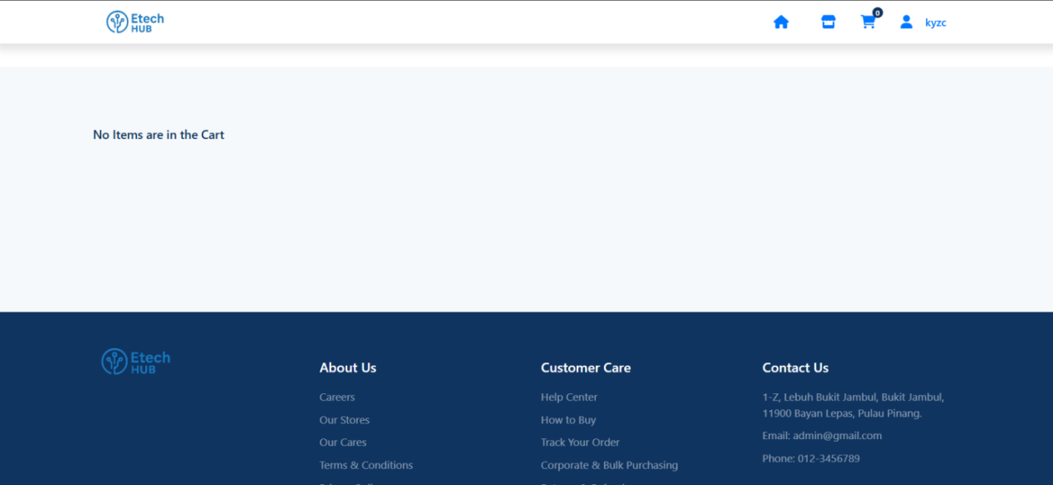

Figure 84 No items are in the Cart

When there are no items in the cart, the web page clearly displays a message stating "No Items are in the Cart" in the main content area. This message is prominently positioned on the left side of the page, making it immediately noticeable to the user. Its placement aligns with where the list of cart items would typically appear, reinforcing the idea that the cart is currently empty. The background around the message is a light blue or gray color, contributing to a clean and minimal look that emphasizes the empty state of the shopping cart. This serves as a visual indicator to inform users that they have not added any products to their cart yet.

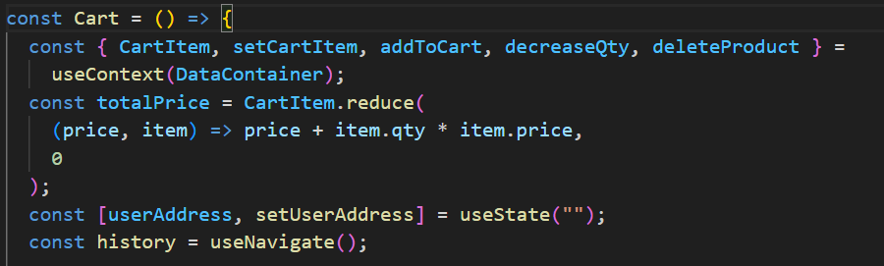

Figure 85 Code snipped Cart

Based on the code snipped above, in this Cart component, several shopping cart functionalities are managed using React and the *useContext* hook. The component accesses cart-related data and functions—such as *CartItem*, *setCartItem*, *addToCart*, *decreaseQty*, and *deleteProduct*—from a shared context called *DataContainer*, which likely manages global application state. It then calculates the total price of all items in the cart by using the reduce method: it iterates over each cart item and sums up the product of each item's quantity (qty) and price. Additionally, the component uses a local state variable *userAddress* to store the user's shipping address input. The *useNavigate* hook from React Router is also used, stored in a variable called history, allowing the component to navigate programmatically to another route when needed—such as during the checkout process. Overall, this setup provides a functional shopping cart view and allows user interaction with cart contents.

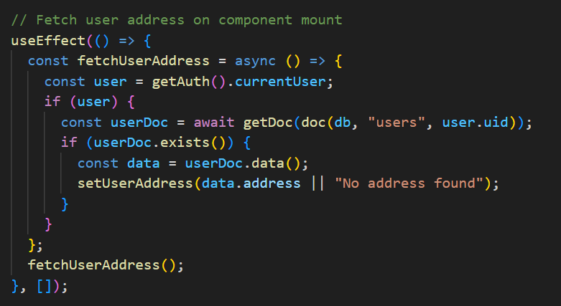

Figure 86 fetchUserAddress

This *useEffect* hook is designed to automatically fetch the logged-in user's address from Firestore when the component is first mounted. Inside the hook, an asynchronous function *fetchUserAddress* is defined and immediately called. It begins by retrieving the currently authenticated user using *getAuth().currentUser*. If a user is logged in, it then attempts to access that user's document from the "users" collection in Firestore, using their unique user *ID* (uid). If the document exists, it extracts the address data and updates the component state using *setUserAddress*. If no address is found, it sets a default message: "No address found". This ensures the component always displays the most up-to-date user address when rendered.

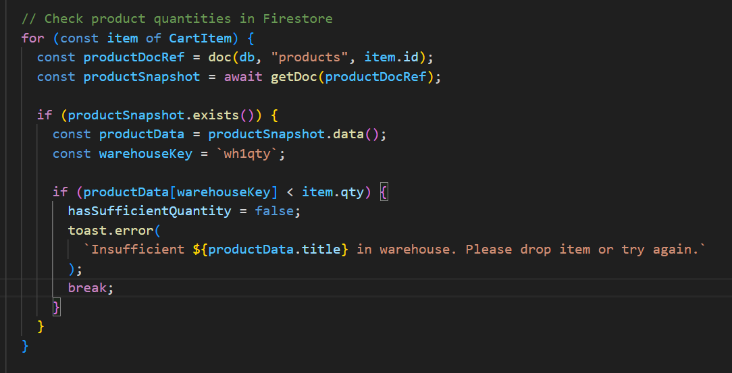

Figure 87 Code Snippet check product quantities

This code snippet checks whether there is enough stock available in the Firestore database for each item in the shopping cart before proceeding with actions like checkout or order submission. It loops through each item in the *CartItem* array and retrieves the corresponding product document from the "products" collection in Firestore using the product's id.

For each product, it checks the quantity stored under the key wh1qty (likely representing the stock in Warehouse 1). If the available stock is less than the quantity requested in the cart *(item.qty)*, it sets a flag *hasSufficientQuantity* to *false*, shows an error message using toast.error, and breaks out of the loop to prevent further processing. This ensures that customers are notified immediately if any item in their cart exceeds the available stock, maintaining accurate inventory control and improving the user experience by preventing failed or partial orders.

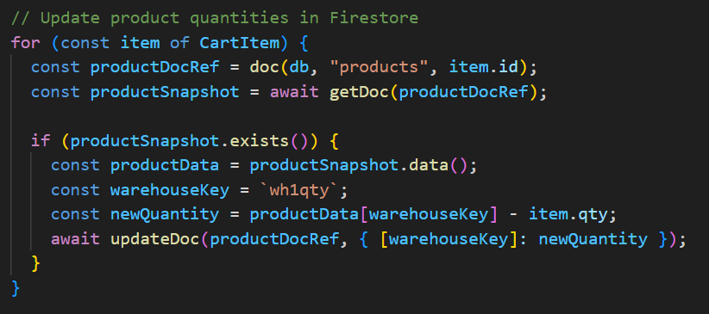

Figure 88 Code snippet Update product quantities

This code is responsible for updating the product quantities in Firestore after a user completes a purchase. It iterates through each item in the shopping cart (*CartItem*) and fetches the corresponding product document from the "products" collection using the product's ID. For each product, it checks if the document exists and retrieves its current stock quantity from the wh1qty field, which likely represents the quantity available in Warehouse 1. The code then calculates the new stock by subtracting the quantity purchased (item.qty) from the existing stock. It updates the product document in Firestore with the new quantity using *updateDoc*. This process ensures that the inventory in Firestore stays up to date with customer purchases and reflects the correct stock levels in the database.

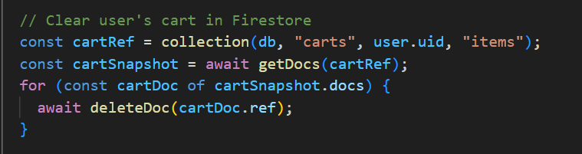

Figure 89 Clear user cart

This code handles the clearing of the shopping cart after a successful order has been placed. It begins by calling *setCartItem*([]), which resets the cart state in the app to an empty array, effectively removing all items from the UI. Then, it removes the stored cart data from the browser’s *localStorage* by calling *localStorage*.*removeItem*("*cartItem*"), ensuring the cart is cleared even after a page refresh. Next, it redirects the user to the homepage using history("/home"), providing a smooth transition after checkout. Finally, it displays a success message using toast.success("Order successfully created!") to give real-time feedback and confirmation that the order process was completed.

### 4.3.7 Track Order Page

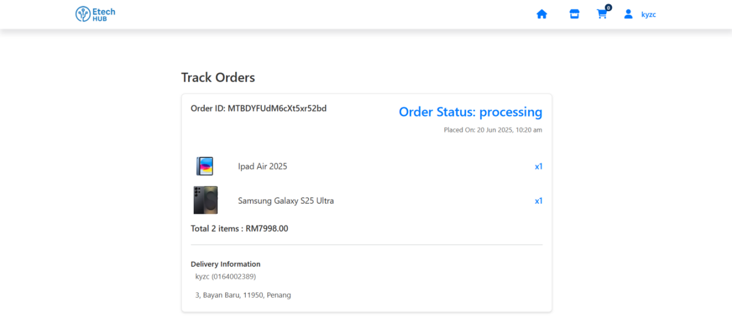

Figure 90 Track Order Page

The page serves as a dedicated *Order Details* view, clearly identifiable by a unique order number displayed at the top. Next to it, the current order status is prominently shown in blue as "Processing," ensuring the user is immediately informed about the progress of their order. Just below this section, the exact timestamp of when the order was placed is presented for added transparency.

The main content dynamically displays a detailed breakdown of the ordered products, including each item's name, quantity, and relevant pricing, all retrieved in real time from the *Firestore* database. Additionally, the page summarizes the total number of items ordered and the grand total amount in a clear and organized manner.

Toward the bottom, the delivery address is thoughtfully laid out, including the recipient's username and contact number, offering users a complete overview of their order in one clean, user-friendly interface.  
  
 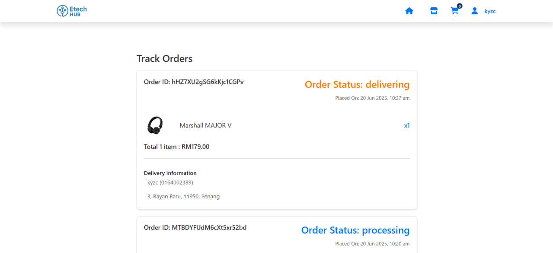

Figure 91 Order status delivering

After a user places an order, the admin initiates the delivery process, triggering an update to the order status, which changes from "Processing" to "Delivering." Along with this status change, the visual indicator also updates—the status label changes to an orange color, making it visually distinct and easily recognizable for both the user and the admin. This dynamic status update not only reflects the real-time progress of the order but also enhances the overall user experience by keeping customers informed at every stage of the delivery process.  
  
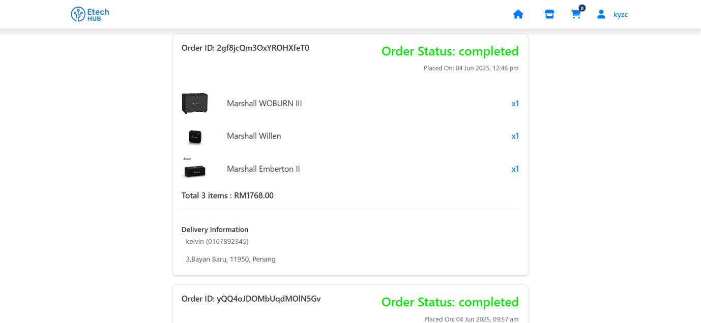

Figure 92 Order status completed

After the delivery is successfully completed, the order status automatically updates to "Completed", and the status label changes to green. This transition from "Delivering" to "Completed" provides a clear and reassuring indication to the user that their order has arrived. The use of color-coded statuses ensures easy tracking and enhances the overall user experience by keeping them informed throughout the entire order life-cycle.  
  
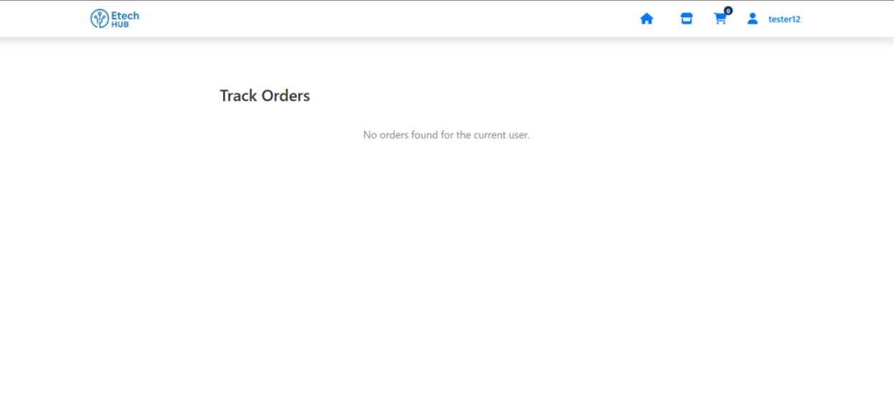

Figure 93 No orders found for the current user

If the user is new or has not placed any orders yet, the page will display a message saying "No orders found for the current user." This message appears centrally in the middle of the page, making it clearly visible and easy to understand. The centered placement ensures that users immediately recognize that there are no past orders associated with their account, providing a clean and straightforward user experience without confusion or clutter.

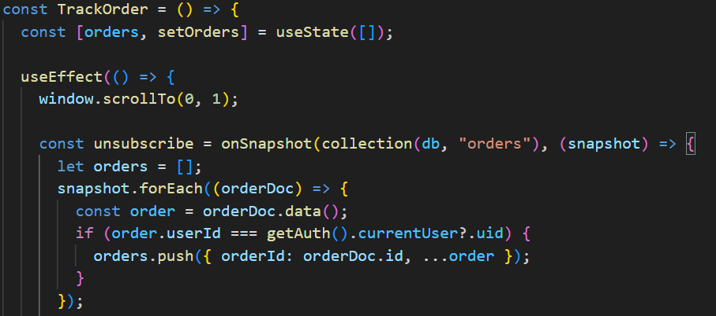

Figure 94 TrackOrder

This *TrackOrder* component is responsible for displaying the current user's order history in real time using *Firestore*. It uses a state variable orders to store the list of orders and initializes it as an empty array with *useState*([]).

Inside the *useEffect*, it first calls window.*scrollTo*(0, 1) to ensure the page is properly positioned at the top on load. Then, it sets up a real-time *Firestore* listener using *onSnapshot* on the "orders" collection. This listener retrieves all orders from the database, and for each order document, it checks if the *userId* field matches the currently logged-in user's UID (*getAuth*().*currentUser*?.uid). If it does, the order is added to a temporary array orders.

The order data is then stored in the component state by calling *setOrders*(...) (which is likely just below the cutoff in your snippet). This allows the component to dynamically display the user's orders, updating in real time if there are any changes in *Firestore*.  
  
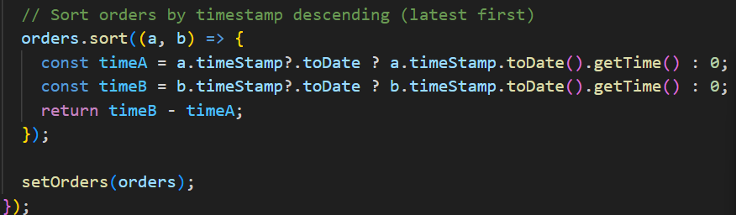

Figure 95 Sort orders

This part of the *TrackOrder* component handles the sorting of user orders by their timestamp in descending order, so the most recent orders appear first. After retrieving and filtering the user's orders, it uses the sort method to compare the *timeStamp* of each order.

For each order, it checks if *timeStamp* exists and can be converted to a JavaScript Date object using *Firestore's* .*toDate*() method. It then compares the timestamps by their milliseconds using *getTime*(). Orders with newer timestamps are placed before older ones by subtracting *timeA* from *timeB*. Once the sorting is complete, the *setOrders* function is called to update the component's state with the sorted list, ensuring the most recent orders appear at the top of the order tracking view.

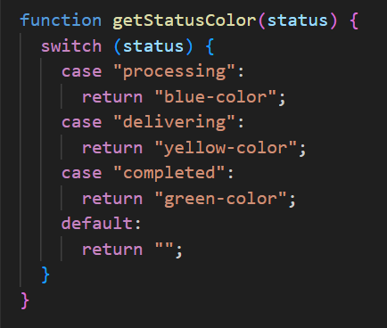

Figure 96 getStatusColor

The *getStatusColor* function is used to determine the CSS class (or color code) associated with a given order status, allowing for dynamic styling based on the order’s current state. It uses a switch statement to return different class names:

* If the status is "processing", it returns "blue-color", likely applying a blue text or background style.
* If the status is "delivering", it returns "yellow-color", which might appear as orange or yellow to indicate the order is in transit.
* If the status is "completed", it returns "green-color" to visually indicate that the order has been successfully delivered.
* If the status doesn't match any of the defined cases, it returns an empty string, applying no specific styling.

This function is typically used in JSX to conditionally style the status label, helping users quickly identify the stage of their order through color.

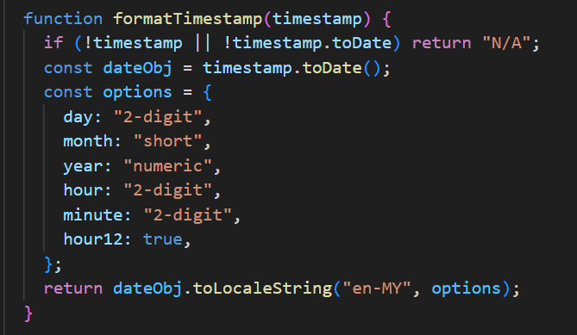

Figure 97 formatTimestamp

The *formatTimestamp* function converts a *Firestore* timestamp into a readable date and time string using JavaScript's *toLocaleString* method with specific formatting options to enhance clarity and user-friendliness. These options include:

* day: "2-digit" – displays the day as two digits (e.g., "05").
* month: "short" – uses a short form of the month (e.g., "Jun").
* year: "numeric" – includes the full year (e.g., "2025").
* hour: "2-digit" and minute: "2-digit" – show the time with leading zeros for both hour and minute (e.g., "03:45").
* hour12: true – formats the time in 12-hour format with an AM/PM indicator.

These settings ensure that the date and time are both precise and easy to understand, tailored to the "en-MY" locale (English, Malaysia).

### 4.3.8 User Profile Page

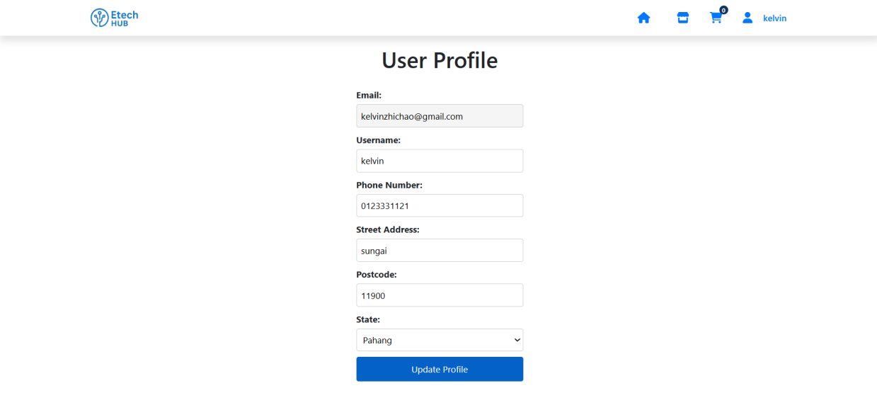

Figure 98 User Profile

The user profile page is structured into several categories, allowing users to view and update their personal and contact information. These categories include Email, Username, Phone Number, Street Address, Postcode, and State. All fields are presented in editable input boxes, except for the Email, which is displayed in a read-only field and cannot be changed by the user. The State field is presented as a dropdown menu to ensure standardized input. At the bottom of the form, there is a prominent "Update Profile" button that allows users to save any changes made to their editable information.  
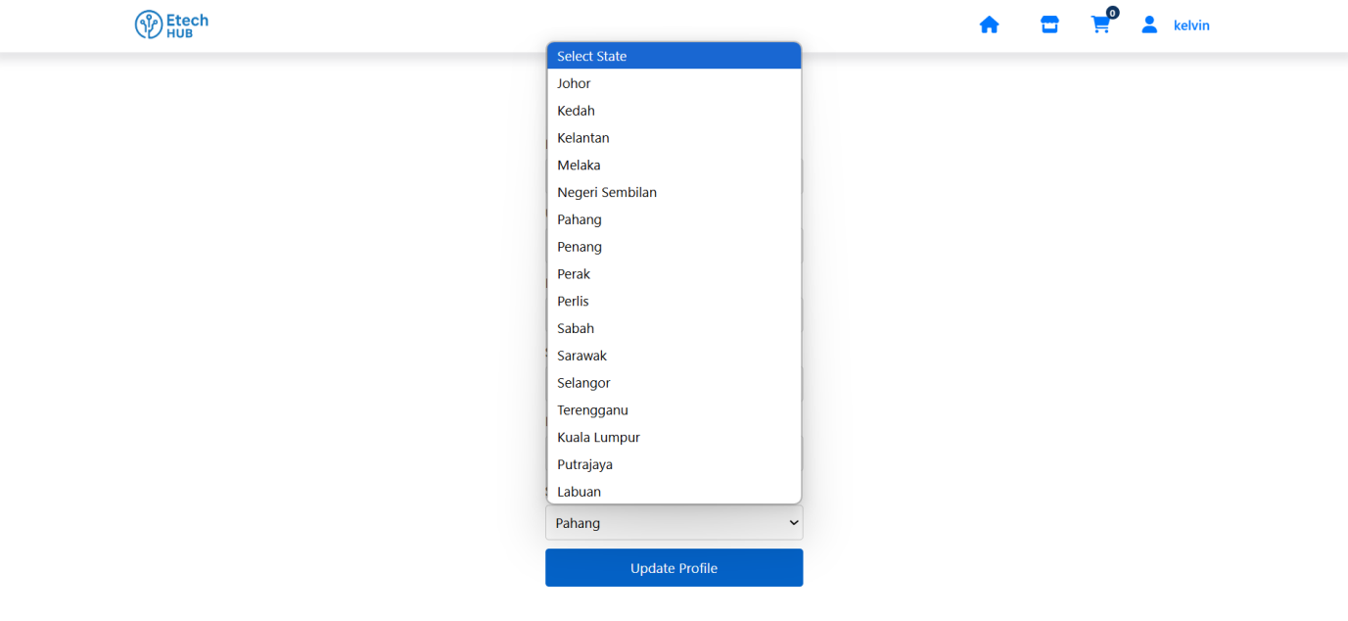

Figure 99 Dowpdown menu of states

The figure 99 displays a user profile page for "Etech HUB", with a dropdown menu for "State" being actively opened. The opened dropdown lists various states and federal territories in Malaysia, from which the user can select their current state.

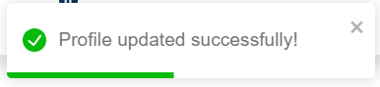

Figure 100 Profile updated successfully

The figure 100 above displays a toast message to notify the user that their profile was successfully updated, showing the message “Profile updated successfully”. This provides both functionality and a positive user experience through real-time feedback, reassuring the user that their changes have been saved.  
  
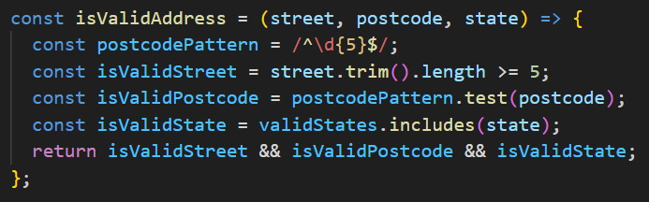

Figure 101 isValidAddress

The *isValidAddress* function is designed to validate a user's address input by checking three key fields: street, postcode, and state. It ensures that the street name is not empty or too short by requiring a minimum length of five characters after trimming any extra spaces. For the postcode, it uses a regular expression to confirm that the input is exactly five digits, matching standard postal code formats. Lastly, it verifies that the selected state is included in a predefined list of valid options (*validStates*). The function returns true only if all three conditions are met, ensuring that the address data entered by the user is complete and correctly formatted before it is saved or submitted.  
  
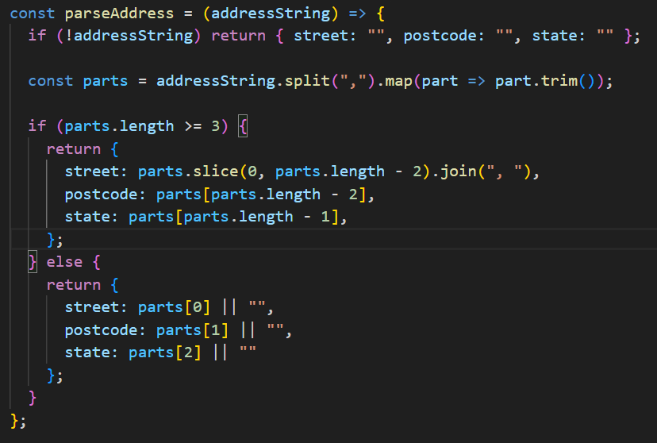

Figure 102 parseAddress

The *parseAddress* function is used to split a full address string into separate parts: street, postcode, and state. It first checks if the *addressString* exists—if not, it returns an object with empty values for all three fields. If the string is present, it splits it by commas and trims extra spaces from each part.

If the resulting array has three or more parts, it assumes the last two parts are the postcode and state, while everything before that is considered the street (this accounts for street names that may contain commas). It then joins those earlier parts back together to form the full street name.

If the address has fewer than three parts, it assigns whatever values are available to street, postcode, and state in order. This function is especially useful for extracting structured address data from a single saved string, such as one retrieved from a database or form input.  
  
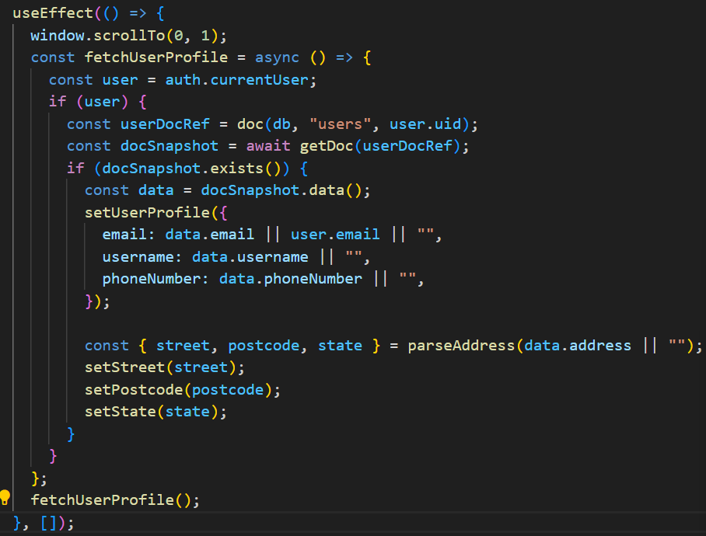

Figure 103 fetchUserProfile

This *useEffect* hook runs when the component mounts and is responsible for loading the user's profile data from *Firestore* and updating the component state accordingly.

It begins by calling window.*scrollTo*(0, 1) to adjust the scroll position slightly, likely for mobile optimization. It then defines and invokes the asynchronous function *fetchUserProfile*. Inside this function, it checks if a user is currently authenticated using *auth*.*currentUser*. If a user is logged in, it retrieves the corresponding document from the "users" collection in *Firestore* using the user's *uid*.

If the document exists, the function extracts profile data such as email, username, and *phoneNumber*. The email is taken from the *Firestore* document if available, otherwise from the authenticated user's account. This data is then stored in the component's state using *setUserProfile*.

Next, it calls *parseAddress* on the address field (or an empty string if not provided), which splits the full address into street, postcode, and state. These are individually stored in their respective state variables (*setStreet*, *setPostcode*, *setState*) to populate the address fields in the user interface. This setup ensures that the form loads with the user's existing profile information for easy viewing or editing.

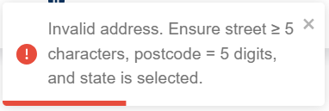

Figure 104 Invalid address

The figure 104 displays a form validation error message within a user interface, indicating that the user’s input for the address section did not meet the required criteria. The message appears inside a grey notification box with a clear header titled "Invalid address." An accompanying red exclamation mark icon visually signals that this is an error or warning.

The content of the message provides specific guidance: "Invalid address. Ensure street ≥ 5 characters, postcode = 5 digits, and state is selected." This informs the user that the street name must be at least five characters long, the postcode must consist of exactly five digits, and a valid state must be selected from a dropdown.

Additionally, there's a prominent 'X' icon in the top-right corner of the message box, which likely allows the user to dismiss or close the alert. This design helps users quickly understand and correct their input while maintaining a clean and interactive form experience.

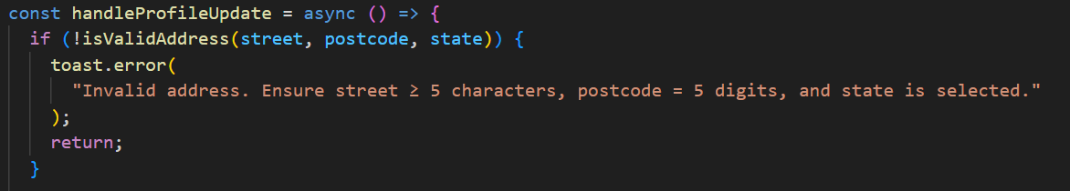

Figure 105 HandleProdileUpdate

The *handleProfileUpdate* function begins by validating the user's address input using the *isValidAddress* function. It checks whether the street, postcode, and state fields meet the required criteria: the street must be at least five characters long, the postcode must be exactly five digits, and a state must be properly selected from the list.

If any of these validations fail, the function immediately triggers an error toast with the message: "Invalid address. Ensure street ≥ 5 characters, postcode = 5 digits, and state is selected."

This provides clear and immediate feedback to the user, preventing submission of invalid data. The return statement ensures the update process is halted until the user corrects their input. This step is crucial for maintaining data integrity and improving user experience through real-time form validation.  
  
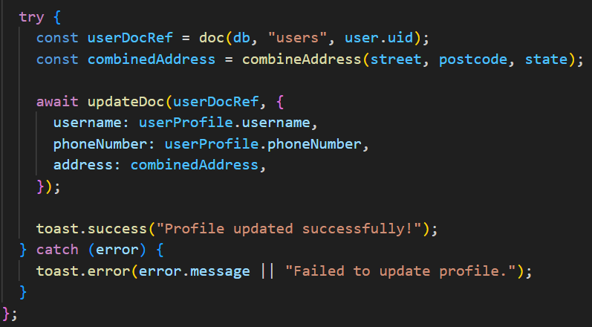

Figure 106 combineAddress

This code handles the process of updating a user's profile information in *Firestore*. It first creates a reference to the user's document using their unique ID, then combines the individual address fields—street, postcode, and state—into a single string using the *combineAddress* function. With this data prepared, it uses *updateDoc* to update the user's username, *phoneNumber*, and address in the *Firestore* database. If the update is successful, a success message—"Profile updated successfully!"—is shown to the user through a toast notification, providing immediate positive feedback. If any error occurs during the process, such as a network failure or database issue, the catch block captures the error and displays an error toast message to inform the user that the profile update failed, ensuring transparency and a smooth user experience.

## 4.4 Implementation of Admin Application

The Admin Application provides a dedicated interface for administrators to manage users, products, orders, and profile settings. It is securely integrated with Firebase to ensure real-time updates and access control. The admin panel includes the following key components:

* **Login Page.** The Login Page in the Admin Application provides secure access for authorized personnel. Admins must enter valid credentials to sign in, which are verified using Firebase Authentication. Upon successful login, they are redirected to the dashboard. This page ensures that only verified admin users can access sensitive backend operations such as managing users, products, and orders.
* **Dashboard Page**. The Dashboard offers a summary view of key metrics such as total users, number of listed products, pending and completed orders, and low-stock alerts. It provides admins with a quick overview of platform activity and performance.
* **User Management Page**. This page displays a list of all registered users. Admins can view user details such as username, email, phone number, and address. While emails are read-only, other contact fields can be edited. Search and filtering functionalities help in locating specific users quickly.
* **Product Management Page**. The Product Management page allows admins to add, edit, or remove products by updating details like name, price, image, description, and stock. All changes are saved in the products collection and reflected in real time across the platform.
* **Order Management Page**. This page displays all customer orders with order ID, timestamp, delivery address, item details, and total amount. Admins can track order progress, update order statuses (e.g., processing, delivering, completed)and ensure stock levels are adjusted accordingly after each confirmed order.
* **Profile Page**. Admins can access their own profile information to view or update their display name and contact number. The email field is read-only and tied to Firebase Authentication for security.
* **Logout Functionality**. A secure logout button is available to end the admin session. Clicking it signs the admin out of Firebase and redirects them to the login screen, ensuring account security and preventing unauthorized access.

### 4.4.1 Admin Login Page

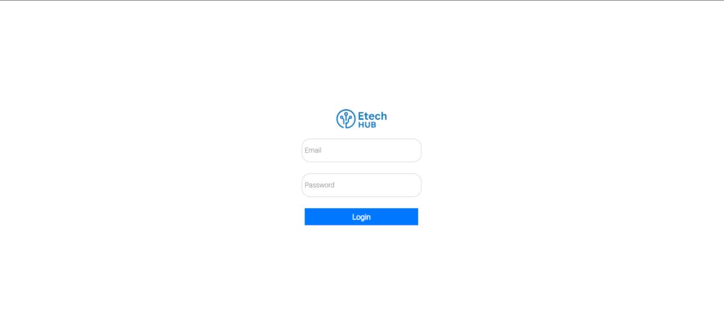

Figure 107 Admin Login Page

The admin login page for "Etech HUB" features a clean and minimalist design, offering a straightforward interface for administrator access. At the top, the brand’s logo is prominently displayed, reinforcing identity and trust. Below the logo, admins are prompted to enter their login credentials through clearly labeled input fields for Email and Password. A bold blue "Login" button is placed beneath the fields to initiate authentication. The use of a plain white background keeps the focus on the login elements, ensuring simplicity and ease of use for administrators.  
  
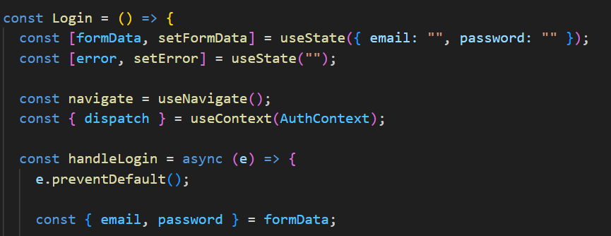

Figure 108 Admin Login

This code defines the beginning of a Login component in React that handles user authentication. It uses React state (*useState*) to manage form data for the email and password inputs, as well as to store any error messages that occur during the login process. The *useNavigate* hook is used for navigation after a successful login, and *useContext* is used to access the *AuthContext*, which likely manages global authentication state across the app.

In the *handleLogin* function, which is triggered when the login form is submitted, *e*.*preventDefault*() prevents the default form submission behavior. Then, the email and password values are extracted from the *formData* object, preparing for the login attempt that would typically follow (e.g., using Firebase Authentication or another *backend* service).This setup ensures that user inputs are validated and handled properly before performing the login logic.

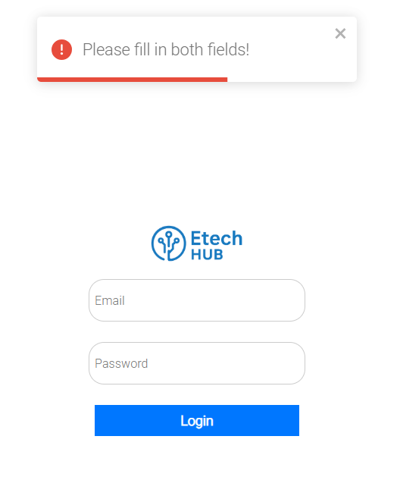

Figure 109 Admin Login page Please fill in both fields

The red box at the top of the login page appears as a validation error message to alert the user that they attempted to submit the form without completing both required fields—Email and Password. This message is triggered by client-side form validation, which checks whether the input fields are empty before allowing the login process to proceed.

The red bottom border, red exclamation mark icon, and bold text stating "Please fill in both fields!" are all visual cues designed to quickly catch the user's attention and clearly communicate what went wrong. The presence of an 'x' icon allows users to manually dismiss the message. Overall, the red box serves to enhance usability by preventing incomplete submissions and guiding users to correct their input.

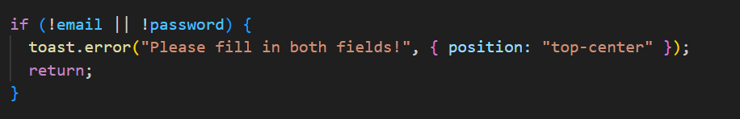

Figure 110 toast error

This code checks if the email or password fields are empty when the user tries to log in. If either field is missing, it triggers an error message using a toast notification that says: "Please fill in both fields!". The return statement stops the login process from continuing until both fields are filled, helping to prevent invalid or incomplete submissions.

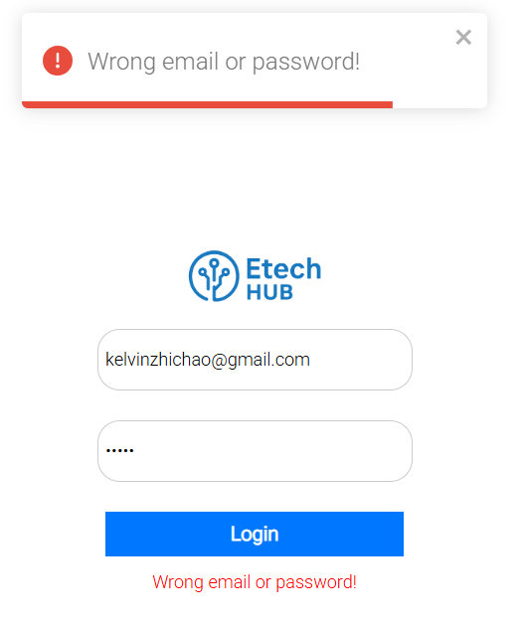

Figure 111 Wrong Email or password

The image 111 shows a failed login attempt on the "Etech HUB" admin page. A red-bordered error box at the top displays the message "Wrong email or password!" along with a red exclamation icon, signaling an authentication error. The email and password fields are filled in, but the credentials do not match any existing account. This clear visual cue helps users quickly understand that their login attempt was unsuccessful due to incorrect details.

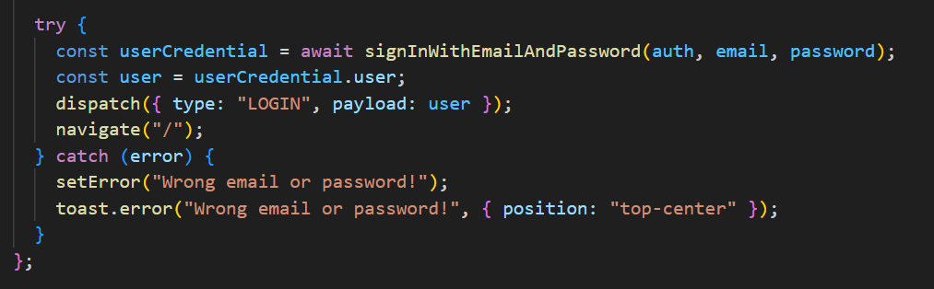

Figure 112 signInWithEmailAndPassword

This code handles the login process using Firebase Authentication. When the user submits valid credentials, the *signInWithEmailAndPassword* function attempts to authenticate them. If successful, the user’s information is retrieved and dispatched to the global authentication context using the LOGIN action, and the app navigates to the homepage. If the login fails—due to incorrect email or password—an error message is set locally and a toast notification saying “Wrong email or password!” is displayed at the top of the screen, providing immediate feedback to the user.

### 4.4.2 Dashboard Page

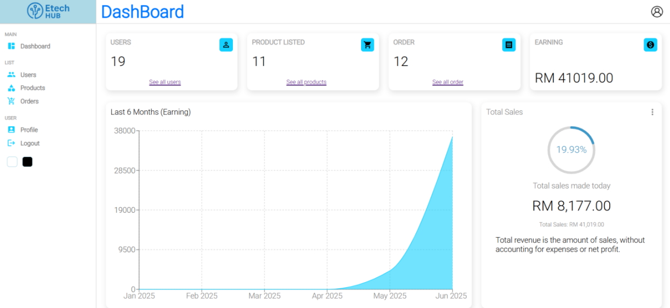

Figure 113 Dashboard Page

The admin dashboard of "Etech HUB" is divided into three main sections: Dashboard Overview, Management List, and User Settings, each serving a specific function to support platform administration.

The Dashboard Overview is the central area that provides a visual summary of the platform's key performance indicators. It features summary cards showing the total number of users, listed products, orders placed, and overall earnings. These cards include relevant icons and quick access links for more detailed views. Below the cards, performance charts offer further insights—a line chart tracks earnings over the last six months, while a circular progress chart displays daily sales progress alongside overall sales figures and clarifying notes.

The Management List, located in the left sidebar under the "MAIN" section, allows administrators to manage core aspects of the platform. The Users section enables admin to view and edit user profiles, the Products section allows for adding, updating, or removing product listings, and the Orders section provides tools for tracking customer orders and updating their delivery statuses.

Lastly, the User Settings section is found below the main menu under "USER" in the sidebar. Here, administrators can access their Profile to update personal details and securely Logout from the system. This three-part structure ensures the admin panel remains organized, intuitive, and efficient for daily operations.

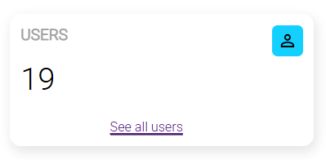

Figure 114 User widget

The figure 114 displays a single dashboard card from an admin panel. The card is labeled "USERS" at the top left, showing the total user count. A blue user icon is placed in the top right corner. At the bottom, there's a purple underlined link labeled "See all users," which navigates to a page with detailed user information.

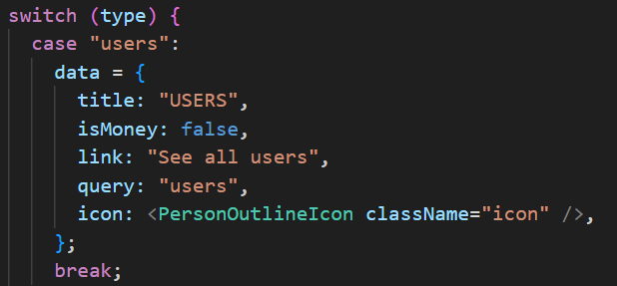

Figure 115 User widget code snipped

This code sets up the configuration for a dashboard card when the type is "users". It assigns a data object with specific properties: the title is set to "USERS", indicating the content of the card; *isMoney* is set to false since the data doesn't represent currency; link contains the text "See all users", which likely serves as a navigation link to the user management page; query is set to "users", referencing the *Firestore* collection to be queried for user data; and icon is set to a user outline icon component styled with the class "icon". This setup helps the dashboard render a user-related summary card dynamically.

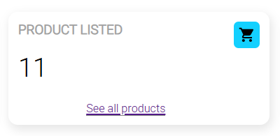

Figure 116 Product widget

The image 116 displays a dashboard card focused on product information. The card is titled "PRODUCT LISTED" in the top left corner. A number is displayed in the center, indicating the total count of listed products. In the top right corner, there is a blue square icon featuring a shopping cart to represent product content. At the bottom, an underlined purple link labeled "See all products" suggests a clickable element to view the complete product list.

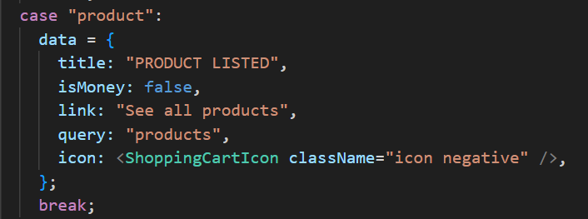

Figure 117 Product widget code snipped

This code sets up a dashboard card for the "product" type. It assigns the title "PRODUCT LISTED", sets *isMoney* to false, and includes a link labeled "See all products". The query points to the "products" collection, and a shopping cart icon is used to represent the product category.

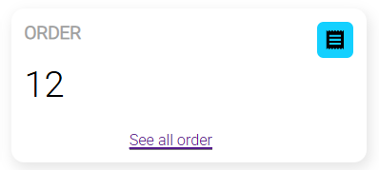

Figure 118 Order widget

The image 118 shows a dashboard card that provides an overview of orders. The card is labeled "ORDER" in the top left corner. A number is displayed in the center, indicating the total number of orders. In the top right corner, there is a blue square icon featuring an image resembling a document or stack of papers, representing order-related content. At the bottom center, an underlined purple link labeled "See all order" suggests a clickable element to view the full list of orders.

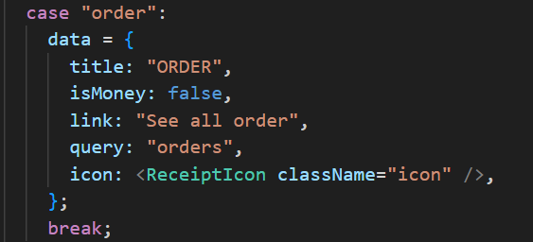

Figure 119 Order widget code snipped

This JavaScript code snippet is a configuration object within a larger application, likely for a dashboard component that displays order-related information. Under the "order" case, it defines the widget's title as "ORDER" and specifies that the data it presents is not monetary (*isMoney*: *false*). It also provides the text for a clickable link, "See all order," which would direct users to a comprehensive list of orders. Crucially, it includes a query property set to "orders," indicating the database collection or API endpoint to fetch the relevant data. Finally, a *ReceiptIcon* component is designated as the visual representation for this order widget.

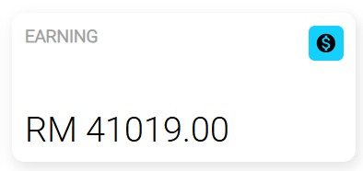

Figure 120 Earning widget

The figure 102 displays a dashboard card focused on "EARNING" metrics. The card is labeled "EARNING" in the top left corner, and a monetary value is shown in the center to represent total earnings. In the top right corner, a blue square icon with a dollar sign symbolizes financial data. Unlike other cards, this one does not have a "See all..." link, suggesting it shows a cumulative total without linking to a detailed view.  
  
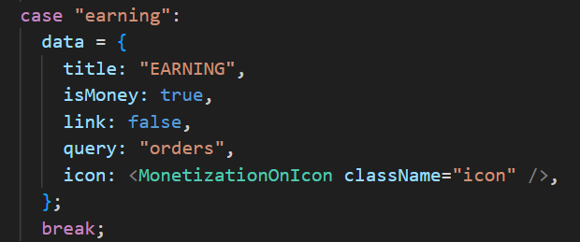

Figure 121 Earning widget code snipped

This code sets the configuration for the dashboard card when the type is "earning". The data object includes the title "EARNING", with *isMoney* set to true to indicate that the value represents a monetary amount. The link is set to false, meaning no navigation link is shown for this card. The query is set to "orders", suggesting that earnings data is derived from the orders collection. A dollar sign icon is used to visually represent financial information, styled with the class "icon".  
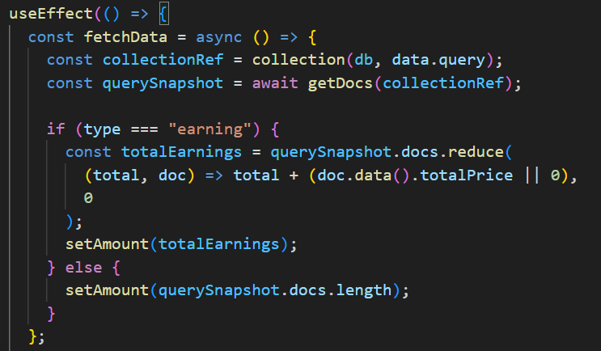

Figure 122 totalPrice

This *useEffect* hook is used to fetch and display data for a dashboard card based on its type. Inside the hook, it defines an asynchronous *fetchData* function that accesses a *Firestore* collection using the data.query value (e.g., "users", "products", or "orders").

If the card type is "earning", the function calculates the total earnings by summing the *totalPrice* field from each document in the "orders" collection. If the type is anything else (such as "users" or "products"), it simply counts the number of documents in the collection and sets that number using *setAmount*. This allows the component to display either a total count or a total sum, depending on the card type.  
  
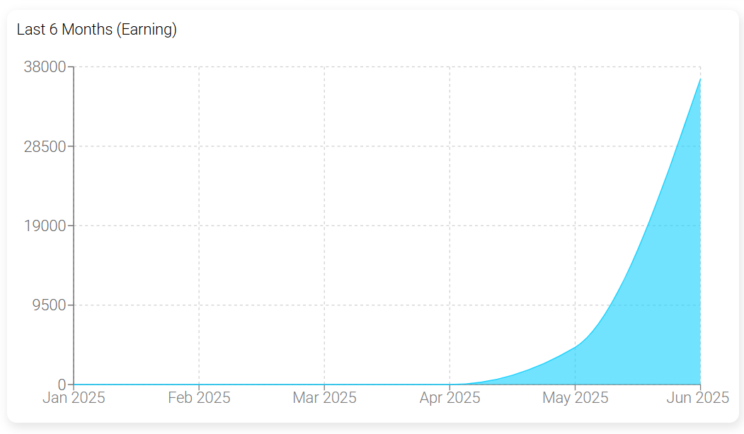

Figure 123 Earning graph

The Figure 123 displays a line graph titled "Last 6 Months (Earning)", showing the trend of earnings from January to June 2025. The Y-axis represents earning amounts, while the X-axis marks the months. Earnings remain low and stable from January to March, begin to rise in April, and then increase sharply through May and June. A light blue shaded area beneath the line highlights the growth, with a noticeable peak in June 2025, indicating a strong upward trend in overall earnings during the last two months.  
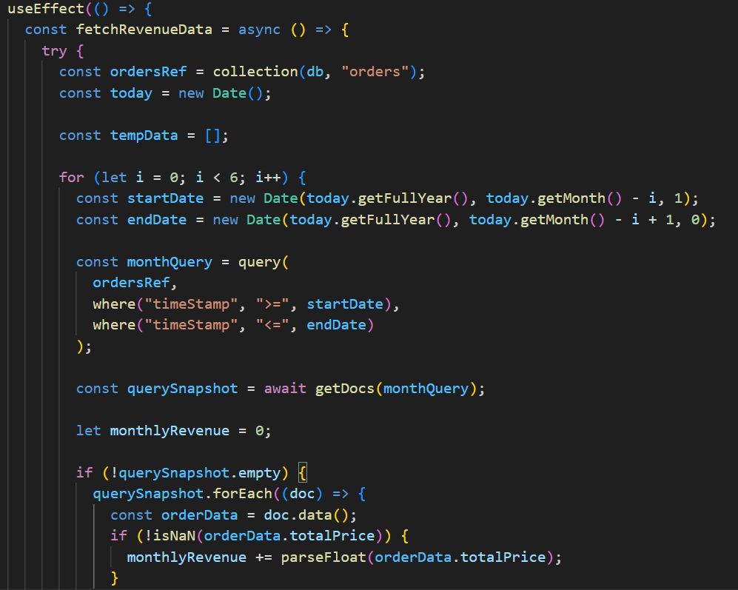

Figure 124 fetchRevenueData

This *useEffect* hook defines a function to fetch and calculate monthly revenue data for the past six months from the "orders" collection in *Firestore*. It starts by referencing the orders collection and getting the current date. Then, it loops through the last six months, and for each month, it constructs a *startDate* (first day of the month) and *endDate* (last day of the month).

Within each iteration, it performs a *Firestore* query to retrieve orders whose *timeStamp* falls between *startDate* and *endDate*. If matching orders are found, it iterates through the documents and sums up the *totalPrice* values to compute the total revenue for that month. These monthly totals are stored in the *tempData* array, which will likely be used later to display the data in a line chart or summary view. This approach helps visualize how revenue has changed over the last six months.

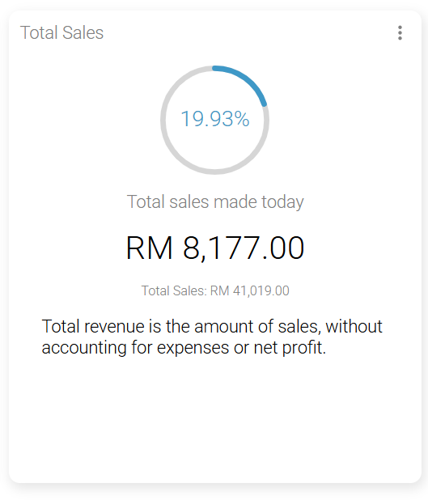

Figure 125 Total Sales

The figure 125 displays a dashboard card titled "Total Sales", which summarizes sales performance. At the top, a circular progress chart shows "19.93%" with a blue-filled segment, visually indicating progress toward a target. Below the chart, the text "Total sales made today" is followed by a bold sales figure, highlighting the day’s earnings. Beneath that, a smaller line shows "Total Sales" with the cumulative amount. At the bottom, a note explains that the figures represent total revenue before expenses or profit, clarifying that the data reflects gross sales only.

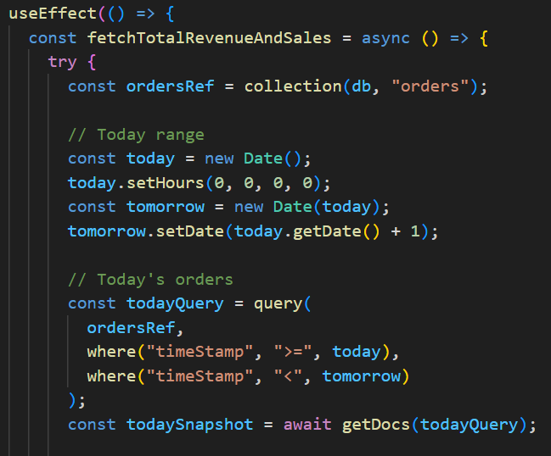

Figure 126 fetchTotalRevenueAndSales

This *useEffect* hook is designed to fetch and calculate today's total revenue and number of sales from the Firestore "orders" collection.

It begins by referencing the orders collection in the database. Then, it creates a date range to represent today only, by setting the current date (today) to midnight and creating a tomorrow date by adding one day. This ensures that only orders placed between midnight of the current day and just before midnight of the next day are included.

Next, it performs a Firestore query (*todayQuery*) to retrieve all orders where the *timeStamp* falls within this range. The result of the query (*todaySnapshot*) will contain all orders made today. This snapshot will be used to calculate the total revenue for the day and count the number of sales, which can then be displayed on the dashboard under sections like "Total Sales Made Today" or similar summary cards.

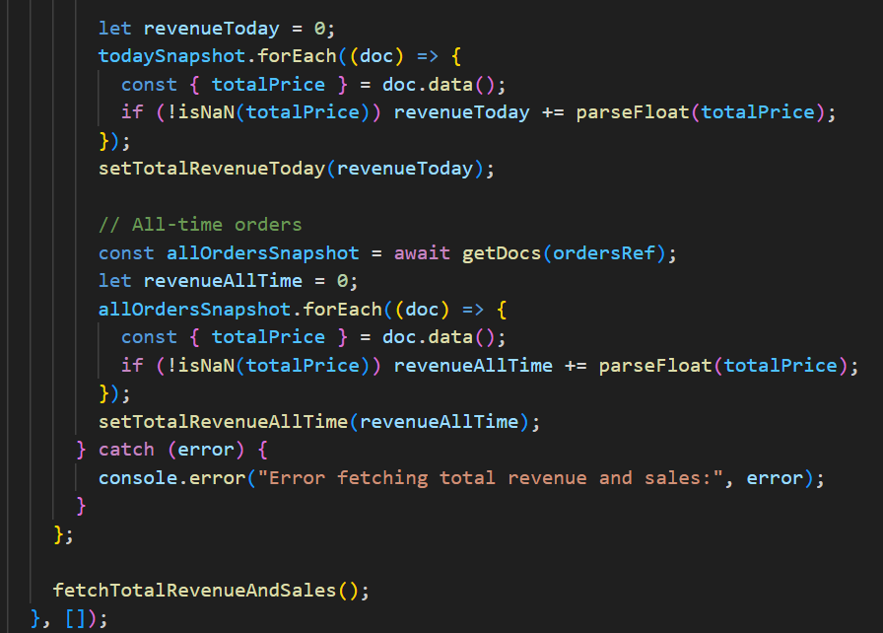

Figure 127 revenueToday

This code continues the *useEffect* hook to calculate and set today's revenue and all-time revenue for an e-commerce dashboard. First, it initializes *revenueToday* to zero, then loops through *todaySnapshot* (orders placed today). For each order, it extracts the *totalPrice* and adds it to *revenueToday* after verifying it’s a valid number. The result is saved using *setTotalRevenueToday*().

Next, it retrieves all orders from the database using *getDocs*(*ordersRef*) and calculates the total revenue across all time (*revenueAllTime*) in a similar way. This value is stored using *setTotalRevenueAllTime*().

If any errors occur during this process, they’re caught and logged in the console. This logic ensures that both daily earnings and overall revenue are accurately calculated and displayed when the component mounts.

### 4.4.3 User Management Page

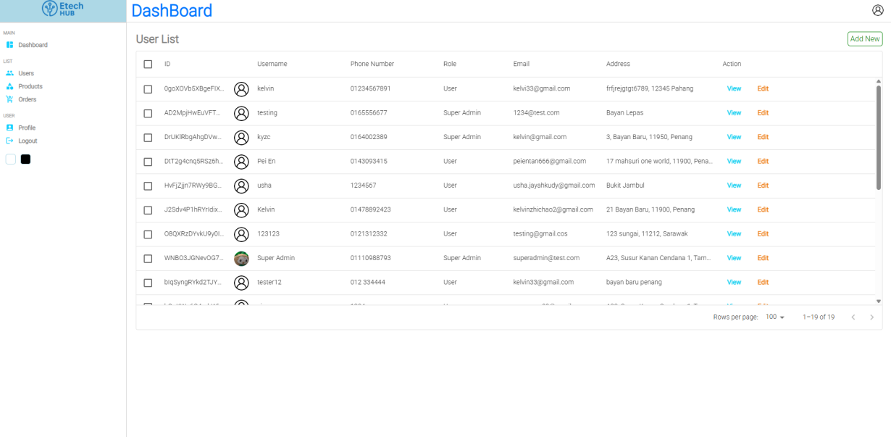

Figure 128 User Management Page

The User Management Page presents the "User List" section within the Etech HUB admin dashboard. A navigation sidebar appears on the left, featuring options such as Dashboard, Users, Products, and Orders. The "Users" option is highlighted, indicating that it is the currently active page. This layout helps administrators easily identify and manage user-related tasks within the dashboard interface.

The main content area is a table titled "User List" with an "Add New" button in the top right corner, suggesting the ability to add new user entries. The table columns are:

* **ID**: Displays a unique identifier for each user.
* **Username**: Shows the username, accompanied by a small profile picture or icon.
* **Phone Number**: Phone number of the user.
* **Role**: Indicates the user's role (e.g., "User", "Super Admin").
* **Email**: Provides the user's email address.
* **Address**: Lists the user's address.
* **Action**: Contains "View" and "Edit" links for each user, allowing administrators to manage individual user details.

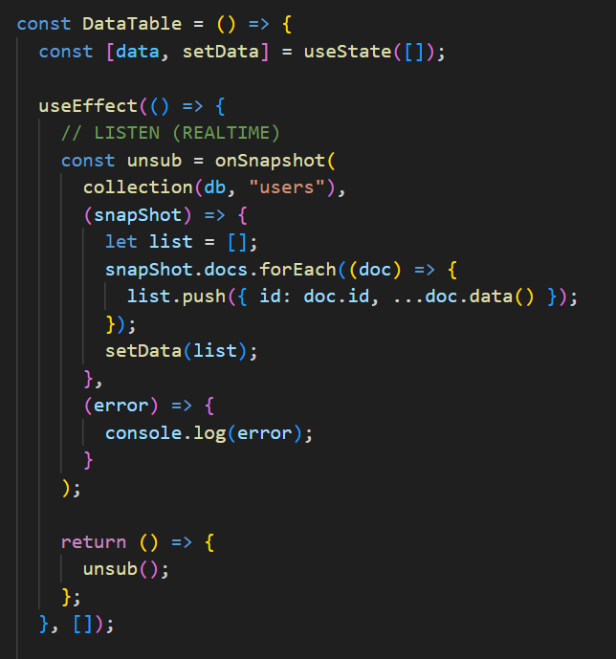

Figure 129 onSnapshot

This *DataTable* component sets up a real-time listener to the "users" collection in Firestore using the *onSnapshot* function. When the component mounts, it subscribes to changes in the user data. Each time there's an update (such as a new user being added or an existing one being modified or removed), the listener fetches the latest documents from *Firestore*, builds a new list of user objects with their IDs and data, and updates the local data state using *setData*.

The *useEffect* ensures this listener is only set up once on mount, and it returns a cleanup function to unsubscribe from the *Firestore* listener when the component *unmounts*, preventing memory leaks. This enables the admin panel to display a dynamic, always-up-to-date list of users.  
  
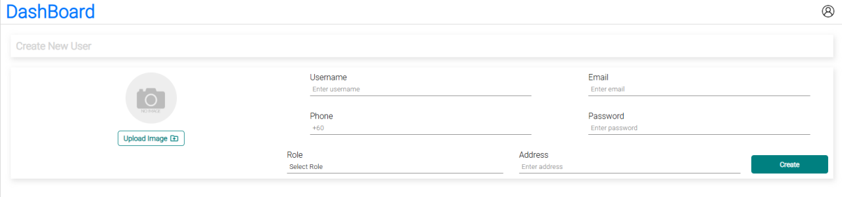

Figure 130 Create New User

The "Create New User" interface allows the input of various user details such as username, email, phone number, password, role, and address. However, the interface itself does not display any clear indicators or visual cues about access restrictions or role-based permissions—for example, whether only a "super admin" has the authority to add new users, as opposed to a regular "admin." Such permission controls are typically managed in the backend and may affect the visibility of this feature depending on the logged-in user's role or result in an error message if an unauthorized user attempts the action. Therefore, without additional context on the system's role-based access control (RBAC) or a comparison between the experiences of different user roles, this single image does not provide enough information to determine the system’s permission structure.  
  
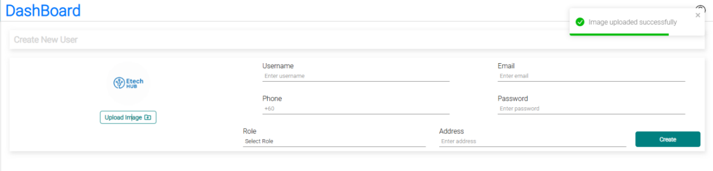

Figure 131 Image upload successfully

The figure 131 above showcases the "Create New User" interface, which closely resembles the layout and fields of the first. However, it introduces a key visual element: a bright green notification box located in the top-right corner, displaying the message "Image uploaded successfully." This alert serves as immediate feedback to confirm that the image upload process—initiated by the user—has been completed successfully. Its presence implies that the user has selected an image file, triggered the upload, and the system has processed and stored the file without errors.

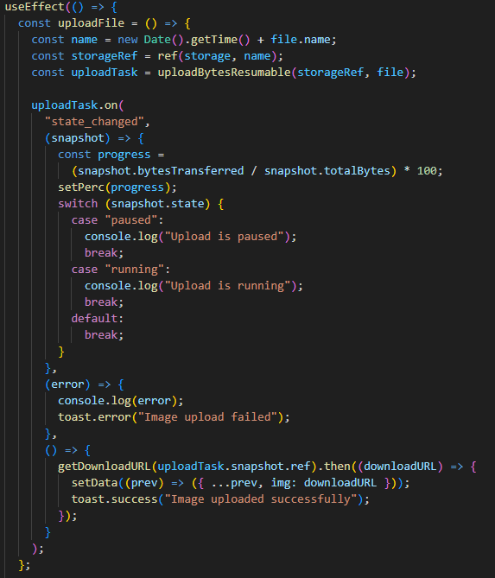

Figure 132 uploadFile

This *useEffect* hook is triggered whenever the file variable changes, typically when a user selects a new file to upload. Inside the hook, a function named *uploadFile* is defined to handle the upload process. It begins by generating a unique filename using the current timestamp combined with the original file name, which helps prevent naming conflicts in Firebase Storage. A storage reference is then created using this unique name, and the file is uploaded using *uploadBytesResumable*, which allows real-time tracking of the upload process. The *uploadTask*.*on* method listens for upload state changes. As the upload progresses, it calculates the percentage completed and updates it via *setPerc*, which is likely used to show a progress bar in the UI. It also logs whether the upload is paused or running. If an error occurs during the upload, it logs the error and displays a toast notification indicating failure. Once the upload is successful, it retrieves the file’s download URL and updates the component’s state with this URL using *setData*, allowing the uploaded image to be used later (e.g., in a form or preview). A success toast notification is also displayed to inform the user of the successful upload.  
  
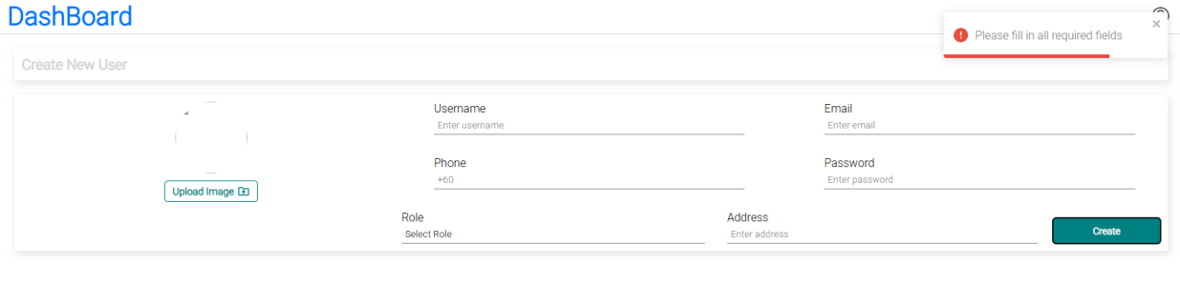

Figure 133 Please fill in all required fields

The figure 133 captures the state of the "Create New User" form after an unsuccessful attempt to submit it without completing all required fields. A prominent red notification box appears in the top-right corner, accompanied by an exclamation mark and the message "Please fill in all required fields." This serves as a clear and immediate form validation error, informing the user that their submission was incomplete. The form itself still shows several empty or partially filled input fields, indicating that not all mandatory data—such as username, email, password, or other fields—were provided. While the status of the image upload is not explicitly visible in this screenshot, the absence of any related notification suggests that the error occurred before the image upload was triggered, or that it is simply not the focus in this state. The central emphasis of this image is the system's response to missing input, demonstrating effective validation and user feedback.

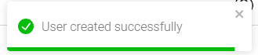

Figure 134 User created successfully

This image 134 presents a close-up view of a green notification box, visually consistent with the style used for success messages such as "Image uploaded successfully." The box prominently features a green checkmark icon, followed by the message "User created successfully," clearly indicating that a new user has been added to the system without issue.

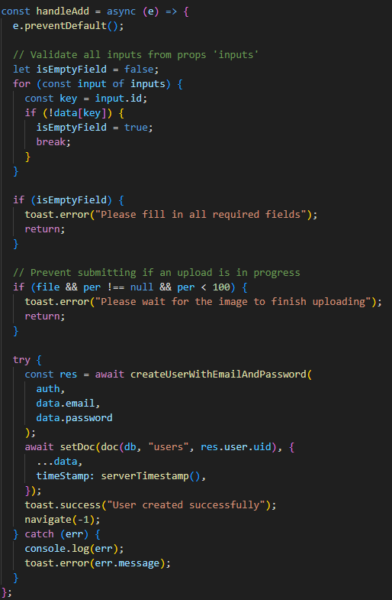

Figure 135 handleAdd

The *handleAdd* function is an asynchronous event handler responsible for submitting the "Create New User" form. It begins by preventing the default form submission behavior using *e*.*preventDefault*(). The function then performs validation by checking each input field defined in the inputs prop to ensure that all required fields have been filled out. If any field is empty, it sets a flag and displays an error message using toast.error, halting the submission process. Next, it checks if a file is being uploaded by verifying if a file exists and if the upload progress (per) is not yet 100%. If an upload is still in progress, it displays another error message prompting the user to wait. If all validations pass, the function proceeds to create a new user in Firebase Authentication using the provided email and password. Upon successful account creation, it stores the user’s additional data in *Firestore* under the users collection using the user’s UID as the document ID, along with a timestamp. A success message is then shown, and the user is redirected back to the previous page. If any errors occur during this process, they are logged to the console and displayed to the user through a toast notification.  
  
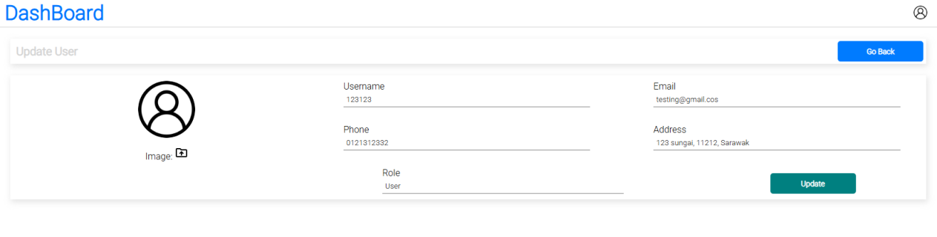

Figure 136 Update User

The figure 136 displays an "Update User" form, which differs notably from the previously shown "Create New User" forms. Unlike the blank fields in the creation form, this interface presents input fields that are pre-populated with existing user data. The "Role" field is also pre-filled with the value "user." Notably, there is no visible "Password" field—an intentional and common design choice in update forms to maintain security, as passwords are typically modified separately through dedicated workflows. A default person icon is displayed in place of a custom profile image, suggesting either a placeholder or an already existing profile picture. At the bottom right, the action button is labeled "Update" rather than "Create," reflecting the form's purpose. Additionally, a "Go Back" button is positioned in the top right corner, offering users a way to navigate away from the form without making changes.  
  
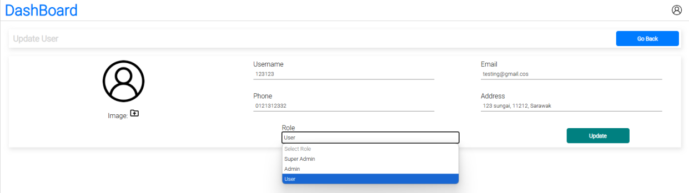

Figure 137 Role

With one notable distinction, the "Role" dropdown menu is expanded and fully visible. As with the previous version, the form is pre-filled with existing user information. The key change in this view is the expanded "Role" field, which reveals a list of selectable roles—namely "user," "super admin," "admin," and "new." Among these, the "user" role is highlighted, indicating it is the current selection. This expanded dropdown offers insight into the available role options that can be assigned to a user, which is useful for administrative updates or role changes within the system.

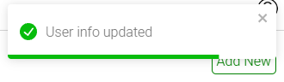

Figure 138 User info updated

This image presents a close-up view of a green notification box, visually consistent with the style used for success messages such as "Image uploaded successfully." The box prominently features a green checkmark icon, followed by the message "User info updated," clearly indicating that the user's information has been successfully modified.

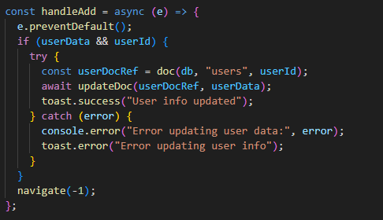

Figure 139 handleAdd User info update

This JavaScript code defines an asynchronous function *handleAdd* designed to update user information in a database, likely Firebase *Firestore*. Upon execution, it first prevents the default behavior of the event that triggered it (e.g., a form submission to avoid a page reload). It then proceeds only if both *userData* (the new information to be saved) and *userId* (the identifier for the specific user) are available. Within a try-catch block for robust error handling, the function creates a reference to the user's document in the "users" collection using the provided *userId* and then attempts to update that document with the *userData*. A success message is displayed to the user if the update is successful, while any errors encountered during the database operation are caught, logged to the console for debugging, and presented to the user as an error notification. Regardless of whether the update succeeds or fails, the function concludes by navigating the user back to the previous page.

### 4.4.4 Product Management Page

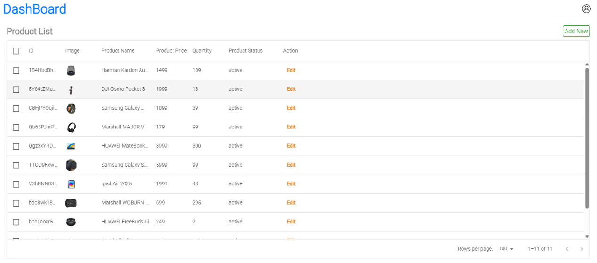

Figure 140 Product Management Page

The Product Management Page displays the "Product List" section within the DashBoard interface. The page header prominently features "DashBoard" on the left, indicating the overall system context.

The main content area is dominated by a table titled "Product List," with an "Add New" button conveniently placed in the top right corner, signifying the administrator's ability to introduce new products into the system. The table is structured with the following columns to organize product information effectively:

* **Checkbox**: A column with checkboxes, likely for selecting multiple products for bulk actions (though no actions are visible).
* **Image**: Displays a small thumbnail image representing each product.
* **Product Name**: Shows the name of the product (e.g., "Harman Kardon Au...", "Dell Cherry Pocket").
* **Product Price**: Indicates the numerical price of the product (e.g., "1400", "1999").
* **Quantity**: Lists the available stock quantity for each product (e.g., "180", "15").
* **Product Status**: Shows the current status of the product, such as "active".
* **Action**: Contains an "Edit" button for each product, allowing administrators to modify individual product details.

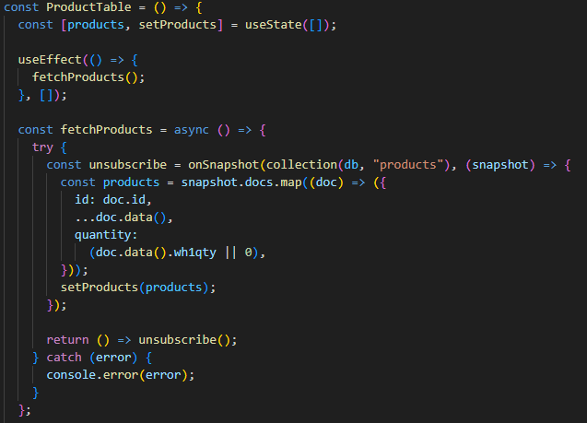

Figure 141 ProductTable

The *ProductTable* component is a React functional component that manages and displays a list of products retrieved in real time from a *Firestore* database. It uses the *useState* hook to store product data and the *useEffect* hook to fetch this data when the component is first mounted. The *fetchProducts* function sets up a real-time listener on the *Firestore* products collection using *onSnapshot*. Each document in the snapshot is mapped into an object containing its unique id, the rest of its data, and a quantity value derived from the wh1qty field (defaulting to 0 if not present). The resulting array is saved to the products state via *setProducts*. The listener ensures the component stays updated whenever changes occur in the products collection. The function also includes a cleanup mechanism by returning an unsubscribe function to remove the snapshot listener when the component unmounts. Error handling is implemented via a try-catch block to catch and log any potential issues during data fetching.

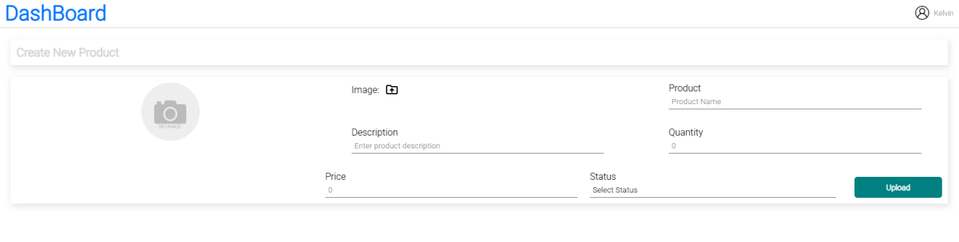

Figure 142 Create New Product

The Figure 142 displays a "Create New Product" form designed for adding new items to the system's inventory. The form includes input fields for essential product details such as "Product Name," "Description," "Price," "Quantity," and "Status," with the latter likely being a dropdown menu for selecting the product's availability or condition. An image upload section is also present, represented by a camera icon placeholder, indicating that users can attach a product image. At the bottom right, a green "Upload" button suggests the action to submit the form and complete the product creation process. Notably, the "Quantity" field has a red underline, a visual cue commonly used to indicate a required field that hasn't been filled or a potential input validation issue, although no explicit error message is shown at this stage. Overall, the form is structured to gather all necessary data for defining and storing a new product entry.  
  
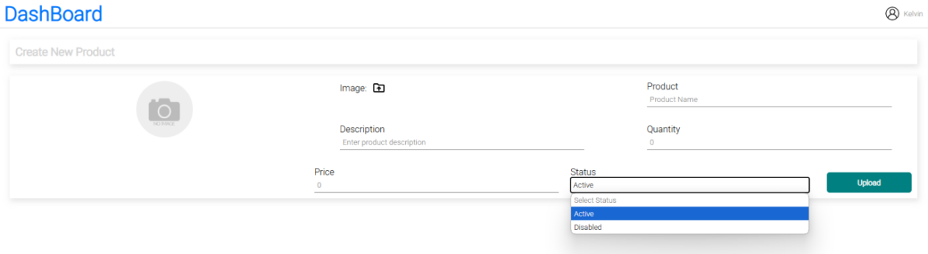

Figure 143 Product Status

The Figure143 emphasizes the functionality of selecting a product’s operational status during creation. By expanding the "Status" dropdown, it reveals predefined options—"Active," "Inactive," and "Disabled"—which allow administrators to determine how the product will appear or behave within the system. This helps ensure consistent control over product visibility, availability, or restriction based on business needs.  
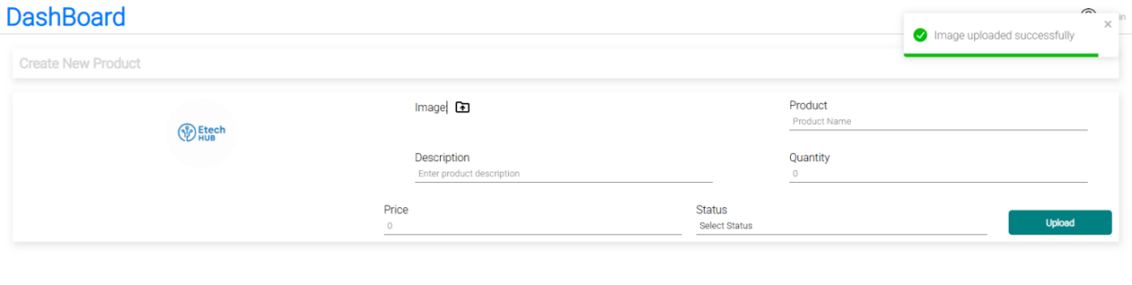

Figure 144 Product Image upload successfully

This image illustrates the successful upload of a product image during the creation of a new product. The replacement of the default camera icon with a branded circular "Etech HUB" image visually confirms that the file has been accepted. Simultaneously, a green notification box in the top-right corner displays the message "Image uploaded successfully," offering immediate feedback to the user that their image has been processed and stored by the system. This confirmation enhances user confidence and ensures a smoother form submission experience.

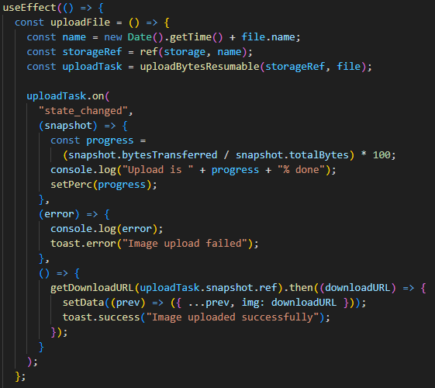

Figure 145 UploadFile

The code snipped sets up a *useEffect* hook that handles image uploads to Firebase Storage when a file is selected. When the file state changes, the *uploadFile* function is triggered. It generates a unique filename using the current timestamp and the original file name, then creates a Firebase Storage reference for the file. Using *uploadBytesResumable*, it begins uploading the file and monitors its progress through the state_changed event. As the upload progresses, it calculates the percentage of data uploaded and updates the component’s state with this value. If an error occurs during the upload, a toast message notifies the user of the failure. Upon successful completion, the function retrieves the download URL of the uploaded image and updates the component's state with this URL, followed by displaying a success toast to confirm the upload.  
  
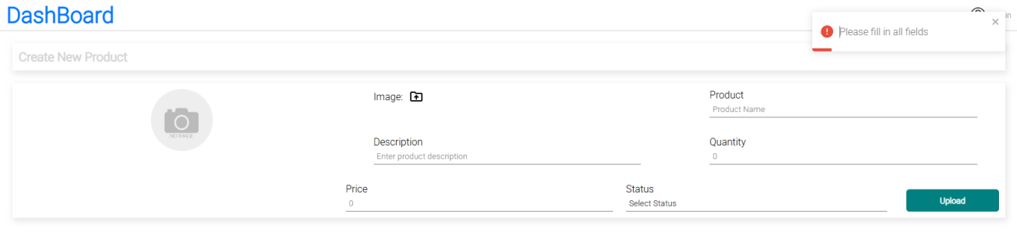

Figure 146 Create New User Please full in all field

The figure 146 highlights the form’s validation mechanism, which activates when a user attempts to submit the "Create New Product" form without completing all mandatory fields. As a result, a red error notification appears in the top-right corner with the message: "Please fill in all fields." This prompt provides immediate feedback to the user, ensuring that all required information is entered before the product can be successfully added to the system.

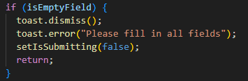

Figure 147 isEmptyField

This code handles form validation by checking if any required fields are empty. If such fields are detected, it first dismisses any existing toast notifications using toast.dismiss() to avoid duplicate messages. Then, it displays a clear error message—"Please fill in all fields"—to inform the user that the form cannot be submitted until all required inputs are completed. Finally, it sets *isSubmitting* to false to reset the form’s submission state, ensuring that no further processing occurs until the issue is resolved.

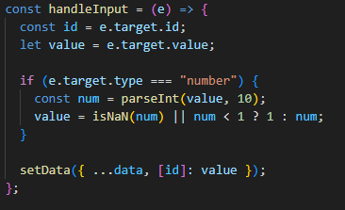

Figure 148 handleInput

The *handleInput* function is designed to manage form field updates within the component's state. It captures the id and value of the input element that triggered the change event. If the input type is a number, it includes a safeguard to ensure that the user cannot enter invalid or negative values. Specifically, it parses the value to an integer and forces it to be at least 1, defaulting to 1 if the value is either not a number or less than 1. This ensures that fields like "price" or "quantity" cannot be set to zero or negative numbers. Finally, the function updates the data state by merging the new field value with the existing state, preserving all previously entered data while modifying only the targeted field.  
  
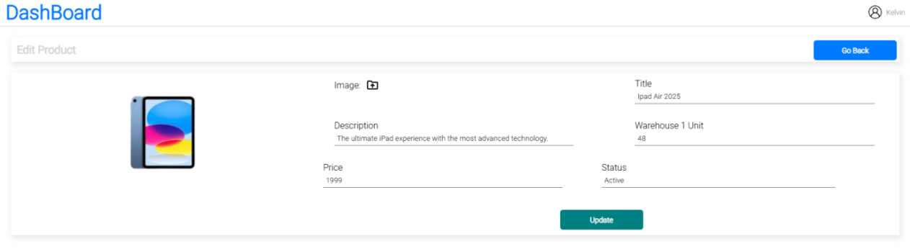

Figure 149 Edit Product Page

The Edit Product page is designed specifically for updating the details of an existing product stored within the system. Unlike the Create Product form, this interface is pre-populated with current product information, allowing administrators to efficiently review and modify fields such as product title, description, price, stock quantity, and status. The inclusion of a previously uploaded product image, along with the presence of an "Update" button (replacing the "Upload" button found in the creation form), clearly indicates its function as an editing tool. This design ensures that all updates to product data are performed in a controlled, intentional, and user-aware manner, streamlining the maintenance of accurate inventory records.  
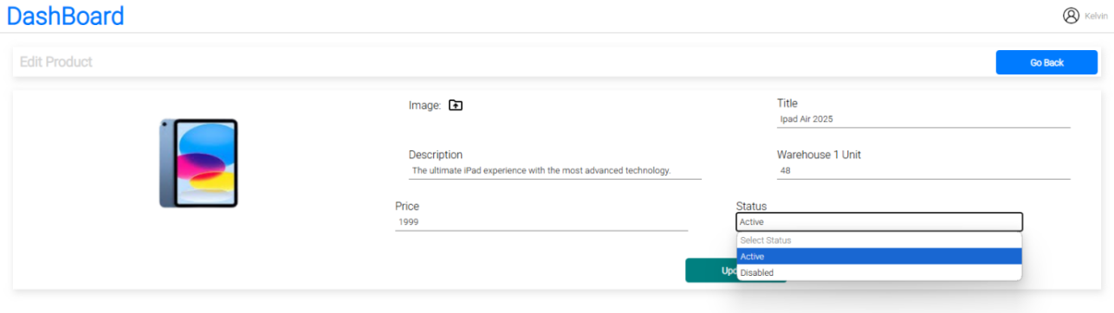

Figure 150 Edit Product status

This figure highlights the ability to modify a product’s operational status through the expanded dropdown menu in the Edit Product form. Specifically, it allows administrators to switch between *Active* making the product visible and available within the system and *Inactive* temporarily hiding the product from users without permanently deleting it. This functionality provides flexible control over product availability.

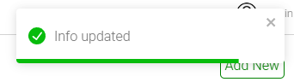

Figure 151 Info Update

This notification serves as a general confirmation that an update operation has been successfully completed. It is likely triggered after an administrator clicks the “Update” button on forms such as Edit Product or Update User. The message “Info updated” is broad, indicating that it may be used across multiple update scenarios within the dashboard interface to confirm that changes have been saved.  
  
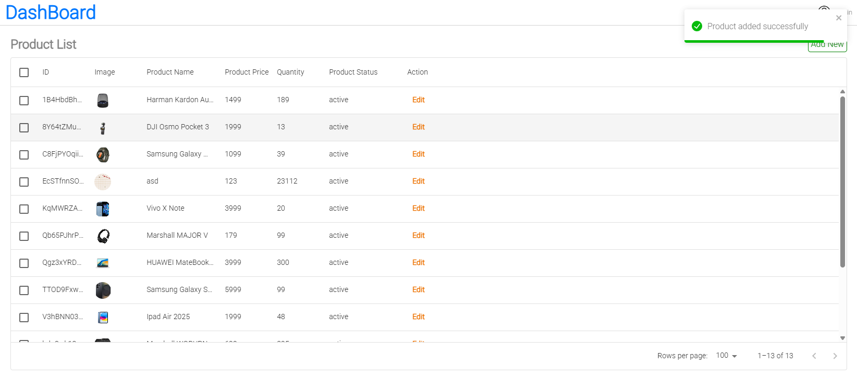

Figure 152 Product ListFigure 153 Product added successfully

The Figure 152 illustrates the final step in the product creation process, where the user is redirected back to the Product List page after successfully adding a new item. The appearance of the green success notification—"Product added successfully"—serves as immediate confirmation that the action was completed and the new product is now part of the inventory. This feedback mechanism ensures clarity and provides a smooth user experience by validating the result of the submission.  
4.4.5 Order Management Page

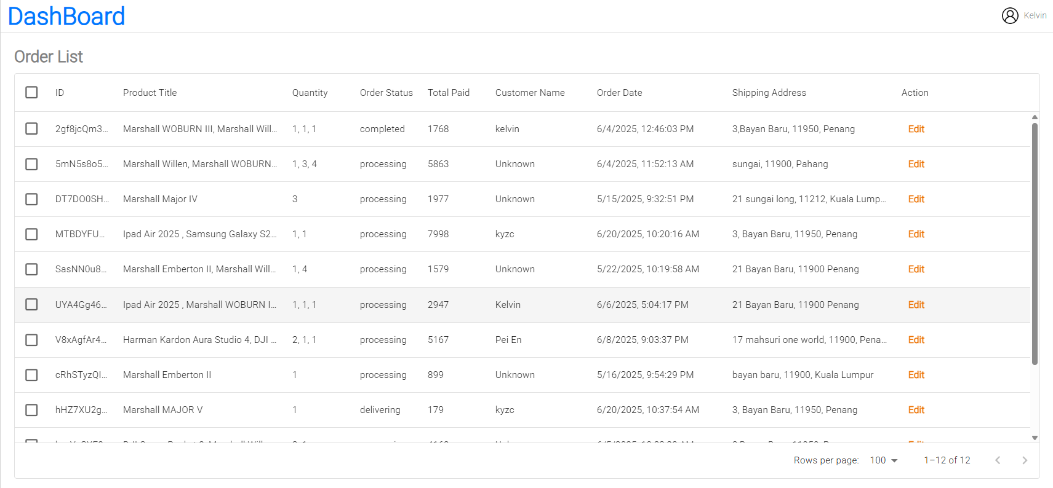

Figure 154 Order Management Page

The Order Management Page displays the "Order List" section within the Dashboard interface. The page header prominently features "Dashboard" on the left, providing context for the overall system environment.

The main content area is occupied by a structured table titled "Order List", with an "Add New" button positioned in the top-right corner—suggesting functionality for administrators to manually create or add new orders if permitted. The table is organized into the following columns to present order-related information efficiently:

* **Checkbox**: Allows selection of individual or multiple orders, potentially for bulk processing (e.g., status updates or deletions).
* **Order ID**: Displays the unique identifier assigned to each order.
* **Product Title**: Indicates the name or title of the product(s) included in the order.
* **Quantity**: Lists the number of units ordered for each product.
* **Status**: Reflects the current status of the order (e.g., "proccessing", "Delivering", "Completed").
* **Total Paid**: Indicates the total price or value of each order.
* **Customer Name**: Shows the name of the customer who placed the order.
* **Order Date**: Lists the date when the order was placed.
* **Shipping Address**: The full delivery address provided by the customer.
* **Action**: Contains an "Edit" or "View" button for each entry, allowing administrators to review or modify specific order details.

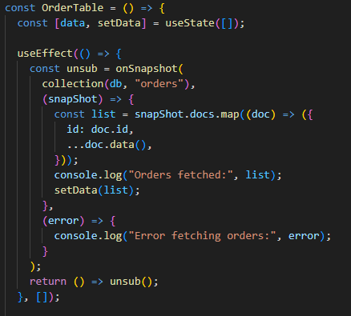

Figure 155 OrderTable

The *OrderTable* component fetches and listens to real-time updates from the *Firestore* orders collection. When the component mounts, it sets up a listener using *onSnapshot*, which automatically triggers whenever there are changes to the order data—such as additions, updates, or deletions. The snapshot received from *Firestore* is mapped into a list of order objects, each containing its unique id and associated data fields. This list is then stored in the data state using *setData*, allowing the component to render the latest orders. Additionally, a console log outputs the fetched orders for debugging purposes. When the component *unmounts*, the listener is unsubscribed to avoid memory leaks or unnecessary background activity.

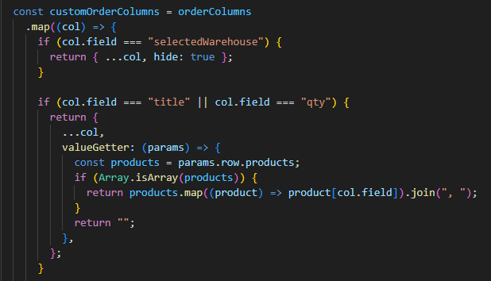

Figure 156 orderColumns

This code defines a customized version of the *orderColumns* array by mapping through each column and modifying it based on specific conditions. If a column has the field "*selectedWarehouse*", it is hidden by setting its hide property to true. For columns with the fields "title" or "qty", a *valueGetter* function is added. This function handles how values are displayed for those fields, especially when the data contains an array of products. It maps through each product in the products array of the row and extracts the relevant field (title or qty), joining them into a comma-separated string. This ensures that multiple products within a single order are displayed clearly and concisely in the table.

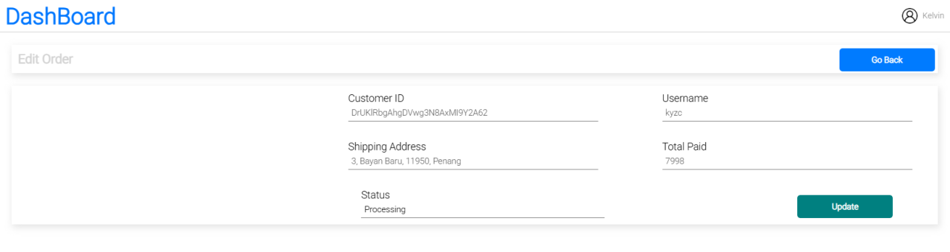

Figure 157 Edit Order

The figure 157 shows the "Edit Order" form within the Order Management section of the Dashboard, specifically designed to allow administrators to oversee and manage individual orders. The form is clearly pre-populated with existing order details, including a system-generated *Customer ID*, the *Username*, the *Shipping Address*, and the *Total Paid*. Each of these fields is displayed in a non-editable, read-only format, ensuring that critical customer or transactional information remains protected from unauthorized modifications. The only field that is editable within this interface is the "Status" field, allowing the administrator to update the current state of the order, such as marking it as "Processing," "Delivering,"or "Completed." Positioned at the top right is a "Go Back" button for easy navigation, and at the bottom right is an "Update" button to confirm status changes.

This design serves a specific purpose to provide administrators with comprehensive visibility into order records while enforcing strict role-based permissions. By restricting edits to only the status field, the system maintains data integrity and adheres to organizational policies where only end-users can modify their own personal or order details. Meanwhile, administrative users are empowered to control and reflect changes in order progress, ensuring accurate fulfillment and tracking throughout the order lifecycle.  
  
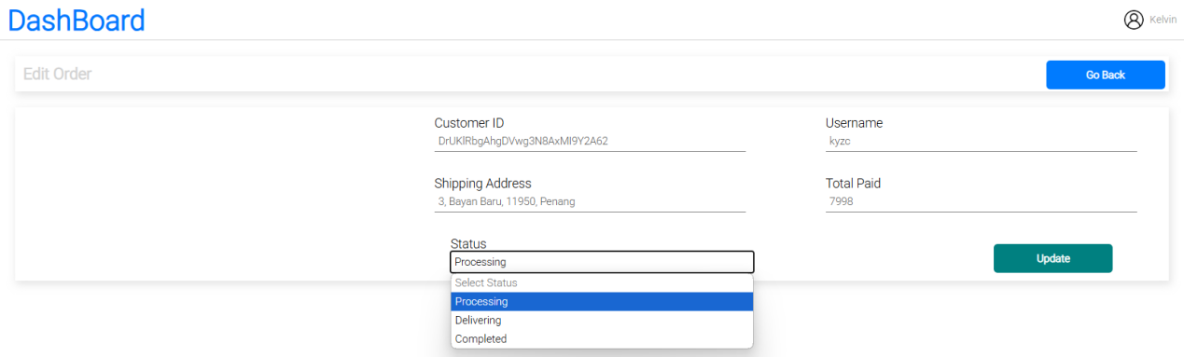

Figure 158 Edit Order dropdown menu

The status dropdown menu in the "Edit Order" form provides administrators with a controlled set of options to track and update the progress of an order. When expanded, it displays three predefined statuses: "Processing", "Delivering", and "Completed".  
  
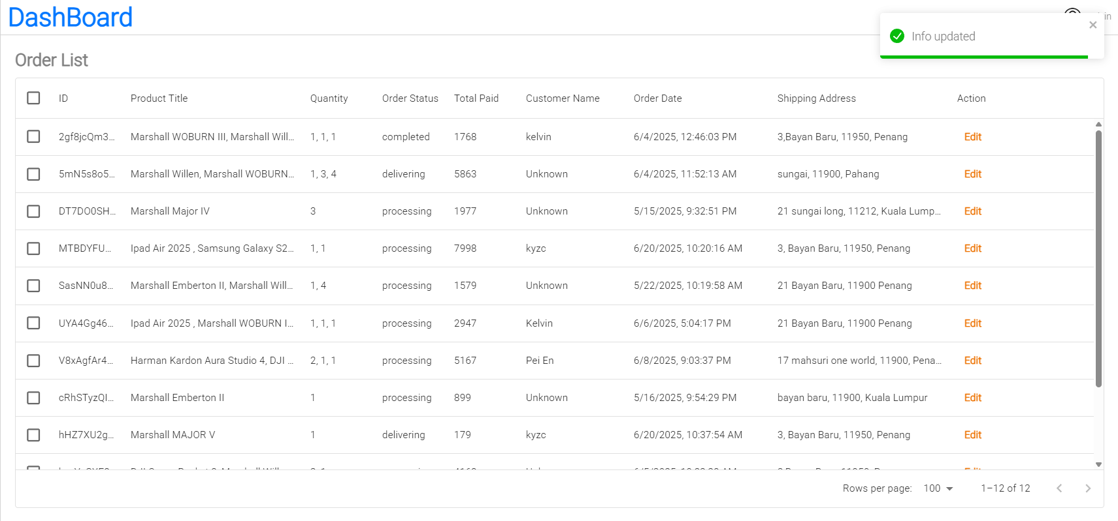

Figure 159 Order info update

After the admin updates an order’s status, a green success toast appears in the top-right corner with the message "Info updated". This confirms that the new status has been successfully saved and provides immediate feedback to the user.

### 4.4.6 Profile Page

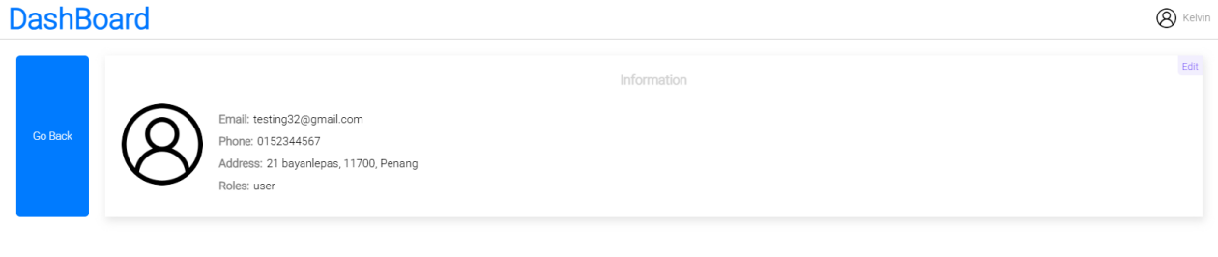

Figure 160 Dashboard Profile Page

In the User Management section, administrators can view a list of all users and access a read-only view of a specific user's profile. The profile displays key user information such as email, phone number, address, and role, accompanied by a generic profile icon. This view offers a clean and concise way to retrieve user details without entering edit mode. A prominent "Go Back" button allows easy navigation back to the previous page or user list. The dashboard’s consistent layout and intuitive controls ensure that tasks like user management are straightforward and efficient.

## 4.5 Conclusion

The implementation phase of the electronic gadget website marks a significant step toward delivering a functional and user-friendly e-commerce platform. Core features such as product browsing, user authentication, cart management, and order processing have been successfully integrated. Initial testing shows promising results in terms of performance and usability. Further refinements, including enhanced security measures and UI improvements, will continue as the project moves into the finalization and deployment stages.

Simultaneously, the admin dashboard has been effectively implemented to support key backend operations such as user management, product inventory control, and order tracking. Core functionalities, including role-based access control and real-time data updates, have been integrated to ensure smooth administrative workflows. While the system is operational, further fine-tuning and usability enhancements will be carried out in the upcoming stages to ensure optimal performance and a seamless management experience.

# CHAPTER 5: TESTING AND EVALUATION

## 5.1 Introduction

This chapter presents the testing and evaluation phase of the electronic gadget website and its accompanying admin dashboard. The primary objective is to ensure that all implemented features function as intended, meet user requirements, and maintain system reliability under various conditions. Testing includes both functional and non-functional aspects, covering areas such as user authentication, product transactions, data validation, and role-based access in the admin panel. Evaluation is conducted through a combination of manual testing, user feedback, and performance analysis to identify any issues, verify usability, and guide necessary improvements before final deployment.

## 5.2 Functional Testing

Functional testing is a type of software testing that focuses on verifying that each function of the application operates in accordance with the specified requirements. For the e-commerce website, functional testing ensures that critical features—such as user registration, login, product browsing, cart operations, checkout process, and admin management—work correctly. It involves checking inputs, outputs, and user interactions to confirm the system behaves as expected under normal and edge-case scenarios. This testing is essential to guarantee that users can successfully complete tasks and that the system supports all intended business functions.

### 5.2.1 Register Module

Table 9 Register Module

|  |  |  |  |  |
| --- | --- | --- | --- | --- |
| Register of new users | | | | |
| No | Test Case | Expected Outcomes | Test Screenshot | Result |
| 1 | Check all fields filled | Pop-up message: "Please fill out this field" if any field is empty | A1 | Pass |
| 2 | Email duplication check | Error shown if the email is already registered | A2 | Pass |
| 3 | Email format/domain check | Error shown for invalid email formats (e.g., missing '@' or domain) | A3 | Pass |
| 4 | Password length check | Error if password is too short (e.g., less than 6 characters) | A4 | Pass |
| 5 | Phone number check | Error shown for invalid or empty phone number | A5 | Pass |
| 6 | Address check | Prompt error if address field is empty or invalid | A6 | Pass |
| 7 | SignUp check | The Sign Up button responds correctly when clicked, successfully triggering the registration process. | A7 | Pass |

The "Register Module" test cases in Table above focus on validating each component of the user registration process to ensure it functions as intended. These tests cover critical field validations such as proper email formatting, password strength, phone number correctness, and required address/postcode inputs. Special attention is also given to domain-specific email restrictions and email duplication handling. The goal is to confirm that appropriate error messages are triggered for invalid or missing inputs, preventing users from proceeding with incomplete or incorrect data. Upon successful validation, a unique Firebase user ID is generated and user information is securely stored in Firebase Realtime Database. These checks collectively verify the robustness, security, and reliability of the sign-up flow, helping to prevent unauthorized access and maintain data integrity.

### 5.2.2 Login Module

Table 10 Login Module

|  |  |  |  |  |
| --- | --- | --- | --- | --- |
| Login of users | | | | |
| No | Test Case | Expected Outcomes | Test Screenshot | Result |
| 1 | Check all fields filled | Pop-up message: "Please fill out this field" if any field is empty | A8 | Pass |
| 2 | Email validation check | Error shown if the email is not registered | A9 | Pass |
| 3 | Password length check | Error shown if password is shorter than required (e.g., < 6 characters) | A10 | Pass |
| 4 | Forgot password email validation check | Error shown for unregistered email during reset process | A11 | Pass |
| 5 | Reset password link sent to email | Confirmation shown: "Password reset link has been sent to your email address." | A12 | Pass |
| 6 | Reset password length check | Error shown if new password doesn’t meet minimum requirements | A13 | Pass |
| 7 | Password reset link can only be used once | Message shown: "Your request to reset your password has expired or the link has already been used." | A14 | Pass |

The "Login of Users" test cases ensure that all components of the authentication process function securely and as expected. These tests verify that required fields are completed before submission and that invalid inputs such as incorrect email formats or short passwords are properly handled with user-friendly error messages. In addition, the password reset functionality is thoroughly tested—validating email addresses during the "Forgot Password" process, confirming that reset links are sent successfully, and ensuring new passwords meet minimum security requirements. Importantly, the system is also tested to guarantee that password reset links can only be used once, protecting against unauthorized reuse. Collectively, these tests confirm both the usability and security of the login system, helping safeguard user accounts and maintain authentication integrity.

### 5.2.3 Home Page Module

Table 11 Home Page Module

|  |  |  |  |  |
| --- | --- | --- | --- | --- |
| Home Page Module | | | | |
| No | Test Case | Expected Outcomes | Test Screenshot | Result |
| 1 | Page Load Test | Homepage loads successfully without errors or delays | A15 | Pass |
| 2 | Navigation Bar Functionality | All navbar links (e.g., Home, Shop, Profile, Cart) are clickable and route correctly | A16 | Pass |
| 3 | Product Listings | Products are displayed with name, image, and price | A17 | Pass |
| 4 | Product Click Function | Clicking a product opens its detail page | A18 | Pass |
| 5 | Scroll Behavior | Scrolling is smooth, and sticky headers remain in place | A19 | Pass |
| 6 | Footer Visibility | Footer is visible, contains information like About, Contact, Terms | A20 | Pass |
| 7 | Welcome Text / Banner | Homepage includes a greeting, promotional banner, or featured message | A21 | Pass |
| 8 | Cart Icon Function | Cart icon reflects correct item count and links to cart page | A22 | Pass |
| 9 | User Session Detection | If logged in, homepage shows user's name or session; if not, it shows login/signup | A23 | Pass |
| 10 | Logout Check | User is redirected to login page and session ends after logout | A24 | Pass |

The Home Page Module test cases validate the core user experience and interface functionality of the landing page. These tests ensure that the homepage loads efficiently without errors, displays products accurately, and provides seamless navigation through key components such as the navbar, cart, and product listings. Each element—from product thumbnails to promotional banners and the footer—is checked for proper visibility and responsiveness. Critical functions like user session detection and logout handling are also included to verify the dynamic display of user-specific content and secure session control. Together, these tests confirm that the homepage delivers a smooth, user-friendly, and fully interactive experience, forming a solid foundation for the rest of the application.

### 5.2.4 Shop Page Module

Table 12 Shop Page Module

|  |  |  |  |  |
| --- | --- | --- | --- | --- |
| Shop Page Module | | | | |
| No | Test Case | Expected Outcomes | Test Screenshot | Result |
| 1 | Page Load Test | Shop page loads successfully without delay or error | A25 | Pass |
| 2 | Product Grid/List Display | Products are shown clearly with image, name, and price | A26 | Pass |
| 3 | Product Image Quality | Product images load clearly without distortion | A27 | Pass |
| 4 | Product Detail Navigation | Clicking a product redirects to its detailed page | A28 | Pass |
| 5 | Add to Cart Button | Add to Cart button is visible and functioning properly | A29 | Pass |
| 6 | Price Accuracy | Prices displayed match the backend/product database | A30 | Pass |
| 7 | Stock Availability Indicator | Shows whether a product is in stock or out of stock | A31 | Pass |
| 8 | Out-of-Stock Restriction | Prevents adding out-of-stock products to the cart | A32 | Pass |

The Shop Page Module test cases are designed to validate the functionality, usability, and accuracy of the product browsing experience. These tests ensure that the shop page loads correctly and displays products in a clean, organized layout, complete with high-quality images, accurate pricing, and clear stock availability indicators. Critical actions such as navigating to product detail pages and adding items to the cart are verified for reliability. The system is also tested to prevent users from adding out-of-stock products, ensuring a realistic and frustration-free shopping experience. Collectively, these tests confirm that the shop page supports seamless product exploration while maintaining data accuracy and user interface integrity.

### 5.2.5 Cart Module

Table 13 Cart Module

|  |  |  |  |  |
| --- | --- | --- | --- | --- |
| Cart Page Module | | | | |
| No | Test Case | Expected Outcomes | Test Screenshot | Result |
| 1 | Page Load Test | Cart page loads without error or delay | A33 | Pass |
| 2 | Display of Added Products | All added products appear in the cart with correct name, image, quantity, and price | A34 | Pass |
| 3 | Quantity Update Function | Users can increase or decrease quantity; total updates accordingly | A35 | Pass |
| 4 | Remove Product from Cart | Clicking remove button removes product from the cart | A36 | Pass |
| 5 | Price Calculation Accuracy | Subtotal and total price update correctly based on quantity and unit price | A37 | Pass |
| 6 | Empty Cart Display | If no products are added, show message like *"Your cart is empty."* | A38 | Pass |
| 7 | Proceed to Checkout Button | Button is clickable and redirects to the checkout or payment page | A39 | Pass |
| 8 | Stock Sync on Cart | Reflects updated stock if the product is out-of-stock or limited | A40 | Pass |
| 9 | Cart Count Update | Cart icon updates in real-time when an item is added or removed | A41 | Pass |
| 10 | Checkout Function | Allows placing an order after clicking Checkout | A42 | Pass |

Serving as a critical part of the shopping experience, Table above Cart Page Module outlines the test cases used to validate the accuracy, interactivity, and consistency of the cart system. These tests ensure that added products are properly displayed with the correct details and that quantity adjustments dynamically recalculate totals. The ability to remove items, detect empty cart states, and prevent checkout with out-of-stock products is also verified. Additionally, stock synchronization and real-time cart icon updates are tested to maintain system responsiveness. Finally, the checkout function is confirmed to redirect users correctly, allowing for seamless transition into order placement. Altogether, this testing confirms that the cart functions as a stable and user-friendly component of the overall shopping workflow.

### 5.2.6 Profile Module

Table 14 Profile Module

|  |  |  |  |  |
| --- | --- | --- | --- | --- |
| Profile Module | | | | |
| No | Test Case | Expected Outcomes | Test Screenshot | Result |
| 1 | Display User Information | Shows user’s name, email, phone, address, etc. | A43 | Pass |
| 2 | Edit Profile Function | Allows editing of user details like name, phone, address | A44 | Pass |
| 3 | Form Validation | Shows error for invalid inputs (e.g., empty fields, invalid phone number) | A45 | Pass |
| 4 | Update Confirmation Message | Confirmation message appears after successful update | A46 | Pass |
| 5 | Data Persistence Check | Updated user details remain saved after page refresh | A47 | Pass |

Table 14 – Profile Module focuses on testing the core functionalities related to viewing and managing user profile data. These test cases ensure that personal information—such as name, email, phone number, and address—is displayed accurately and can be edited as needed. The form validation mechanisms are tested to confirm that improper inputs trigger appropriate error messages, preventing incomplete or invalid submissions. Upon successful updates, the system is expected to show confirmation messages and retain the changes even after a page refresh. This testing confirms that the profile module maintains both usability and data integrity, offering users a reliable interface for managing their account information.

### 5.2.7 Track Order Module

Table 15 Track Order Module

|  |  |  |  |  |
| --- | --- | --- | --- | --- |
| Track Order Module | | | | |
| No | System Check | Expected Outcomes | Test Screenshot | Result |
| 1 | Page Load Test | Track Order page loads without error or delay | A48 | Pass |
| 2 | Input Field Display | Input field for Order ID is clearly visible and accessible | A49 | Pass |
| 3 | Order Status Display | Displays order info such as product Status | A50 | Pass |
| 4 | Order Details Display | Displays order info such as order amount, username etc | A51 | Pass |

The Track Order Module, as detailed in Table 16, focuses on verifying both the functionality and accessibility of the order tracking feature. The test cases confirm that the page loads efficiently without delays or errors, and that the Order ID input field is clearly displayed and easy for users to interact with. Upon entering a valid Order ID, the system reliably retrieves and displays key order information, including the current status and other relevant details such as order amount and username. Additionally, access control mechanisms were tested to validate system behavior based on the user’s authentication status. The module ensures that access is either granted directly or appropriately restricted, redirecting unauthenticated users when necessary. Overall, these tests confirm that the order tracking process is intuitive, responsive, and secure, delivering a smooth and user-friendly experience across different user scenarios.

### 5.2.8 Admin Login Module

Table 16 Admin Login Module

|  |  |  |  |  |
| --- | --- | --- | --- | --- |
| Admin Login Module | | | | |
| No | System Check | Expected Outcomes | Test Screenshot | Result |
| 1 | Admin Login Page Load Test | Admin login page loads without error or delay | A52 | Pass |
| 2 | Field Validation | Shows error when email or password fields are empty | A53 | Pass |
| 3 | Email format/domain check | Error shown for invalid email formats (e.g., missing '@' or domain) | A54 | Pass |
| 4 | Invalid Credentials Handling | Displays "Wrong email or password" on incorrect login attempt | A55 | Pass |
| 5 | Successful Admin Login | Redirects to admin dashboard after successful login | A56 | Pass |

The Admin Login Module ensures secure and reliable access to the administrative interface by validating both user input and authentication logic. The test cases confirm that the login page loads properly without errors or delays, and that essential form validations are in place. These include error prompts when fields are left empty and format checks for email inputs to ensure correct syntax. The system appropriately handles invalid login attempts by displaying a “Wrong email or password” message, reinforcing both security and user feedback. Upon successful login with valid credentials, the system redirects the admin user to the dashboard, confirming the completion of the authentication workflow. Collectively, these tests validate the stability, accuracy, and usability of the admin login process, forming a critical gateway to the platform’s backend operations.

### 5.2.9 Dashboard Module

Table 17 Dashboard Module

|  |  |  |  |  |
| --- | --- | --- | --- | --- |
| Dashboard Module | | | | |
| No | Test Case | Expected Outcomes | Test Screenshot | Result |
| 1 | Verify Users Count Accuracy | “Users” count matches the actual number of registered users in the database. Clicking "See all users" redirects to the Users management page. | A57 | Pass |
| 2 | Verify Product Listed Count Accuracy | “Product Listed” count matches the number of active product entries. "See all products" link opens the Products management page. | A58 | Pass |
| 3 | Verify Order Count Accuracy | “Order” count reflects the total number of orders in the system. "See all order" navigates to the Orders page. | A59 | Pass |
| 4 | Verify Earning Amount Accuracy | “Earning” amount equals the total sales revenue from all completed orders in the database. | A60 | Pass |
| 5 | Verify “Total Sales Made Today” Accuracy | Daily earnings match sum of all orders completed on the current day. | A61 | Pass |
| 6 | Verify “Last 6 Months (Earning)” Line Chart | Monthly earnings graph displays correct figures from Jan to Jun 2025. Data points align with database records. | A62 | Pass |
| 7 | Verify Sidebar Navigation | Clicking any sidebar link (e.g., Users, Products, Orders) correctly navigates to the appropriate management page. | A63 | Pass |
| 8 | Verify User Icon Functionality (Top Right) | Clicking the user icon shows a dropdown menu or navigates to user account profile. | A64 | Pass |

The Dashboard Module provides administrators with a real-time overview of key business metrics and system data. The test cases validate the accuracy and functionality of each dashboard component. The Users, Products, and Orders summary cards correctly display totals that match the corresponding entries in the database, with their "See all" links navigating to the respective management pages. The Earnings figure accurately reflects cumulative revenue from completed orders, while the “Total Sales Made Today” section precisely sums orders completed within the current day. The line chart displaying earnings for the last six months (Jan–Jun 2025) correctly pulls data from the backend and plots it accurately. Additionally, the sidebar navigation and user icon functionality were verified to ensure smooth redirection and proper access to user profile features. Overall, these tests confirm the dashboard’s integrity, usability, and ability to provide up-to-date business insights at a glance.

### 5.2.10 User Management Module

Table 18 User Management Module

|  |  |  |  |  |
| --- | --- | --- | --- | --- |
| User Management Module | | | | |
| No | Test Case | Expected Outcomes | Test Screenshot | Result |
| 1 | View User List | Admin can see a full list of registered users, including details such as name, email, phone, role, and action. | A65 | Pass |
| 2 | View Individual User Details | Clicking on a user entry displays full profile information (e.g., address, email, contact, role). | A66 | Pass |
| 3 | Edit User Details | Admin can update editable fields like phone number, address, and role. Changes are saved successfully. | A67 | Pass |
| 4 | Form Validation on Edit | If required fields are empty or invalid (e.g., wrong email format), error messages are displayed appropriately. | A68 | Pass |
| 5 | Save Edited User Info | Clicking "Save" updates the database and reflects the changes immediately in the user list or profile view. | A69 | Pass |
| 6 | Add New User | Admin can add a new user by filling out a registration form. New user appears in the user list after saving. | A70 | Pass |
| 7 | Duplicate Email Check (on Add/Edit) | If the entered email is already registered, a relevant error message is shown, and user creation/edit is blocked. | A71 | Pass |
| 8 | Cancel Edit | Clicking “Cancel” discards unsaved changes and returns to the previous state or list view. | A72 | Pass |
| 9 | Upload Profile Picture (Edit User) | Admin can upload/change a profile picture. The new image is displayed immediately and saved upon clicking "Save". | A73 | Pass |
| 10 | Upload Profile Picture (Add New User) | Admin can upload a profile picture during user creation. Image appears correctly in user list/profile after save. | A74 | Pass |

The User Management Module ensures that administrators can effectively view, edit, and manage user data with accuracy and reliability. Test cases confirm that the user list displays all registered users along with essential information such as name, email, phone number, and role. Clicking on a user opens a detailed profile view, and editable fields such as phone, address, and role can be successfully updated. Robust form validation ensures that incomplete or invalid inputs (e.g., incorrect email format) are flagged with appropriate error messages. The system prevents duplicate email entries during both creation and editing, maintaining data integrity. The functionality to add new users via a registration form works as expected, with new entries appearing instantly in the list. Admins can also upload or change profile pictures during both user creation and editing, and images are reflected immediately in the UI upon saving. The Cancel button discards unsaved changes gracefully, returning the user to the previous view. Overall, the module supports efficient user data management with real-time updates, validation mechanisms, and a smooth user experience.

### 5.2.11 Product Management Module

Table 19 Product Management Module

|  |  |  |  |  |
| --- | --- | --- | --- | --- |
| Product Management Module | | | | |
| No | Test Case | Expected Outcome | Test Screenshot | Result |
| 1 | View Product List | Admin can view a complete list of products showing name, price, stock quantity, image, and status. | A75 | Pass |
| 2 | View Product Details | Clicking on a product displays full details including description, category, vendor, price, stock, and images. | A76 | Pass |
| 3 | Add New Product | Admin can add a product by filling out all required fields. Product appears in the list upon saving. | A77 | Pass |
| 4 | Upload Product Image | Admin can upload a product image (JPG/PNG). The image displays correctly in preview and after saving. | A78 | Pass |
| 5 | Edit Product Information and Quantity | Admin can edit product details (e.g., name, price, stock, category). Updates are saved and reflected in the product list. | A79 | Pass |
| 6 | Required Field Validation | Empty or invalid input fields (e.g., missing name or price) show error messages, and form submission is blocked. | A80 | Pass |
| 8 | Price Field Validation | Only valid numeric values are accepted for the price field. Negative or empty inputs are rejected with an error. | A81 | Pass |
| 9 | Product Filtering/Search | Admin can filter/search products by name, category, vendor, or stock level. Results display correctly based on input. | A82 | Pass |

The Product Management Module allows administrators to efficiently manage the product inventory with full CRUD (Create, Read, Update, Delete) capabilities and robust validation. Test cases confirm that the product list view accurately displays all products, including essential attributes such as name, price, stock quantity, image, and status. By selecting a product, admins can access detailed information including category, vendor, and description. The module supports adding new products, ensuring all required fields must be completed before saving. Image upload functionality allows for JPG/PNG previews that display properly both before and after saving. Admins can edit existing product information, including stock and pricing, with changes immediately reflected in the product list. Input validations are enforced, preventing submission when required fields are missing or contain invalid data, such as negative or non-numeric prices. The module also supports product filtering and search, enabling users to quickly locate entries based on name, vendor, category, or stock status. Collectively, these tests confirm the module’s accuracy, usability, and reliability in maintaining an up-to-date and clean product catalog.

### 5.2.12 Order Management Module

Table 20 Order Management Module

|  |  |  |  |  |
| --- | --- | --- | --- | --- |
| Order Management Module | | | | |
| **No.** | **Test Case** | **Expected Outcome** | **Test Screenshot** | **Result** |
| 1 | **View Order List** | Admin can view a complete list of orders showing order ID, user, date, amount, payment status, and order status. | A83 | Pass |
| 2 | **Update Order Status** | Admin can update the order status (e.g., pending, processing, shipped, delivered). Changes reflect instantly. | A84 | Pass |
| 3 | **Search/Filter Orders** | Admin can filter orders by status, date, or user. Relevant results display based on input. | A85 | Pass |
| 4 | **Order Sorting** | Admin can sort orders by newest, oldest, amount, or status. Sorted results update immediately. | A86 | Pass |

The Order Management Module provides administrators with full visibility and control over customer orders. Test cases verify that the order list displays all necessary order details, including order ID, customer name, date, total amount, payment status, and order status. Admins can update the order status seamlessly—such as marking orders as pending, processing, shipped, or delivered—with changes reflecting immediately in the system. The module also supports efficient search and filtering, enabling admins to quickly locate orders based on user, status, or date range criteria. Additionally, sorting functionality allows orders to be organized by attributes like newest, oldest, amount, or status, providing flexibility in data presentation. These test validations confirm that the module is functioning accurately, ensuring streamlined management of orders and enhancing the operational efficiency of the admin interface.

## 5.3 Non-Functional Testing

Non-functional testing was conducted to evaluate the overall quality and user experience of the e-commerce system beyond its core functionalities. This included performance testing to ensure fast page loading and responsiveness, especially during product browsing and checkout. Security testing was performed to validate safe login processes, data protection, and resistance to common vulnerabilities. Usability testing assessed the ease of navigation and overall user experience across both desktop and mobile views. Compatibility tests ensured the website functions correctly across multiple browsers and devices, while scalability testing confirmed that the system can handle growth in users, products, and orders. These tests collectively ensured that the system is reliable, secure, and user-friendly under real-world conditions.  
  
5.3.1 Usability Testing

Usability testing was conducted to evaluate the overall user experience of the developed e-commerce platform, with a focus on how easily and efficiently users could navigate and complete key tasks. The testing involved a group of public users who explored the platform and interacted with core features such as browsing electronic gadgets, using the search function, adding products to the cart, managing their profile, and completing the checkout process. Throughout the evaluation, the interface was assessed for clarity, responsiveness, and visual consistency across both desktop and mobile views. Feedback indicated that users were able to complete tasks without confusion, and interactive elements such as buttons, forms, and navigation menus were intuitive and user-friendly. Overall, the results demonstrated that the platform delivers a smooth, accessible, and satisfying shopping experience, while also identifying minor areas for future improvement.

### 5.3.2 Questionnaire Evaluation Form

To assess the usability and user satisfaction of the E-Tech Hub e-commerce website, a structured questionnaire evaluation form was designed and distributed to public users. This form aimed to gather both qualitative and quantitative feedback regarding the platform's functionality, design, and overall user experience.

The questionnaire consisted of 10 questions, incorporating a combination of Likert-scale, multiple-choice and open-ended formats to ensure a comprehensive evaluation. The questions covered key areas such as ease of use, attractiveness of the interface, clarity of information, overall satisfaction, and suggestions for improvement.  


Figure 161 Google Questionnaire Evaluation Form

The comprehensive feedback survey image displays the Introduction and Important Information sections of a survey titled “Feedback for E-Tech Hub Online Website.” The survey is part of a final-year project developed. Its primary goal is to collect user feedback regarding the usability, functionality, and overall experience of using the E-Tech Hub e-commerce platform. The responses will be used to evaluate the system’s effectiveness and identify areas for future improvement. The survey clearly states that participation is voluntary, all responses are anonymous and confidential, and no personal or sensitive information (such as passwords or payment data) will be collected. It focuses on gathering insights into useful features, user suggestions, and overall satisfaction. All feedback collected will contribute to the academic development of the project and support the creation of a more user-friendly and efficient e-commerce platform.  
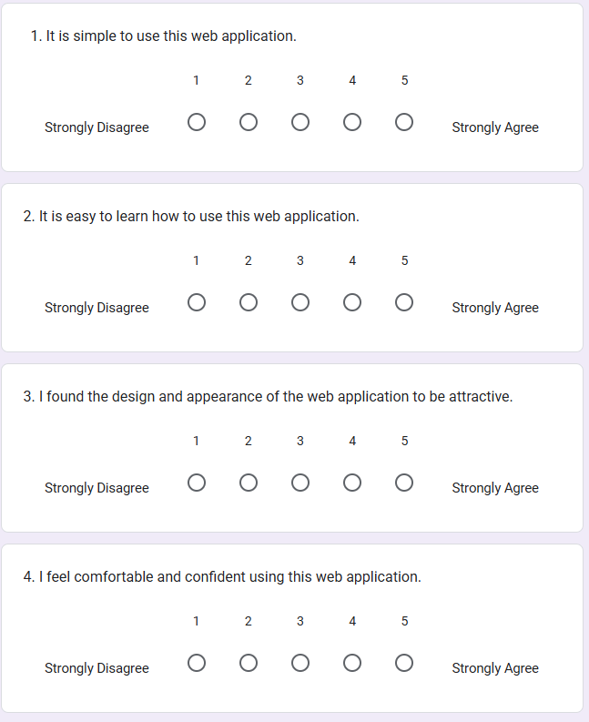

Figure 162 Question1-4

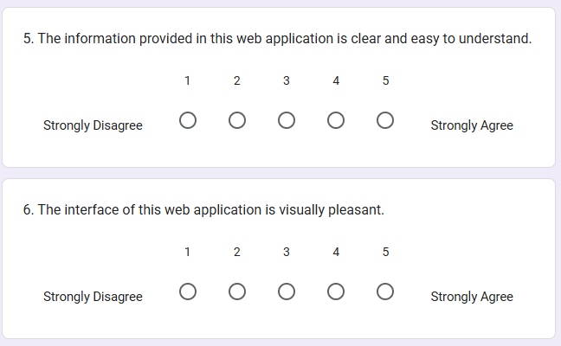

Figure 163 Question 5-6

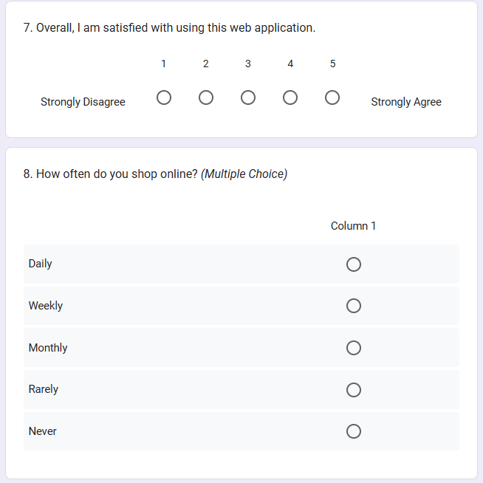

Figure 164 Question 7-8

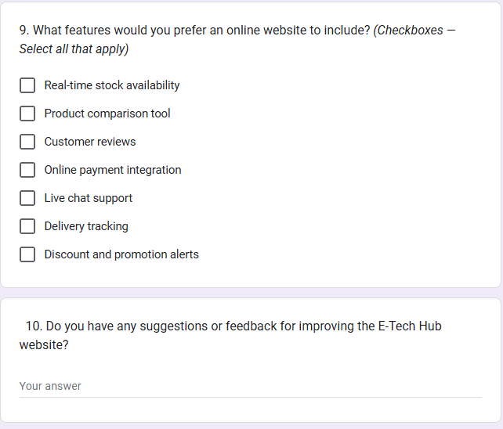

Figure 165 Question 9 -10

### **5.3.3 Participants Questionnaire Evaluation Results and Analysis**

This section presents the results of the questionnaire evaluation completed by all participants during the testing phase, along with a detailed analysis of the collected responses.  
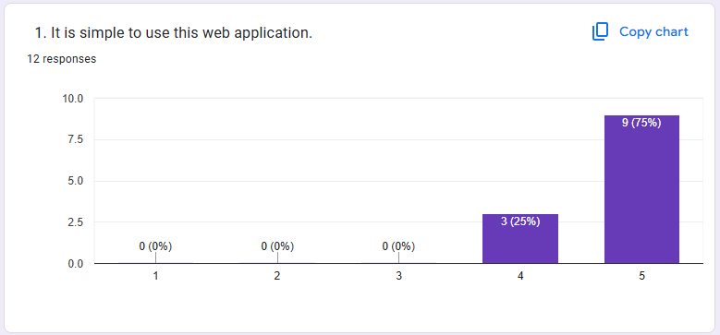

Figure 166 Result 1

Most participants agree that the web application is simple to use. According to the results, nine participants responded with "strongly agree" and three participants responded with "agree."  
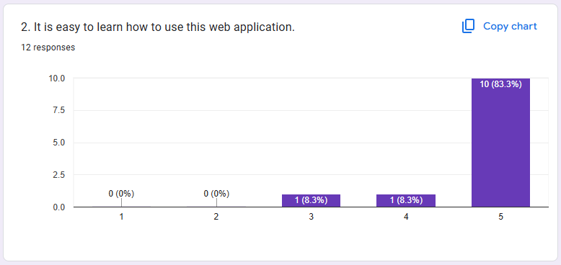

Figure 167 Result 2

Most participants agree that the web application is easy to learn. Ten participants strongly agreed that the web application is easy to learn, indicating that its design, interface, and features are intuitive and readily understood by new users. One participant agreed, further supporting the general ease of learning. One participant responded neutrally, which could suggest a variety of things: perhaps they found it neither particularly easy nor difficult, or maybe they had limited interaction with features that would fully demonstrate its learnability. The absence of negative responses suggests that users are not encountering significant obstacles or confusion when first engaging with the application.

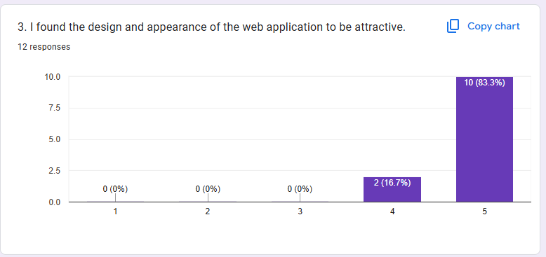

Figure 168 Result 3

Most participants found the design and appearance of the web application to be attractive. Ten participants strongly agreed that the design was appealing, indicating that the visual layout, color schemes, graphics, and overall aesthetic of the E-Tech Hub likely resonate very well with users. Two participants also agreed, further reinforcing the positive reception of the application's visual elements. The absence of any neutral or negative responses suggests that the design effectively creates a pleasant and engaging user experience, which can contribute to user satisfaction and perceived professionalism.

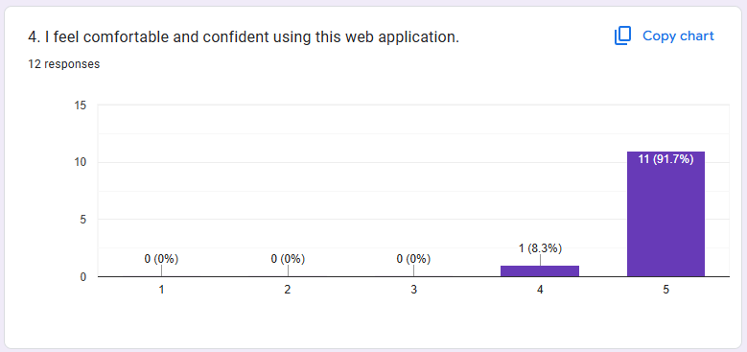

Figure 169 Result 4

The vast majority of participants feel comfortable and confident using the web application. Eleven participants strongly agreed with this statement, indicating that the application's intuitive design, clear navigation, and reliable functionality likely foster a sense of security and ease during user interaction. One participant also agreed, further reinforcing the high level of user comfort and confidence. The complete absence of neutral or negative responses suggests that users do not experience frustration, confusion, or uncertainty when engaging with the E-Tech Hub, which is crucial for a positive user experience and efficient task completion.

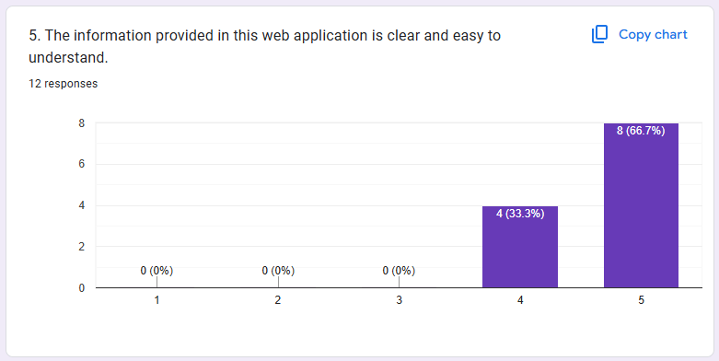

Figure 170 Result 5

Most participants agree that the information provided in the web application is clear and easy to understand. Eight participants strongly agreed with this statement, suggesting that the content is well-organized, concisely written, and free from jargon, allowing users to quickly grasp product details, policies, or navigation instructions. Four participants also agreed, further reinforcing the clarity and comprehensibility of the information presented. The complete absence of neutral or negative responses indicates that users are not encountering difficulties in understanding the content, which is vital for an effective e-commerce platform where users need to make informed decisions.

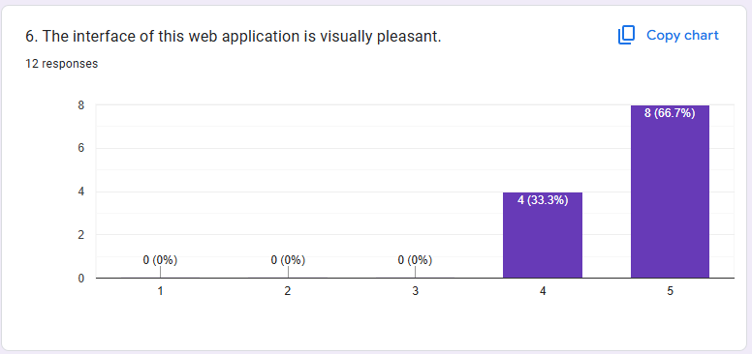

Figure 171 Result 6

Most participants found the interface of the web application to be visually pleasant. Eight participants strongly agreed, indicating that the aesthetic elements such as layout, color scheme, typography, and imagery are well-chosen and contribute to a positive visual experience. Four participants also agreed, further emphasizing the general appeal of the interface. The lack of neutral or negative responses suggests that the design effectively creates an inviting and professional look, which can enhance user engagement and overall satisfaction, especially in an e-commerce context where visual appeal often influences initial impressions and trust.  
  
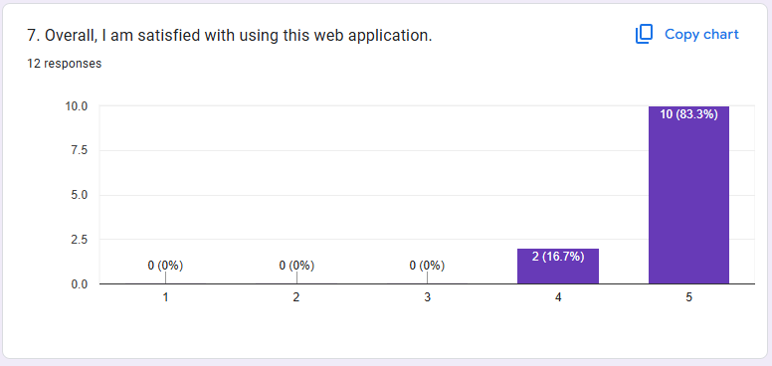

Figure 172 Result 7

The vast majority of participants are overall satisfied with using this web application. Ten participants strongly agreed with this statement, indicating a very positive overarching experience with the E-Tech Hub, likely stemming from its ease of use, learnability, attractive design, clear information, and the comfort/confidence it instills. Two participants also agreed, further solidifying the high level of user satisfaction. The complete absence of neutral or negative responses underscores that the application successfully meets user expectations and provides a generally pleasant and effective experience, which is a critical outcome for any digital platform.

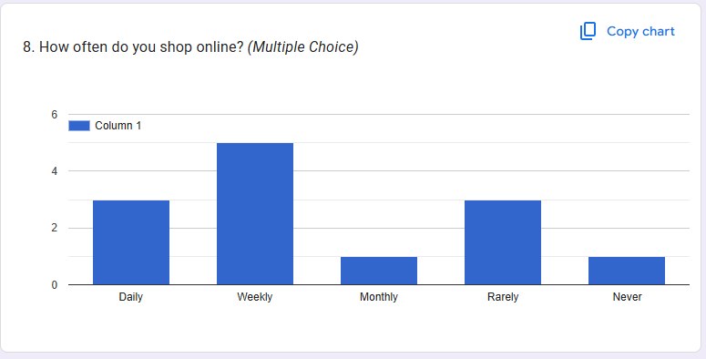

Figure 173 Result 8

The participants exhibit varied online shopping habits. Five participants reported shopping online weekly, indicating a segment of regular and frequent online shoppers among the respondents. Three participants shop daily, suggesting a highly engaged group that relies heavily on e-commerce for their needs. Another three participants shop rarely, which might indicate they prefer traditional shopping methods, only shop online for specific items, or have limited online purchasing needs. One participant shops monthly, representing a moderate frequency. Lastly, one participant never shops online, which could mean they are entirely new to e-commerce, prefer brick-and-mortar stores exclusively, or have no need for online purchases. This diversity in habits provides valuable context for the E-Tech Hub, showing it caters to a range of user engagement levels with online shopping.

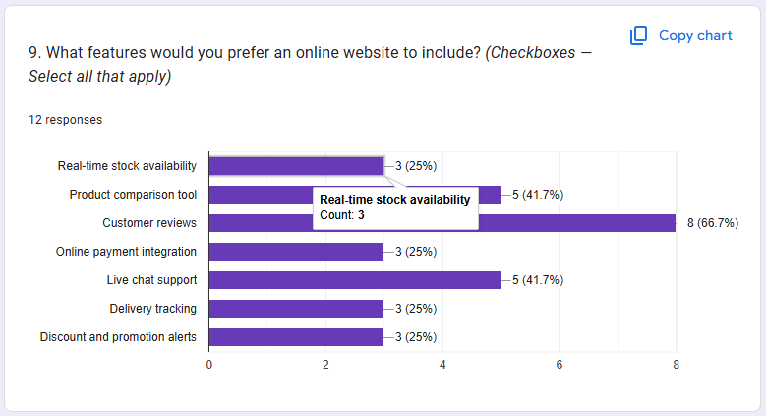

Figure 174 Result 9

When asked what features they would prefer an online website to include, participants showed clear preferences. The most desired feature, selected by eight participants, was Customer reviews, indicating that users highly value peer feedback and social proof when making purchasing decisions. Two other features, Product comparison tool and Live chat support, were equally preferred by five participants each. This suggests that users appreciate tools that aid in decision-making by comparing options, and they value direct, real-time assistance for queries or issues. Real-time stock availability, Online payment integration, Delivery tracking, and Discount and promotion alerts were all chosen by three participants each, showing that while these are important for a complete e-commerce experience, they were slightly less prioritized than reviews, comparison tools, and live chat by this group of respondents. These preferences highlight user needs for both informed purchasing and efficient service.

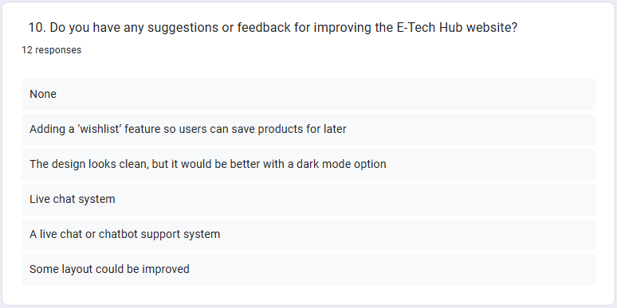

Figure 175 Result 10

When asked for suggestions or feedback for improving the E-Tech Hub website, participants offered several specific ideas. One respondent indicated "None," suggesting satisfaction with the current state of the website. However, several constructive suggestions were provided:

One participant recommended adding a 'wishlist' feature, which would allow users to save products they are interested in for later consideration, enhancing the shopping experience by enabling easier tracking of desired items.

Another participant praised the "clean" design but suggested an additional dark mode option, indicating a desire for personalization and potentially improved visual comfort, especially for prolonged use or in low-light environments.

Two separate suggestions pointed to the need for live chat or chatbot support systems, highlighting a strong user demand for immediate customer service and assistance within the website itself. This reinforces the findings from Question 9 where "Live chat support" was also a highly preferred feature.

Finally, one participant generally suggested that "Some layout could be improved," indicating a subtle area for potential refinement in the arrangement or presentation of elements on certain pages, aiming for an even more intuitive or aesthetically pleasing user interface.

## 5.4 Conclusion

Based on the feedback collected from users during the evaluation of the E-Tech Hub platform, it can be concluded that the system successfully delivers a user-friendly and functional e-commerce experience for electronic gadgets. The majority of participants agreed that the platform was simple to use, easy to learn, visually attractive, and provided clear information. These responses indicate that the system meets fundamental usability standards and offers a pleasant browsing experience.

In terms of desired features, users expressed a strong preference for the inclusion of customer reviews, followed by product comparison tools and live chat support. These selections suggest that users value features that support informed purchasing decisions and real-time interaction. Although features like real-time stock availability, online payment integration, delivery tracking, and promotion alerts were also considered important, they were ranked slightly lower, indicating they are useful but not the top priority for users at this stage.

Overall, the feedback gathered from the questionnaire has been instrumental in identifying both the strengths and areas for improvement in the E-Tech Hub platform. The results confirm that the project has successfully met its core usability and functional goals while also highlighting specific feature enhancements that could be considered in future development phases to further align the system with user expectations.